REPUBLIC OF GHANA



MINISTRY OF EDUCATION

GHANA ACCOUNTABILITY FOR LEARNING OUTCOMES PROJECT

(GALOP)

UPDATED ENVIRONMENTAL AND SOCIAL MANAGEMENT FRAMEWORK

(ESMF)

September 2024

EXECUTIVE SUMMARY
Several key factors contribute to low learning outcomes and regional and gender disparities: (a) poor conditions of school infrastructure and limited textbooks, workbooks and other teaching-learning materials; (b) ineffective teacher management and inadequate support system; (c) inequitable and inefficient use of non-salary budget, delayed and irregular capitation grants, and inequities across wealth quintiles and per-student spending across sub-sectors; and (d) inadequate governance and accountability.
The parent Ghana Accountability for Learning Outcomes Project (GALOP) (P165557) was approved in October 2019 and became effective on 16 April 2020. The project was developed to support the implementation of the Government’s Education Strategic Plan (ESP) with a focus on basic education. It supports investments aimed at improving the quality of low performing basic education schools and strengthen education sector equity and accountability in Ghana. Activities towards achieving these objectives include strengthening teacher capacity, school support and supervision, and strengthening accountability systems. The project targets grades from KG 1 to P6 for the support to teachers and schools, and provision of teaching and learning materials and will impact systems strengthening for basic education from KG1 to JHS3. The project’s focus on early years is equity enhancing because of the long-term benefits in terms of readiness to learn and improved future learning outcomes. The learning interventions are expected to reach approximately 10,000 low performing public basic schools, which represents approximately one half of all basic schools in Ghana. The GALOP provides learning grants for beneficiary schools to stimulate school level management accountability for results. These learning grants are expected to improve literacy and numeracy, through a menu of activities from which the schools can select and implement for the desired outcomes. Schools may also choose additional activities which they expect to improve learning outcomes given their context.
The first Additional Financing grant - Ghana Education Outcomes Fund (P173282), expanded the scope of GALOP and had the following additional components and sub-components: (i) sub-component 2.4: Strengthening support for schools and out-of-school children (OOSC) through outcomes-based commissioning; (ii) Component 5: Supporting the national COVID-19 response for continued learning, recovery and resilience in basic education; and expanded the scope of the parent project’s Component 4 - to support Technical Assistance (TA) and implementation and management of the AF.
This second Additional Financing (AF) - Global Partnership for Education (GPE) GALOP - is designed as an Additional Financing (AF) to the Ghana Accountability for Learning Outcomes Project (GALOP) (P165557). It will expand the scope of successful ongoing components (components one to four of the parent GALOP) and will include: (i) a more ambitious PDO-level indicator to increase the number of learners meeting literacy and numeracy targets in KG2 (school readiness) and P2, and (ii) will scale up effective interventions in the 10,000 GALOP schools to 6,000 additional basic schools, to bring the total number of intervention schools to 16,000 basic schools. The beneficiary schools will be selected using a similar approach to the parent GALOP school selection i.e. indicators comprising: Pupil Trained Teacher Ratio (PTTR), class size, poverty index, and test scores. New sub-components have been added to components 1, 2, and 3 as well as additional activities within existing sub-components to deepen implementation for quality foundational learning in Ghana. A no cost CERC has been proposed as Component 6 in accordance with World Bank IPF Policy.
The second AF will focus on early years, KG and lower levels of primary school extending interventions to all public KG schools and a significant proportion of primary schools (about 90 percent). The interventions will strengthen districts to implement activities to achieve agreed district-level targets and will specifically: (i) implement communities of excellence (CoEx) aimed at improving overall school performance; (ii) ensure that teachers are deployed to low performing and deprived KG and primary schools; (iii) train teachers in beneficiary KGs and primary schools to apply improved teaching approaches (play-based and differentiated learning) in the classroom; (iv) ensure that teaching learning resources (TLRs) reach and are used by all beneficiary teachers and learners; (v) monitor the improved teaching practices and individual learner improvements and infuse this evidence/information into in-service training, policy decisions and processes implemented at the district and other education management levels. The use of result-based financing under the original GALOP has incentivized and focused the government on the quality and results areas of activities being implemented to improve foundational learning and has strengthened collaboration among key agencies under the MoE.
The parent project and first Additional Financing were prepared under the World Bank’s Environmental and Social Framework (ESF) and is committed to meeting the ESF which requires that for project with series of subprojects, where the risks and impacts cannot be determined until the details of subprojects have been identified, an Environmental and Social Management Framework (ESMF) be prepared. This ESMF is an updated version of the one originally prepared for the parent GALOP. It incorporates the additional components and activities envisaged under this second AF. It sets out the principles, rules, guidelines and procedures to screen, assess, manage and monitor the mitigation measures of environmental and social impacts. These include:
- Screening subprojects for potential environmental and social risks and impacts;
- Assessment of potential adverse E&S impacts commonly associated with the sub-projects;
- Managing risks and impacts and monitoring specific mitigation measures
- Establishment of clear procedures and methodologies for the E&S planning, review, approval and implementation of sub-projects;
- Delineation of roles and responsibilities and the necessary reporting procedures for managing and monitoring sub-project E&S concerns;
- Budgeting for E&S implementation.

The second AF components present lower environmental and social risks and impact compared to those already assessed in the parent GALOP and first AF. The potential adverse impacts of the parent GALOP and first AF identified through the E&S assessment process included:
Generation of Waste: The Parent Project involves renovation of schools and provision of WASH facilities. The refurbishment and renovation at the construction phase as well as the maintenance and usage of the facilities at the operational phase could generate both solid and liquid wastes which may be hazardous or non-hazardous. These wastes could include: plastics, metal shavings, wood shavings, food wastes, plants, gases (carbon, nitrous and sulphurous oxides), fumes (from glues and other hydrocarbons), stone, ceramics, bricks, glass, cardboard, soil, cement, asphalt, sand, concrete, paper, paints, sealants, adhesives, fasteners, construction effluent (greywater), human excreta from WASH facilities etc. Risks and impacts from waste generation are expected to be moderate, direct and localized. As mitigation measures, the Project will ensure that specific Environmental and Social Management Plans (ESMPs) inclusive of Waste Management Plans (WMPs) are prepared and implemented at sub-project sites, where necessary. Specific mitigation measures for waste management will include but not limited to bulk purchasing of construction materials to reduce waste; provision of labelled waste bins and sensitization of workers, pupils to segregate wastes; proper waste collection and disposal at approved dumping sites through accredited waste management companies. Chemical and other hazardous waste e.g. paints, solvents, oils etc. will be handled by accredited waste companies following the World Bank EHS Guidelines and Good International Industrial Practices (GIIP).

Emission of Air Pollutants: There may be emission of various air pollutants which may have negative effects on both human and the environment. Exposure to cement dust, emission from paints, thinners and chemicals for treating wood and the solvents as well as delivery vehicles can reduce ambient air quality and put site workers at the risk of respiratory tract diseases. Dusts from the soil excavation, carving of bricks and movement of trucks on loose topsoil after the land has been cleared could pollute the air. Excavations and the use of cement and sand among other like-materials are bound to increase the dust and particle levels in the air around the development area. The Project will, among other mitigation measures, suppress dust through dousing of construction routes and sites; provide nose covers and other PPE to workers; observe vehicle speed limits; use well-serviced construction vehicles and machinery which produce less fumes and soot etc. Additionally, the Project will prepare site specific ESMP and request contractor’s Environmental, Social, Health and Safety (ESHS) Management Plan which will detail specific actions against these impacts before commencement of the works.

Generation of Noise: The renovation or construction activities and processes may also generate noise. Increased noise levels could be expected from moving equipment and construction machinery. The primary noise source associated with site preparation and construction works will be noise from operation of construction machinery such as excavators, compactors, trucks etc., as well as noise from construction activities and workers. Increased noise levels have the potential of causing auditory fatigue, temporary and permanent loss of hearing ability, sleep disorders, and can even contribute to learning problems in children. One of the risks of the noise would be to the surrounding areas where they may create a nuisance or disturbance to students and teachers. Per EPA guidelines, the permissible ambient noise levels in residential areas are 55 decibels (dBA) during the day and 48 dBA at night. Those at and around educational and health facilities are 55 dBA during the day and 50 dBA at night, while the noise level for areas with light commercial or light industrial activities are 60 dBA and 55 dBA during the day and night respectively. At the site, the loud noises may pose a risk to the workers and site personnel since loud noises increase the risk of ear damage and deafness. There may be an increase in the levels of noise in the construction site owing to the nature of machinery in use and the activities such as drilling and excavation. The normal levels of 55 decibels recommended by EPA and World Health Organisation (WHO) may be surpassed in the duration of the construction process.
The Project will ensure that the noisiest activities are carried out when schools have closed or over the weekend or when schools are on vacation. Also, to reduce impacts of noise on project communities, the Project will ensure that noisiest construction activities are carried out during the day and not in night. Other control measures include the provision of ear plugs for workers, use of well-serviced and low noise producing machinery etc.

Loss of Flora, Fauna and Habitats: The project areas are not likely to be within sensitive areas, habitats or spawning ground for any threatened, rare or endangered species. However, the clearing of site vegetation during renovation or construction activities especially for areas which expand into green fields could likely cause minimum disturbance to the vegetation and the topsoil. Consequently, this could pose minimum adverse impacts on fauna and flora living within or near the corridor of influence and their habitats. The potential loss of flora and fauna are expected to be direct, minimal and restricted to the project site. The impacts could be easily mitigated through proper landscaping or revegetation of the site after completion of the construction activities. This will additionally contribute towards preventing soil erosion.

Changes in Soil Characteristics: Some changes in the characteristics of the soil may occur due to the excavation and compaction of soil for the foundation. Also, movement of heavy vehicles (trucks, tractors, excavators etc.) may reduce the soil’s percolative ability and thereby increasing run-off either on the specific routes or large area. These impacts could be mitigated using light construction machinery, proper timing of construction works to avoid the rainy season and provision of appropriate drains to intercept, collect and direct run-offs through proper channels. Proper landscaping could also improve the soil’s percolative ability.

Labour Influx: Labour influx is not expected to be a major adverse impact as the civil works involved are minor in nature and will involve the use of local workforce. No work camp will be constructed and hence, the project does not envisage accommodation of workers at the construction sites. However, it is likely that ongoing rehabilitation and construction works will attract food vendors and petty traders to the construction area. Waste from such commodities might pollute the area if appropriate dumping bins are not provided for collection and onward disposal at approved dumping sites.

Sexual Exploitation and Abuse and Sexual Harassment (SEA/SH): SEA/SH risks including sexual exploitation and harassment, underage sex, rape, defilement etc. may arise from interaction between construction workers and school children. SEA/SH might also be of concern during operation from stakeholders such as teachers or students. Search for jobs and procurement opportunities from the project could provide grounds for sexual harassment and exploitation of girls and women. Therefore, the Prevention Against Abuse and Sexual Exploitation (PAASE) Action Plan developed under the Parent project will be used to facilitate SEA/SH education, sensitization, trainings and grievance redress mechanisms and worker profiling to identify and apply strong sanctions embedded clauses in the contractors’ agreements on child labour, sexual harassment. Again, regarding SEA/SH related to workers, a Code of Conduct will be signed by all contractor and service provider workers and information about the CoC will be posted in a visible place on site/workplace.

Occupational Health and Safety (OHS) Risks: Exposure to dust/emission during site clearing as well as mixing of concrete and elevated noise level within the work environment could also have negative implications on the health of the site workers, vendors and sellers, visitors and neighbouring communities during the construction phase of the project. Work related accidents such as burns, falls and cuts may also occur due to human errors, workers not wearing appropriate PPEs required for their assignments and mechanical faults on equipment. Accidents may also result from improper storage of equipment, paints and other solvents and construction materials as well as poor management of construction waste. Another source of accidents during the construction phase of the project is human-vehicular conflicts as equipment and supplies are transported to the site and waste is hauled from the construction site to designated disposal site. Accidents of this nature can result in spills, destruction of property, injuries and fatalities on-and-off site. Several OHS risks may occur from the activities, processes, materials and equipment involved in the construction phase of the project. Though the threat of Covid-19 has subsided, workers could be exposed to the COVID-19 virus if adequate procedures and protocols are not put in place to avoid their exposure.

Community Health and Safety Risks: During the renovation or construction process, there could be excavation of trenches on site. If the site is not hoarded, safety signs are not provided, and trenches are not covered quickly and/or well protected, then the general public would be at risk of accidental falls, being hit by falling objects or cuts. These accidents could cause injuries and fatalities. Trucks supplying materials to the site or hauling spoil from the site could also be involved in traffic-related accidents which could involve residents of the communities along the haulage routes. Such accidents could cause injuries, fatalities, loss of property and/or traffic disruptions along the haulage routes. The Project will therefore prepare a Traffic Management Plan (TMP) either as a standalone report or as part of the site specific ESMP before commencement of construction on site.

Incidence of Crime and Conflicts: Civil works could be associated with theft and pilfering of construction materials normally from the general public and site workers. Site workers could also steal from the offices within the immediate project environs. Other crimes include sexual harassment, illicit sexual affairs and rape as well as defilement, which are criminal under the laws of Ghana. There may also be conflicts arising out of accidents and destruction of property by the contractors’ work force, equipment or vehicles.

Land Acquisition and Restriction of Land Use: While the project is expected to use school or government lands, in many cases, unused or underused state land might have been subject to occupation, sometimes by “squatters”. The utilization of such state acquired lands may impact on livelihoods of people occupying such lands. In Ghana, there are cases that government acquisition has not been duly completed or undocumented resulting in disputes over ownership and boundary demarcation. While no massive land acquisition is envisaged under this project, the project has developed a standalone Resettlement Policy Framework (RPF) to guide the preparation of Resettlement Plans (RPs) during implementation including all AF projects, should such an instrument be required.

The second AF is generally expected to have positive net gains on the environment through the proposed climate smart interventions in schools such as the promotion and establishment of environmental clubs, promotion of tree planting, awareness creation about the effects of deforestation etc. The environmental risk classification is low. The envisaged risks/impacts are:
1. Potential minimum generation of end-of use electronic waste (e-waste) which may arise from the tablets and laptops supplied to GALOP schools for capturing data on schools and pupils into the Education Management and Information and System (EMIS), virtual training etc.
2. The potential use of inefficient electronic equipment which may contribute to inefficient exploitation of energy.
3. Minimum generation of domestic waste at workshops, schools, and training sessions.
These risks will be low and can be easily managed. The parent GALOP has already prepared an electronic waste management plan which will be continuously implemented throughout the project life cycle.

Similarly, the project will have positive social impacts as it will empower children to acquire further learning, improve quality of early grade, increase enrollment and retention, and keep children safe in school. Key potential social risks include inadequate stakeholder engagement, grievances, sexual exploitation, and abuse/sexual harassment (SEA/SH), discrimination, and stigmatization of pupils if health and disability screening is poorly conducted.
The key ESMF implementation areas and the relevant institutional roles as well as the institutional arrangement and collaboration for successful implementation of the ESMF have been determined and outlined. The E&S monitoring and reporting roles and responsibilities within institutions and among the stakeholders have been mapped out.
Stakeholder engagement is very important for the successful implementation of the project. This ESMF has been prepared taking into consideration the views and opinions expressed by the various stakeholders. Since stakeholder engagement is a continuous process throughout the life of the project, a standalone Stakeholder Engagement Plan (SEP) has been prepared to guide future stakeholder engagement activities. In case of the unlikely recurrence of the COVID-19 virus, stakeholder engagement will be permitted to take place in accordance with national protocols, GIIP and following the World Bank Technical Note: Public Consultations and Stakeholder Engagement in World Bank-supported operations when there are constraints on conducting public meetings issued on 20 March 2020.
An E&S screening process, selection and evaluation of sub-projects are required to identify E&S risks and impacts as well as mitigation measures, preferably in a participatory manner with beneficiary communities. MoE, GES and the other implementing entities will use the screening tool provided in this ESMF to screen all potential subprojects and report accordingly as part of the usual project formulation (feasibility phase) exercise.
Environmental and social mitigation guidelines designed with an aim to outline actions necessary to prevent, mitigate and control possible negative impacts during the sub-projects have been outlined. These guidelines include chance-find procedures and labour management procedures (including grievance management measures for workers).
Implementation arrangements. The Project will be mainstreamed in the Ministry of Education (MoE), the Ghana Education Service (GES) and the other implementing entities, and have a Project Technical Team (PTT) within the Planning, Budgeting, Monitoring and Evaluation (PBME) Division of the MoE (the Project Coordinating Unit (PCU)). The PTT will be responsible for implementing their mandated activities under the program and will comprise technical representatives of the MoE implementation agencies and key departments (including GES, NaSIA, NaCCA, NTC, CENDLOS, CEA, and NSS). The PTT will also include the current coordination units for GALOP and GEOP. The PTT/PCU will collate the ESMF implementation plans and budgets of the relevant activity owners (as part of the larger project annual work plan and budgeting) and submit to the World Bank (Grant Agent) for clearance. The PBME will also clear activities with the MoE and MoF for a period of six months to ensure that program activities run smoothly and are not hindered by multiple signatories for every small amounts. The agencies and departments will implement the day-to-day activities based on their approved implementation plans and budgets and will provide the necessary information for monitoring and evaluating the program.
A Project Oversight Committee (POC), which will have members of the heads of implementing agencies and the MoE, will have the responsibility for oversight of the project to ensure facilitated and effective implementation. The POC will meet on a quarterly basis and will also have representation from the MoF, funders and the GPE. The PTT which will meet monthly, will liaise with the Project Oversight Committee (POC).
The existing Environmental Specialist seconded from the EPA to oversee environmental risk and impacts management on the parent project will continue exercising oversight of environmental risks management. The PBME of MoE will procure the services of a Social Development Specialist to oversee social risks management, gender, and inclusion. The Environment and Social Specialists will directly facilitate implementation of the ESMF. The safeguards team forms part of the project management team/unit reporting directly to the head of the PTT.
District Assemblies (DAs) are empowered under Act 936 of 2016 to be responsible for development, improvement and management of human settlements and the environment in their districts. The District Education Oversight Committee (DEOC) which will be composed of (i) MCE or DCE; (ii) District Director of Education; (iii) District Engineer; (iv) District Planner; and (v) District Environmental/Social Officer will have responsibility for the project implementation (including environmental and social compliance) in collaboration with the beneficiary schools and communities.
Internal compliance monitoring mechanisms are put in place to ensure that environmental and social guidelines are followed. The School Management Committees (SMCs) will ensure the observance of the ESMF guidelines at the renovation and operational phase of the project (monitoring indicators and feedback mechanism will be developed to guide them). Any member of the SMC can approach the contractor or artisan to do the right thing as the first level of resolution and then to the DEOC through the District Director of Education if required. The DEOC of the respective districts led by the District Engineer in this regard will make routine as well as surprise visits to the schools during rehabilitation as well as occupancy phases of the project. During renovation works they will take the opportunity to supervise the work of contractors or artisans to ensure that they work according to environmental and social guidelines. They will act on resolving issues on the ground and will submit their monitoring reports to the PTT. The Safeguards team at the national level will also undertake monitoring of renovation works and related environmental and social issues and report to the GALOP coordinating unit at the national level.
Stakeholder consultation would be carried out throughout the lifecycle of the GALOP. The Project has prepared a standalone Stakeholder Engagement Plan (SEP) including a Grievance Mechanism (GM). Consultations were undertaken throughout the country to sensitize major stakeholders from the MoE, GES and other implementing entities at the national, regional and district levels during the preparation of the parent GALOP, the first AF and the second AF, and will continue in all phases of the project. Representative consultations will regularly be held as the need arises for GALOP-related activities at the sub project level. Participants will cut across various stakeholders, PAPs and focus groups in the selected communities, i.e., traditional leaders, women, youth, etc. Information obtained during consultations will be used to enhance the GALOP database and to aid decision making and addressing grievances.
Grievance Mechanism. The MoE through the implementation of the Secondary Education Improvement Project (SEIP) has put in place a GRM. GALOP has assessed the strengths and weaknesses of the existing GRM and has adopted it for the project. A four-tier Grievance Mechanism structure is adopted for the GALOP. This includes a national, regional, district and school/community level tier. At the school/community level, the existing GES GRM structures (learners, teachers, headteacher and SMCs) will be uptake points. The headteacher or a designated teacher shall receive, record, and facilitate resolution of grievances lodged at the school or community level. At the district level, the District Education Directorate, DEOC, and the Clients Service Units at the MMDAs will receive, record and resolve all grievances lodged at the district level or escalated from the school/community level. Grievances that are unresolved at the district level would be referred to the regional education directorate for resolution which is the third tier of the GM structure. If these grievances remain unresolved, they would be referred to the MoE and other implementing MDAs (which is the fourth tier) for resolution.
The grievance redress mechanism has a central online system housed at the PBME at MoE that links up standard systems (standard or proposed) from the Client Service Unit (CSU) of MoE and CSU at GES. Each of these linked units would have a dedicated staff that records cases pertaining to GALOP, either manually or electronically and feed it onto the central online system. Case resolutions would mainly be the responsibility of the implementing units (GES, NaSIA, NaCCA, NTC, CENDLOS, CEA, NELI and NSS) and the beneficiary entities (regional directorates, district directorates/DEOC and GALOP schools). Cases would only be transferred to the PCU, when all attempts fail. The Safeguards Specialist or a dedicated staff at the PCU/PTT would be responsible for management of the central grievance redress system.
Implementation and mitigation strategy. The ESMF provides a general impact identification framework and guidance on procedures to be followed and standards to be met in implementing the GALOP which should agree with national and World Bank safeguard provisions. The ESMF will ensure the screening of sub-project activities during implementation to inform the need to prepare appropriate environmental and social assessment instrument such as ESIAs, ESMPs, etc. On issues of land acquisition, restriction on land use and involuntary resettlement, the Project has prepared a standalone RPF to guide implementation and mitigation of such issues.

TABLE OF CONTENTS
EXECUTIVE SUMMARY ii
LIST OF TABLES xi
LIST OF FIGURES xii
LIST OF ABBREVIATIONS AND ACRONYMS xiii
1.0 INTRODUCTION 1
1.1 Project Overview 1
1.2 Purpose of the Environmental and Social Management Framework (ESMF) 3
1.3 Approach for the preparation of ESMF 4
2.0 PROJECT DESCRIPTION 5
2.1 Development Objective (PDO) and Indicators 6
2.2 Project Components and Activities 7
3.0 RELEVANT LEGAL AND INSTITUTIONAL FRAMEWORK 13
3.1 Institutional and Administrative Framework 13
3.2 National Environmental Legislation and Policies 15
3.3 National Educational Legislation and Policies 17
3.4 Other Legislation and Policies 18
3.5 International Treaties, Conventions and Protocols 20
3.6 Relevance of the World Bank Environmental and Social Framework (ESF) to the Project 22
3.6.1 Environmental and Social Overview 22
3.6.2 Environmental and Social Standards 22
3.6.3 Environmental and Social Risk Classification (ESRC) 25
4.0 DESCRIPTION OF THE ENVIRONMENTAL AND SOCIAL RISKS AND IMPACTS 27
4.1 Positive Impacts 27
4.2 Negative Impacts 28
4.2.1 Design, Pre-Refurbishment, Renovation or Pre-Construction Phase 28
4.2.2 Renovation or Construction Phase Impacts 28
4.2.3 Occupancy and Maintenance Phase Impacts 32
5.0 ENVIRONMENTAL AND SOCIAL MITIGATION GUIDELINES 34
5.1 Mitigation Measures 34
5.2 Chance Find Procedures 38
5.3 Labour Management Procedures 39
5.4 Working Conditions and Management of Worker Relationship 40
5.5 Protecting the Work Force 40
5.6 Occupational Health and Safety 41
5.7 Workers Engaged by Third Parties 41
6.0 INSTITUTIONAL ARRANGEMENTS FOR ESMF IMPLEMENTATION 42
6.1 Institutional Arrangements 42
6.2 Project Oversight Committee 43
6.3 Project Technical Team (PTT) 43
6.4 Environmental and Social Focal Persons 44
6.5 District Education Oversight Committee (DEOC) 44
6.6 Environmental Protection Agency 45
6.7 Internal Compliance Monitoring 46
6.8 Capacity Analysis and Building for Implementation of Framework 47
6.8.1 District Level Training 47
6.8.2 National Level Training 47
7.0 PUBLIC CONSULTATIONS AND PARTICIPATION AND INFORMATION DISCLOSURE 48
7.1 Introduction 48
7.2 Community Participation 48
7.3 Citizen Engagement/Education 48
7.4 Previous GALOP Stakeholder Engagement Activities 49
7.4.1 Parent GALOP Pre-Appraisal Meeting 49
7.4.2 GALOP AF1 Zonal Consultations at the Regional level 50
7.4.3 GALOP AF2 Zonal Consultations at the Regional level 51
7.5 Framework for Sub Project Level Consultations 51
7.6 Stakeholder Engagement and Consultation in the unlikely event of outbreak of COVID-19 52
7.7 Grievance Redress Mechanism 52
7.7.1 Grievance Redress Structure 53
7.7.2 Grievance Uptake Options 55
7.8 ESMF Disclosure 56
8.0 ENVIRONMENTAL AND SOCIAL MANAGEMENT FRAMEWORK IMPLEMENTATION AND MITIGATION STRATEGY 57
8.1 Screening of Sub-Projects and Potential Environmental/Social Impacts 57
8.2 Environmental and Social Mitigation, Monitoring and Reporting 57
8.2.1 Compliance Monitoring 58
8.2.2 Impacts Monitoring/Reporting 58
8.3 Estimated Budget for the Implementation of ESMF for Year One 68
APPENDICES 69
Appendix 1 – Elaboration of Project Components 70
Appendix 2: GALOP Sub Project Screening Form 79
Appendix 3: Environmental and Social Management and Monitoring Guidelines 86
Appendix 4: Stakeholder Consultations Workshops at Regional Level 90
Appendix 5: Additional Consultations on the first AF (March 2020) 94
Appendix 6: Photos from Additional Consultations on the first AF (March 2020) 95
Appendix 7: Attendance Lists for Zonal Stakeholder Consultation Workshops for GALOP AF2 96
Appendix 8: Pictures From CSOs Stakeholder Consultations for GALOP AF2 102
Appendix 9: Proposed GALOP Indicators 103

LIST OF TABLES
Table 3--1: Other Relevant Legislation Applicable to the Project 20
Table 3--2: International Treaties, Conventions and Protocols Applicable to Project 21
Table 4--1: Construction Phase OHS Risks 31
Table 5--1: Potential Impact Mitigation Table 34
Table 6--1: Summary of Key Institutions/Focal Persons and their Responsibilities 45
Table 8--2: Indicative Environmental and Social Mitigation Measures, Monitoring Indicators and Responsibilities 59

LIST OF FIGURES
Figure 2--1: GALOP Theory of Change for second AF 12
Figure 6--1: Illustration of Implementation Arrangements 45
Figure 7-1: Proposed GALOP GM Structure 54

LIST OF ABBREVIATIONS AND ACRONYMS

ADEOP Annual District Education Operational Plan
BECE Basic Education Certificate Examination
CE Citizen Engagement
CS Circuit Supervisors
CSO Civil Society Organisation
CSU Client Service Unit
DCE District Chief Executive
DEOC District Education Oversight Committee
DE District Engineer
DLI Disbursement Linked Indicators
DTST District Training Support Teams
EA1 Environmental Assessment Form 1
EA2 Environmental Assessment Form 2
EGMA Early Grade Mathematics Assessment
EGRA Early Grade Reading Assessment
EIA Environmental Impact Assessment
EIS Environmental Impact Statement
EMIS Education Management Information System
EPA Environmental Protection Agency
E&S Environmental and Social
ESCP Environmental and Social Commitment Plan
ESF Environmental and Social Framework
ESHS Environment Social Health and Safety
ESMF Environmental and Social Management Framework
ESMP Environmental and Social Management plan
ESMS Environmental and Social Management System
ESMTDP Education Sector Medium Term Development Plan
ESP Education Sector Plan
ESS Environmental and Social Standards
GALOP Ghana Accountability for Learning Outcomes Project
GES Ghana Education Service
GPE Global Partnership for Education
GRM Grievance Redress Mechanism
ICT Information and Communication Technology
IDA International Development Association
IE Inclusive Education
KG Kindergarten
LEG Local Education Group
MCA Maximum Country Allocation
MCE Metropolitan or Municipal Chief Executive
MMDA Metropolitan Municipal District Assembly
MLGRD Ministry of Local Government and Rural Development
MoE Ministry of Education
MOF Ministry of Finance
MCA Maximum Country Allocation
NACCA National Council for Curriculum and Assessment
NaSIA National Schools Inspectorate Authority
NCCP National Climate Change Policy
NEA National Education Assessment
NELI National Educational Leadership Institute
NGO Non-Governmental Organisation
NTC National Teaching Council
ODL Open and Distance Learning
OOSC Out-Of-School Children
P2 Primary 2
P4 Primary 4
PAASE Prevention Against Abuse and Sexual Exploitation
PASEL Program for Analysis of Education Systems
PDO Project Development Objective
PER Preliminary Environmental Report
PMP Pest Management Plan
PO Planning Officer
PISA Program for International Students Assessments
PIT Project Implementation Team
PST Project Steering Team
RAP Resettlement Action Plan
RPF Resettlement Policy Framework
SCD Systematic Country Diagnostic
SEP Stakeholder Engagement Plan
SHEP School Health Education Programme
SMC School Management Committee
SPED Special Education Division
SORT Systematic Operations Risks Rating Tool
SPIP School Performance Improvement Plans
SRC School Report Card
TA Technical Assistance
TLM Teaching and Learning Material
UNICEF United Nations International Children’s Emergency Fund
USSD Unstructured Supplementary Service Data
WB World Bank

INTRODUCTION

Project Overview
Ghana’s education system comprises a basic level (kindergarten, primary and lower secondary), secondary (upper general secondary/technical/vocational), and a tertiary level, as well as complementary education or non-formal education. The Ministry of Education (MoE) provides policy guidance and systemic oversight guided by the Education Sector Plan (ESP) (2019-2030). The ESP sets out medium- and long-term goals, objectives, and targets for the sector. The Ghana Education Service (GES) is the sector implementing agency, for all pre-tertiary education with 16 regional and 261 district offices of education across Ghana. The Ghana Education Service’s district offices across the 261 districts are responsible for public basic education within their districts. The Ghana Technical and Vocational Education and Training Service (GTVETS) is the implementation agency for technical and vocational education and training (TVET) at pre-tertiary level. Complimentary to the GTVETS is the Council for Technical and Vocational Education and Training (CTVET) which provides policy oversight for TVET education in Ghana. The Ghana Tertiary Education Commission (GTEC) is responsible for all tertiary education in the country including technical universities, nursing training colleges and teacher colleges of education. Basic and secondary public education is free for all beneficiaries, while public tertiary education is tuition free but charges academic user fees.
Ghana has made significant progress on improving access to education in the decade from 2000 to 2022. Gross enrollment rate (GER) has improved significantly at the kindergarten (KG) and primary levels from 60 percent to 122 percent and from 83 percent to 107 percent, respectively. The government's flagship Free Secondary Education Policy rolled out in 2017, is associated with a 28 percent increase in the number of students enrolled at higher secondary level between 2017 and 2023. Gross enrolment increased from 55.9 percent in 2017 to 60.7 percent in 2023. Through the IDA financed Ghana Accountability for Learning Outcomes Project (GALOP) the MoE has implemented a wide variety of reforms at scale. These achievements include implementing Differentiated Learning approach, supporting teachers with a coaching and mentoring program, and providing grants to 10,000 lowest performing basic schools specifically to improve learning. The GALOP has also supported the development of an accountability for learning framework and dashboard which provides decision makers with relevant data for accountable decision-making.
Despite improvements in access over the past two decades many learners fall below proficiency levels across most regions, and assessment of Socio-emotional learning is limited. Only about half of assessed learners in P4 meet the minimum competency benchmarks (51.3 percent for English and 49 percent for mathematics) according to the National Standardized Test (2022). The NST results for P4 reveals significant regional disparities in learners’ English language proficiency ranging from 21 percent of learners in the Ahafo region with advanced proficiency, to 97 percent of learners in Volta region with below basic proficiency. For both English and Mathematics, all 16 regions had less than 25 percent of P4 learners registering less than 25 percent with advanced proficiency. For mathematics, the Upper West had 88 percent of their P4 learners below basic proficiency compared to 36 percent in the Northern region. There is limited focus on measurement of socio-emotional learning.
Social inclusion remains a challenge, and additional efforts are required to enroll and retain children, especially from poor backgrounds, children with disabilities, and adolescent boys and girls. According to the 2021 population and housing census (PHC), 219,022 children between the ages of 5 and 15 faced difficulties in performing activities. Even though 8.6 percent of children 5-15 years have never been to school based on the 2021 PHC, 16.3 percent of children with disabilities in that age have never attended school. The intersection between poverty and schooling status is also well documented, with children from low-income households more likely to be out of school.
There is the need to enroll out-of-school children (OOSC), improve overall learning outcomes, and increase quality access to early childcare education services for improved foundational learning. Out of Ghana’s estimated 1.2 million OOSC among 4 to 18-year-olds (representing 10 percent of the school going cohort), 80 percent have never attended. The challenge of OOSC is more pronounced at the junior and senior high levels where net enrollment rates are 59 and 25 percent, respectively (Education Sector Analysis, 2024). UNICEF (2019) notes that 43 percent of children globally aged 5 and below are not meeting their potential because of the lack or limited healthcare, good nutrition, early stimulation, learning opportunities and protection. Further studies in Ghana also indicate that low access to quality early childcare educational services affects women labor participation in Ghana.
There are also variations in OOSC in the 16 regions of Ghana and contrary to expectations, there are more boys (55 percent) out of school than girls (45 percent) at primary and lower secondary levels. Despite progress made in expanding access to education for OOSC, there remains much to be done. Under the ongoing GALOP, about 70,000 OOSC are targeted with interventions starting with an Accelerated Learning Program (ALP) followed by transition to mainstream schools while monitoring learning gains from standardized national assessments. However, the GALOP targets only about 6 percent of the OOSC population in the country and thus far about 17,000 OOSC have been transitioned from accelerated learning programs to mainstream schools. The data suggests a plateauing of net enrollment rates in the past decade and suggests it will be harder to enroll the remaining OOSC. The planned targeted interventions under the GPE GALOP AF are to ensure more OOSC enroll.
Education expenditure in Ghana has decreased as a percentage of total government spending, particularly affecting basic education. In 2024, the education sector's share of the government recurrent budget is projected at 14%, below the international benchmark of 15-20%. Spending is skewed towards upper secondary and tertiary education, with only 20% of the education budget allocated to basic education in 2023. This allocation is lower than that of similar countries. Additionally, the non-salary budget for education is not fully executed, impacting funding for schools, districts, and regions, especially through capitation grants, which are eroded by inflation and usually delayed. This decline in the education budget, particularly for basic education, negatively affects infrastructure development and the quality of education services at the school and district levels.
Several key factors contribute to low learning outcomes and regional and gender disparities: (a) poor conditions of school infrastructure and limited textbooks, workbooks and other teaching-learning materials; (b) ineffective teacher management and inadequate support system; (c) inequitable and inefficient use of non-salary budget, delayed and irregular capitation grants, and inequities across wealth quintiles and per-student spending across sub-sectors; and (d) inadequate governance and accountability. The Government’s response to the education sector challenges has been guided by the government’s strategic framework for education as outlined in its Education Strategic Plan (2018 to 2030) and the medium-term national development plan on “Coordinated Program of Economic and Social Development Policies (CPESDP) 2017–2024”. Education is a major national priority as stated in the medium-term development plan and Education Strategic Plan. The Government’s commitment to addressing Ghana’s access to quality early childhood education and the learning crises is visible through the implementation of several reforms including the expansion of free basic education to include the kindergarten classes, the set-up of the National Teaching Council (NTC) to strengthen teachers’ capacity in a systematic approach. The National Schools Inspectorate Authority (NaSIA) was set-up to strengthen independent periodic external evaluation of quality and standards in both public and private schools among others.
The Government has also paid special attention to addressing disparities in access to education and promoting gender equality and inclusive education. Ghana has progressed significantly in addressing gender gaps in education enrolment at both the primary (including pre-primary) and secondary levels. Notwithstanding this progress, there continue to exist gender gaps enrolment in specific regions and areas in the North, Oti and Western North regions. The Government continues to support accelerated learning and integration of children out of school back to schools. The government has set up the Complementary Education Agency (CEA) to lead the implementation of supporting out of school children (OOSC) back into schools where possible and providing skills.
The Ghana Accountability for Learning Outcomes Project (GALOP) intervention serves as the government’s anchor to improving foundational learning. The Ministry of Education (MoE) and the Ghana Education Service (GES) have introduced differentiated learning (DL) which includes teaching at the right level, play-based learning and universal learning design (UDL) as the main approach to teaching at the primary level in all schools implementing the GALOP intervention. Teaching and learning materials accompanying DL teaching have been distributed to all schools implementing the intervention. Further, school learning grants have been provided at the school level to support targeted interventions in schools to improve learning. At the national level, the GALOP intervention is supporting the roll out of the national standardized test (NST) to track student learning outcomes on an annual basis and deepen community involvement in demanding accountability in schools through the reconstitution and empowerment of the School Management Committees (SMCs). The Ghana 2023–2027 Partnership Compact (developed by the Government of Ghana and partners and approved by the Global Partnership for Education [GPE] in December 2023) defines foundational learning for all as its overarching policy priority reform area. The proposed second AF will support the implementation of the partnership compact goal of improving foundational learning for all children in Ghana.

Purpose of the Environmental and Social Management Framework (ESMF)
The general framework for the assessment and management of environmental and social (E&S) risks and impacts of developments/projects in Ghana is provided in the Environmental Assessment (EA) Regulations - Legislative Instrument (LI) 1652. Some development partners, however, have their respective E&S safeguards procedures and policies which must be followed for projects funded by them. As part of the funding arrangements for the GALOP therefore, the Government of Ghana prepared an Environmental and Social Management Framework (ESMF) in compliance with the World Bank’s Environmental and Social Framework (ESF), which was consulted upon, cleared by the Bank and publicly disclosed. The existing ESMF of the parent GALOP has now been revised to provide guidance to mitigate environmental and social risks and impacts of the additional components and activities of the first and second AF. The revised ESMF provides the E&S safeguards procedures for the implementation of the GALOP including the additional components and activities resulting from the first and second AF.
GALOP is committed to meeting the World Bank’s Environmental and Social Framework (ESF) which requires that for projects with series of subprojects, that the risks and impacts cannot be determined until the details of subprojects have been identified, an Environmental and Social Management Framework (ESMF) be prepared. It is envisaged that GALOP will have a number of subproject activities especially in the area of providing learning grants to schools which could potentially include some minor construction, renovation and refurbishment works (e.g. minor repairs of school building, refurbishment of ICT laboratory, refurbishment of science laboratory, beautification of school compound construction of walkways and construction of fence wall/main gate etc.). Since the specific schools that will receive grants and the specific activities each of the grant proposal will likely fund is undetermined at this point, an ESMF is required. This updated ESMF provides a general impact identification framework to assist project implementers to screen sub-projects and institute measures to address potential adverse E&S impacts associated with the parent GALOP, the first AF and the second AF. It sets out the principles and processes within which the subprojects would be implemented agreeable to all parties. Specifically, the ESMF:
- Assesses the potential adverse E&S impacts commonly associated with the sub-projects and the way to avoid, minimize or mitigate them;
- Establishes clear procedures and methodologies for the E&S planning, review, approval and implementation of sub-projects;
- Provides an E&S assessment screening process; and
- Specifies the roles and responsibilities and the necessary reporting procedures for managing and monitoring sub-project E&S concerns.
Using the E&S screening tool, the project will identify the potential risks of subprojects and determine which environmental assessment instrument such as ESIAs, ESMPs, Resettlement Action Plan that may be required.

Approach for the preparation of ESMF
The ESMF has been prepared in accordance with World Bank’s Environmental and Social Framework and applicable Ghana environmental assessment guidelines. The following approach and techniques were used in the development of the ESMF:
- Data gathering;
- Participatory public consultations and discussions with relevant sector institutions;
- Data collection and analysis, consisting of literature reviews; environmental and social screening and scoping studies; determination of potential impacts; identification of impacts mitigation measures; preparation of an Environmental and Social Management Plan (ESMP); and preparation of sub-project guidelines;
- Workshops;
- Review of comments from stakeholders; and
- Preparation and submission of reports.

PROJECT DESCRIPTION
The parent Ghana Accountability for Learning Outcomes Project (GALOP) (P165557) was developed to support the implementation of the Government’s Education Strategic Plan (ESP) with a focus on basic education. It supports investments aimed at improving the quality of low performing basic education schools and strengthen education sector equity and accountability in Ghana. Activities towards achieving these objectives include strengthening teacher capacity, school support and supervision, and strengthening accountability systems. The project targets grades from KG 1 to P6 for the support to teachers and schools, and provision of teaching and learning materials and will impact systems strengthening for basic education from KG1 to JHS3. The project’s focus on early years is equity enhancing because of the long-term benefits in terms of readiness to learn and improved future learning outcomes. The learning interventions are expected to reach approximately 10,000 low performing public basic schools, which represents approximately one half of all basic schools in Ghana. The GALOP provides learning grants for beneficiary schools to stimulate school level management accountability for results. These learning grants are expected to improve literacy and numeracy, through a menu of activities from which the schools can select and implement for the desired outcomes. Schools may also choose additional activities which they expect to improve learning outcomes given their context.
The first Additional Financing grant - Ghana Education Outcomes Fund (P173282), expanded the scope of GALOP and had the following additional components and sub-components: (i) sub-component 2.4: Strengthening support for schools and out-of-school children (OOSC) through outcomes-based commissioning; (ii) Component 5: Supporting the national COVID-19 response for continued learning, recovery and resilience in basic education; and expanded the scope of the parent project’s Component 4 to support Technical Assistance (TA) and implementation and management of the AF.
The second Additional Financing (AF) - Global Partnership for Education (GPE) GALOP (P165557) will expand the scope of successful ongoing components (components one to four of the parent GALOP) and will include: (i) a more ambitious PDO-level indicator to increase the number of learners meeting literacy and numeracy targets in KG2 (school readiness) and P2, and (ii) will scale up effective interventions in the 10,000 GALOP schools to 6,000 additional basic schools, to bring the total number of intervention schools to 16,000 basic schools. The beneficiary schools will be selected using a similar approach to the parent GALOP school selection i.e. indicators comprising: Pupil Trained Teacher Ratio (PTTR), class size, poverty index, and test scores. New sub-components have been added to components 1, 2, and 3 as well as additional activities within existing sub-components to deepen implementation for quality foundational learning in Ghana. A no cost CERC has been proposed as Component 6 in accordance with World Bank IPF Policy.
The second AF will focus on early years, KG and lower levels of primary extending interventions to all public KG schools and a significant proportion of primary schools (about 90 percent). The interventions will strengthen districts to implement activities to achieve agreed district-level targets and will specifically: (i) implement communities of excellence (CoEx) aimed at improving overall school performance; (ii) ensure that teachers are deployed to low performing and deprived KG and primary schools; (iii) train teachers in beneficiary KGs and primary schools to apply improved teaching approaches (play-based and differentiated learning) in the classroom; (iv) ensure that teaching learning resources (TLRs) reach and are used by all beneficiary teachers and learners; (v) monitor the improved teaching practices and individual learner improvements and infuse this evidence/information into in-service training, policy decisions and processes implemented at the district and other education management levels. The use of result-based financing under the original GALOP has incentivized and focused the government on the quality and results areas of activities being implemented to improve foundational learning and has strengthened collaboration among key agencies under the MoE.
The program would use a hybrid Investment Project Financing (IPF) instrument with Performance-based Conditions (PBCs). The combination of investment financing and results-based funding (a modality which has been used in Bank funded projects in Ghana and is currently being used under the GALOP) would help ensure that there are adequate funds available for program activities while incentivizing the achievement of key milestones and actions and improving performance for sustainable interventions.

Development Objective (PDO) and Indicators
The development objective of the GALOP is “to improve the quality of education in low performing basic education schools and strengthen education sector equity and accountability in Ghana.” The objectives of the first AF and the second AF are well aligned with the parent project. However, because of the expansion of scope to cover almost all public basic schools in Ghana, the PDO of second AF has been slightly modified to read “to improve the quality of education in basic education schools and strengthen education sector equity and accountability in Ghana.”
Four changes are proposed to the PDO indicators.
- The baseline and target for PDO indicator 3(a) Increased percentage of targeted KG with PTTR below 50:1 is revised as the baseline and target in the original PAD was established on estimated data. The actual baseline for this indicator is 54.66 percent and the end-of-project target is estimated at 71 percent (compared to a baseline of 74 percent and end-of-project target of 90 percent estimated in the PAD).
- PDO indicator 2 - Students benefiting from direct interventions to enhance learning will be rephrased to align with the new corporate scorecard indicator Number of students supported with better education.
- A new PDO indicator 5 will be added as Increased percentage of P2 learners achieving basic proficiency or higher in literacy and numeracy assessment. The rationale for adding this new indicator is to increase the project’s ambition with the additional financing by including a new indicator that measures learning gains in beneficiary schools.
- PDO indicator 6 will measure the level of school readiness of children aged 4-5 to assess the quality of kindergarten education.

The PDO level indicators are summarized below in Table 2.1.

Table 2.1: Summary of Proposed Changes to PDO Indicators
PDO | Unchanged/Revised/New Indicator | Comment
PDO indicator 1. Increased percentage of targeted schools with teaching practices meeting inspection standards.  (disaggregated by KG and primary schools and by parent and AF schools) | Revised target to 70 percent | This indicator will now be disaggregated for KG and primary schools  This indicator will apply to both parent GALOP and AF schools
PDO Indicator 2. Number of students supported with better education  (disaggregated by sex, students with disabilities) | Revised Indicator including end of project target | Replaces previous PDO Indicator 2, Students benefiting from direct interventions to enhance learning  This indicator will apply to both parent GALOP and AF schools
PDO Indicator 3a. Increased percentage of targeted KG with PTTR below 50:1  (disaggregated by parent GALOP and AF schools) | Revised baseline and target | The new baseline for this indicator is 54.66% and the end-of-project target is 71%
PDO Indicator 3b. Increased percentage of targeted primary schools with PTTR below 50:1  (disaggregated by parent GALOP and AF schools) | New baseline and target for AF schools | Baseline and endline targets to be outlined in the PIM & M&E framework
PDO indicator 4. Increased number of schools using accountability dashboard data during cluster-level meetings | Unchanged
PDO indicator 5. Increased percentage of P2 learners achieving basic proficiency or higher in literacy and numeracy assessment | New | This indicator replaces the previous PDO indicator 4. Increased number of schools using accountability dashboard data during cluster-level meetings  This indicator applies only to AF schools
PDO indicator 6. Increased percentage of children demonstrating school readiness at the end of KG2 | New | An assessment would be administered to measure the level of school readiness across five domains measuring pre-mathematics, pre-literacy, executive functioning, fine motor skills, and socioemotional knowledge

Project Components and Activities
The parent GALOP includes five components:
Component 1: Strengthen teaching and learning through support and resources for teachers
  - Teacher capacity building and innovative delivery of in-service training
  - School-based support and instructional leadership
  - Provision of teaching and learning materials (TLMs)

Component 2: Strengthen school support, management and resourcing
2.1 Learning grants to support activities focused on learning
2.2 Strengthening district education management capacity
2.3 Strengthening SMCs for enhanced citizen engagement
2.4 Strengthening support for schools and OOSC through outcomes-based commissioning

Component 3: Strengthen accountability systems for learning
3.1 Development and implementation of an accountability for learning framework
3.2 Development and implementation of a national assessment strategy
3.3 Policy reforms for efficient education sector human resource management, administrative and leadership practices

Component 4: Institutional strengthening, technical assistance, monitoring and research
  - Technical assistance for capacity building and institutional strengthening
  - Monitoring and evaluation, management and operational costs

Component 5: Supporting the Education Response Plan to COVID-19 in Ghana for continued learning, recovery and resilience in basic education
5.1: Strengthening remote education service delivery
5.2: Support to safe school reopening and re-entry
5.3: Strengthening management for education sector resilience
The first AF provided additional support to the parent GALOP Component 2 and Component 4 and financed a new Component 5 which aimed at strengthening the educational sector’s response to COVID-19. Component 5 was completed on November 30, 2021.
The second AF will expand the scope of all successful ongoing components (components one to four) by increasing the beneficiary schools by an additional 6,000 schools. These additional 6,000 schools will be the next category of the poorest performing basic schools after the original 10,000 from the parent GALOP. The schools will be selected using a similar approach to the parent GALOP school selection. The indicators used to rank schools for the parent GALOP are the Pupil Trained Teacher Ratio (PTTR), class size, poverty index and test scores. The AF 2 indicators will utilize the NST scores which are school specific compared to the BECE scores, used for the parent GALOP, which tracks performances at a higher level (end of grade 9 school leaving exams) and are not available for all schools as some primary schools are without junior high schools. Further additional activities will be added to the ongoing components to deepen the implementation of foundational learning in Ghana.
Program activities under the AF 2 would be organized under five components:
(1) Component 1: Strengthening teaching and learning through support and resources for teachers
Sub-component 1.1: Teacher capacity building and innovative delivery of in-service training
Sub-component 1.2: School-based support and instructional leadership (including coaching and mentoring)
Sub-component 1.3: Provision of teaching and learning resources (TLRs)
Sub-component 1.4: Play-Based INSET rollout to all teachers in public KGs (new sub-component)
These would increase teacher capacity for improved and equitable teaching practices and foundational learning. The component will strengthen teacher capacity for improved teaching practices in play based, DL and SEL.
(2) Component 2: Strengthen school support, management, and resourcing.
Sub-component 2.1: Learning grants to support activities focused on learning
Sub-component 2.2: Strengthening district education management capacity
Sub-component 2.5: Childcare and Targeted After-school Interventions for improved school readiness (new sub-component)
Sub-component 2.6: Improved Identification of and Support to Learners with Disabilities at the District Level - Health and disability screening for learners. (new sub-component)
These will scale up the number of KGs and primary schools benefiting from enhanced learning grants to fund the implementation of school performance improvement plans (SPIPs) for improved foundational learning, strengthen district education management capacity, improve school readiness, and improve health and disability screening for learners.
(3) Component 3: Strengthening accountability systems for learning.
Sub-component 3.1: Development of an accountability for learning framework and dashboard
Sub-component 3.2: Development and implementation of a national assessment strategy
Sub-component 3.3: Policy reforms for efficient education sector human resource management, administrative and leadership practices.
Sub-component 3.4: Support to Communities of Excellence (CoEx) to develop localized solutions for improved learning outcomes.
These will support and strengthen practices targeted at districts and communities and will deepen capacity to achieve improved foundational learning. Also strengthen accountability of education officials to the communities based on the government-approved Communities of Excellence strategy to strengthen accountability of education delivery at the community level.
(4) Component 4: Technical Assistance, Institutional Strengthening, Monitoring, and Research
Sub-component 4.1: Technical assistance for capacity building and institutional strengthening.
Sub-component 4.2: Monitoring and evaluation, management and operational costs.
These will strengthen technical capacity and institutional strengthening within the MoE and its agencies, and support management and operational activities and monitoring and evaluation.
(5) Component 6: Contingency Emergency Response (CERC). A no-cost CERC is included in accordance with World Bank IPF Policy which would allow for rapid reallocation of the grant proceeds in the event of a natural or manmade disaster or crisis that has caused or is likely to imminently cause adverse economic and/or social impact.
In addition to AF2 schools, the project will support parent GALOP schools in some key activities. Table 2-2 below presents the district and school-based activities to be supported through this AF and their coverage in terms of parent GALOP schools and AF schools.

Table 2 - 2: Coverage of Activities for AF2 and Parent GALOP Schools
Sub Component Activity |  | AF Schools | Parent GALOP Schools | Scale
1.1 | Differentiated learning training for primary school teachers | Yes | Yes (support for reporting on the DL plus platform) | 16,000 schools
 | Counseling support for teacher wellbeing | Yes | Yes | 16,000 schools
1.2 | Coaching and mentoring of teachers | Yes | Already supported | 6,000 schools
1.3 | Provision of TLM s | Yes | Yes, but only GALOP schools with KGs | 14,732 schools
1.4 | Rollout of KG INSET program | Yes | Yes, for GALOP schools with KGs | 14,732 schools
1.5 | Health and disability screening for learners | Yes |  | 16,000 schools
2.1 | Learning grants to schools | Yes | Already supported | 6,000 schools
2.2 | District planning and performance grants | Yes | Yes | 261 districts
2.5 | Childcare interventions | Yes | Yes, if there is a gap and demand | National
3.1 | Scale up accountability for learning dashboard to cover AF schools | Yes | Already supported | 6,000 schools
3.3 | Improve teacher deployment and retention in hard-to-deploy areas | Yes | Yes | TBD
3.4 | Support to Communities of Excellence (CoEx) to develop localized solutions for improved learning outcomes | Yes | Yes | 100 districts  Number of communities under each district to be determined

The theory of change for the second AF is presented below.

Key Challenges |  | Components |  | Activities |  | Expected Outputs |  | PDO |  | Longer-term Outcomes
Low quality of teaching due to ineffective teaching practices |  | 1.Strengthen teaching and learning through support and resources for teachers |  | 1.1Teacher training on differentiated learning pedagogies (including PBL, TI & UDL)  -health, nutrition, and safeguarding training  -Teacher counseling support for well-being |  | Teacher knowledge and skills enhanced, increased implementation of DL in classrooms  Improved teacher well-being |  | Improved quality of education  Improved equity  Improved education sector accountability |  | Improved Foundational Learning
Limited coaching and mentoring of  teachers based on classroom observation and feedback |  |  |  | 1.2 Support school heads and teachers in instructional leadership, coaching and mentoring Train master trainers to roll out training |  | Increased coaching and mentoring support for teachers
Inadequate TLRs for teachers and learners |  |  |  | 1.3 Provision of TLRs for all beneficiary teachers and learners |  | Increased access to TLRs
limited access to quality KG education |  |  |  | 1.4* Rollout of Play-Based INSET across all Public KGS |  | Increased teacher knowledge and skills and implementation of KG Play-Based pedagogies in the classroom
Insufficient resources at the school level to support foundational learning |  | 2. Strengthen school support, management, and resourcing |  | 2.1 Provision of enhanced learning grants to schools |  | Increased school financing, improved school performance
Insufficient resources at the district level and limited accountability of districts  Limited identification of and support to children with learning challenges |  |  |  | 2.2 Provision of district accountability grants  Health and disability screening for learners* |  | Improved accountability of districts, increased district financing and monitoring  Improved identification of, and support to students with disabilities
Limited community oversight of school |  |  |  | 2.3 Strengthening SMCs for enhanced citizen engagement (including SMC federations) |  | Enhanced capacity SMCs
Out of school children with limited opportunities for education |  |  |  | 2.4 Support to OOSC through Education Outcomes Fund |  | Increased number of OOSC enrolled/mainstreamed  Improved learning outcomes
Low access to childcare and limited early stimulation of young children |  |  |  | 2.5* Implement childcare and after-school learning interventions for improved school readiness, and increased female economic participation in CoEs |  | Increased access to childcare  Increased school readiness of young children  Increased hrs. of economic activity for mothers/caregivers
Education data not effectively utilized for accountable decision-making purposes |  | 3. Strengthen Accountability Systems for Learning |  | 3.1 Integrated school level data available on accountability dashboard and utilized |  | Improved utilization of education data for evidence-based decision making
 |  |  |  | 3.2 Development and implementation of national assessment strategy |  | Strengthened systems for learning
Inefficient deployment/retention of teachers in remotely located schools |  |  |  | 3.3 Teacher deployment to hard to deploy schools |  | Improved teacher deployment and retention in hard to deploy schools
Limited community engagement and ownership in education |  |  |  | 3.4* Support to Communities of Excellence to develop localized solutions for improved learning |  | Improved community oversight of, and involvement in learning
Limited evidence-based policy making |  | 4.Technical assistance, institutional strengthening, monitoring, and research |  | 4.1Technical assistance for capacity building and institutional strengthening |  | Enhanced capacity of MoE to design and implement education programs
 |  |  |  | 4.2 Monitoring, Evaluation and Research  GEEDLab support to evidence-based policymaking* |  | Improved evidence-based policy-making and increased uptake of policy research  Enhanced monitoring of project activities and greater accountability
[NEW]  Lack of emergency financing for the education sector |  | [NEW]  6. CERC* |  | Flexibility to allow for reallocation of funds in the event of natural or manmade disasters |  | Enhanced education sector resilience to disasters
 |  | Program Management, Coordination, and Monitoring and Evaluation
Note: (a) Activities in red are supported through the proposed AF (b) * denotes new sub-components/activities added to the project through this restructuring

Figure 2-1: GALOP Theory of Change for second AF

3.0 RELEVANT LEGAL AND INSTITUTIONAL FRAMEWORK
GALOP will strictly adhere to and follow the World Bank’s Environmental and Social Framework (ESF) as well as the legal and regulatory frameworks of Ghana. This section provides an overview of relevant policies, laws and regulations specifically addressing this educational sector project. It focuses on the environmental legislation, the land administration and then the pertinent planning and other related regulations. The key environmental policies, legal framework and procedures considered as relevant under the GALOP are the following:

3.1 Institutional and Administrative Framework
The Ministry of Education (MoE) was established under the Civil Service Law 1993 and the PNDC Law 327, the MoE is mandated to provide relevant education to all Ghanaians as a vehicle for human growth and national development. The goal of the MoE is to formulate and implement policies that would ensure quality and accessible education to all Ghanaians to meet the needs of the labour market; and accelerate the acquisition of requisite skills to achieve human development, good health, poverty reduction, national integration and international recognition and to create an honest, creative and responsible citizenship. Its vision is to prepare and equip all Ghanaians with relevant education and skills to promote socio-economic development and national orientation. Its mission is to provide relevant education with emphasis on science, information, communication and technology to equip individuals for self-actualization and peaceful coexistence as well as skills for the workplace for national development.
The Ghana Education Service (GES) was established as part of the Public Service of Ghana in 1974 by NRCD 247 and was subsequently amended by NRCD 252, 357 and SMCD 63. Under the fourth Republican Constitution of Ghana, these earlier legislations have been amended by Acts of Parliament, including Act 506 (1994) and Act 778 (2008), more recently by Act 1049 (2020). GES seeks to create an enabling environment in all educational institutions and management positions that will facilitate effective teaching and learning and efficiency in the management of the attainment of the goals of the Service. Its mission is to ensure that Ghanaian children of school-going age are provided with quality formal education and training through effective and efficient management of resources to make education delivery relevant to the manpower needs of the nation. The key objectives of the Service are as follows:
- Increase inclusive and equitable access to and participation in education at all levels;
- Ensure provision of life skills training and management of personal hygiene, family life, gender, health, Acquired Immunodeficiency Syndrome (AIDS), Human Immunodeficiency Virus (HIV)/Sexually Transmitted Diseases (STIs), etc.;
- Improve the quality of teaching and learning;
- Improve the management of education service delivery.

The Special Education Unit of the Ministry of Education has as its responsibility the supervision of Special Education schools and units island-wide that are Government-owned or Government-aided, and those which receive special grants. The unit also supervises special education facilities in private homes and community-based schools and groups. In addition, the unit offers curriculum supervision and monitoring services, and facilitates training, networking, assessment and programme planning. The unit monitors the special education programme for children through six areas: Hearing Impairments, Visual Impairments, Physical Impairments, Mental Retardation, Giftedness and Learning Disabilities.
The Complimentary Education Agency of Ministry of Education (CEA) has an oversight to coordinate non-formal education activities in Ghana and offer quality and equitable lifelong learning opportunities for youths and adults outside formal education. The unit also supports the provision of functional literary and skills development programmes across Ghana. Since its launch in 1991, the unit has contributed to increase functional literacy of over 2 million Ghanaians.
The Ministry of Sanitation and Water Resources was established in January 2017 to act and lead national efforts to improve the living standards of Ghanaians through increased access to and use of safe water, sanitation and hygiene practices and sustainable management of water resources. The core mission of the ministry is to formulate and implement policies, plans and programs for the sustainable management of the nation’s water resources, the provision of safe, adequate and affordable water, provision of environmental sanitation facilities, effective and sustainable management of liquid and solid waste for the well-being of all people living in the country.
The Ministry of Gender, Children and Social Protection was created by an Executive Instrument 1 (E.I. 1) in January 2013 as a successor to the Ministry of Women and Children’s Affairs. The primary objective for its establishment was to have a Ministry responsible for policy formulation, coordination, monitoring and evaluation of Gender, Children and Social Protection issues within the context of the national development agenda. The Ministry’s mission is to contribute to national development by achieving gender equity and equality, facilitate the enforcement of rights of children, promote the integration and protection of the vulnerable, excluded, and persons with disability in the development process through appropriate policies and strategies with adequate resources.
The Environmental Protection Agency (EPA) is the principal institution established for environmental protection in Ghana and was created under the Environmental Protection Agency Act, 1994 (Act 490). The EPA's policy direction is articulated by the Environmental Assessment Regulations, 1999 (LI 1652). These two pieces of legislation mandate the EPA to manage, control and monitor compliance of environmental regulations by specific industries. The EPA has an important role in the Project implementation as the lead environmental regulator, which oversees compliance with environmental assessment requirements, facilitate public participation and disclosure and issue environmental permits for the project. The EPA has the mandate to decide on project screening, guide the conduct of the environmental assessment studies and to grant environmental approval for the project to commence. It’s mandate also covers monitoring of implementation phase of the project to confirm compliance with approval conditions, mitigation measures, and other environmental commitments and quality standards.
The National Council for Curriculum and Assessment (NaCCA), mandated by the Education Regulatory Bodies Act, 2020 (Act 1023), is responsible for the development and determination of its advice on matters relating to curriculum and assessment. The mission of NaCCA is to raise the quality of education at the pre-tertiary level, with emphasis on science and mathematics as fundamental building blocks for accelerated national development and to instil in young Ghanaians a heightened sense of cultural identity and nationalism.
The National Teaching Council is mandated by the Education Regulatory Bodies Act, 2020 (Act 1023), to improve professional standing and status of teachers and to license and register teachers in Ghana. The purpose of the licensure examination is to enable qualified teachers to acquire a professional license, and also attract excellent young graduates from the Universities and Colleges of Education who have the required professional knowledge, skills and attitudes necessary to deliver effectively in schools.
The National Schools Inspectorate Authority (NaSIA) is an agency of the Ministry of Education mandated by Parliament to provide an independent external evaluation of the quality and standards in basic and second cycle educational institutions in the country on a periodic basis. The NaSIA was established under the the Education Regulatory Bodies Act, 2020 (Act 1023) and consists of representatives of major education stakeholders, including the Universities of Education, the West African Examinations Council, the Association of Private Schools, the National Teaching Council, the Council for Technical and Vocational Education and Training, and the Religious Bodies (Christian and Muslim).
The Ghana Library Authority (GhLA) was established by the Ghana Library Board Act, 1970 (Act 372) as amended by Act 562 of 1998 for Ghana Library Board to become Ghana Library Authority. It was setup to improve literacy outcomes, which is key to the development of the country. As a centre for connecting citizens around intellectual discussions, GhLA maintains conference facilities across the regions in Ghana. Across the 30 branches in the country, GhLA offers opportunity for both school children and adult to learn the use of technological devices to solve everyday problems. The GhLA therefore contributes towards improving the learning outcomes of children which aligns very well with the objective of the GALOP project.
The Centre for National Distance Learning and Open Schooling (CENDLOS) is an agency under the MoE. Its role is to reinforce Open and Distance Learning (ODL) at the tertiary level and make it a reality at the pre-tertiary level including formal and informal sectors. It is also charged to work toward regulating and harmonising ODL in Ghana. Its core mission is to ensure that learning is accessible, flexible, and affordable to all citizens at home and abroad using open and distance learning technologies.
The Ministry of Local Government, Decentralisation and Rural Development and its departments and agencies belong to the Central Management Agencies category of Government Machinery with the mandate to ensure good governance and balanced development of Metropolitan / Municipal / District Assemblies. The Ministry derives its mandate from the 1992 constitution and section 12 of the PNDCL 327 which provides the responsibilities of Ministries.

3.2 National Environmental Legislation and Policies
The 1992 Constitution of Ghana sets out the first source of environmental protection requirements in Ghana. Article 36 (9) of the Constitution states that “the State shall take appropriate measures needed to protect and safeguard the national environment for posterity; and shall seek co-operation with other states and bodies for purposes of protecting the wider international environment for mankind”. In addition, Article 41 (k) requires that all citizens protect and safeguard the natural environment of the Republic of Ghana.
Article 25 (1) states that all persons shall have the right to equal educational opportunities and facilities and with a view to achieving the full realization of that right. The following sections of Article 25 (1) are referenced: (d) functional literacy shall be encouraged or intensified as far as possible; (e) the development of a system of schools with adequate facilities at all levels shall be actively pursued.
The Environmental Protection Agency Act, 1994 (ACT 490) came into being to establish the EPA as a body for the protection, conservation and management of environmental resources for the Republic of Ghana. The Act mandates the EPA with the formulation of environmental policy, prescribing of standards and guidelines, issuing of environmental permits and pollution abatement notices. Section 2 (i) of Act 490 further mandates the EPA to enforce compliance with established EIA procedures among companies and businesses in the planning and execution of development projects, including existing projects. Section 10 (2) of the Act also promulgates the establishment of a Hazardous Chemicals Committee with functions to monitor the use of hazardous chemicals by collecting information on the importation, exportation, manufacture, distribution, sale, use and disposal of such chemicals.
The Environmental Assessment Regulations, 1999 (LI 1652) was established to provide a framework for environmental assessment of development projects in Ghana. The LI 1652 is organised into five schedules of categorised projects which may either be subjected to a complete EIA or a Preliminary Environmental Assessment. The Schedules include:
- Schedule 1, Regulation 1 (1) outlines activities for which an Environmental Permit is needed.
- Schedule 2, Regulation (3) outlines activities for which EIA is mandatory.
- Schedule 3, Regulation 15 (2) provides requirements for disclosure of scoping notice and “notice of intent” to undertake the project.
- Schedule 4, Regulation 16 (3) provides requirements for disclosure and public consultation in the EIA process.
- Schedule 5, Regulation 30 (2) outlines environmentally sensitive areas known as Sites for Special Scientific Interest (SSSI).

Regulation 1 (2) of LI 1652 mandates that no person shall commence an undertaking which in the opinion of the Agency has or is likely to have adverse effects on the environment or public health unless, prior to the commencement, the undertaking has been registered by the EPA and an environmental permit has been issued by the Agency in respect of the undertaking.
The LI 1652 prescribes requirements for the following documents:
- Environmental Impact Statement (EIS).
- Preliminary Environmental Assessment (PEA).
- Environmental Management Plan (EMP).
- Annual Environmental Report (AER).
- Environmental Permits and Certificates

The National Environmental Policy - NEP (2010) sets out a new vision for environmental management in Ghana and is based on an integrated and holistic management system for the environment. It is aimed at sustainable development now and in the future. The policy seeks to unite Ghanaians in working toward a society where all residents of the country have access to sufficient and wholesome food, clean air and water, decent housing and other necessities of life that will further enable them to live in a fulfilling spiritual, cultural and physical harmony with their natural surroundings.

The NEP is defined under key operational principles of accountability, equity, environmental justice, inclusivity and open information, precautionary and polluter pays principles. Within the NEP are sector specific environmental protection policies. The NEP is intended to serve as the roadmap for Ghana towards protection, management and promoting sustainability of environmental objects.
The Environmental Sanitation Policy (Revised, 2010) lays the basis for developing a systematic approach and framework for identifying and harnessing resources for value-for-money services to all. It is the outcome of reviews to address limitations of the old policy published in 1999 and a result of nation-wide consultation among sector stakeholders. The Policy has been revised to update its scope to meet current development objectives and address aspirations of sector actors. The revision also takes on board the changing context of national and international development priorities. Emphasis is placed on the need to ensure systematic collection of data on wastes from all sectors of the economy to support relevant research and development to meet the challenges of managing wastes associated with the growing economy and rapidly changing lifestyles.
The National Climate Change Policy (2012) is to help policy makers think about the national policy actions and programmes needed to contribute to the fight against climate change and how such needs can be articulated in order to seek or leverage internal and external resources from public, private and international organisations.

3.3 National Educational Legislation and Policies
The Education Act 2008 (Act 778) has the objective to provide for the establishment of an educational system intended to produce well-balanced individuals with the requisite knowledge, skills, values, aptitudes and attitudes. Lift deleted to implementation strategies.
The Education Strategic Plan (2018-2030) builds on Ghana's achievements in expanding education. the Education Strategic Plan sets out the vision and policies for realizing the ambition of transforming Ghana into a ‘learning nation'. It puts Ghana on the road towards meeting the Sustainable Development Goals and represents a deliberate reorientation towards this aim, as it replaces the previous ESP for 2010-2020. This plan not only sets the long-term vision but also how this will be operationalized in the medium term through the accompanying Educational Sector Medium Term Development Plan 2018 – 2021.
The National Inclusive Education Policy defines the strategic path of the government for inclusive education. The Policy builds upon sections in the 1992 Constitution, the National Development Agenda, the Education Strategic Plan and international commitments to achieve national as well international goals for creating an environment for addressing the diverse education needs of Ghanaians. The Inclusive Education (IE) Policy provides an opportunity for all stakeholders in the education sector to address the diverse learning needs of various categories of citizens in the Ghanaian education system under the universal design for learning and within a learner friendly environment for all. IE is based on the value system which holds that all persons who attend an educational institution are entitled to equitable access to quality teaching and learning, and which transcends the idea of physical location but incorporate the basic values that promote participation, friendship and interaction.

3.4 Other Legislation and Policies
The Ghana National Fire Service Act, 1997 (Act 537) makes provision for the management of undesired fires and as per the functions of the service, provides technical advice for building plans in respect of machinery and structural layouts to facilitate escape from fire, rescue operations and fire management. Other functions of the service are:
- Organise public fire education programmes;
- Inspect and offer technical advice on fire extinguishers; and
- Offer rescue and evacuation services to those trapped by fire or in other emergencies.
The Fire Precaution (Premises) Regulations, 2003 (LI 1724) - The Ghana National Fire Service Act, 1997 (Act 537) states that a fire certificate will be required for premises used as a public place or place of work. This requirement is reinforced by the Fire Precaution (premises) Regulations, 2003 (LI 1724). It is incumbent on any project developer to ensure that adequate measures are introduced to minimise or prevent fire out breaks and a fire permit is obtained for development prior to the commencement of works.
The Local Governance Act, 2016 (Act 936) seeks to give a fresh expression to government’s commitment to the concept of decentralization. It is a practical demonstration of a bold attempt to bring the process of governance to the doorstep of the populace at the regional and more importantly, the district level. The Act establishes metropolitan, municipal and district assemblies as the highest decision-making authority at the local level with powers to enforce zoning and building regulation as well as responsibility of waste management.
The Land Use and Spatial Planning Act 2016 (Act 925) consolidates the laws on land use and spatial planning. It provides sustainable development of land and human settlements through a decentralized planning system and ensures judicious use of land to improve the quality of life, promote health and safety in respect of human settlements. This gives a clearer direction to ensure compliance and enforcement of development regulations by the Ghanaian society. It will also contribute to a more sustainable and well-functioning land administration system that is fair, efficient, cost effective and decentralized and will enhance land tenure security in the country.
The Labour Act 2003 (Act 651) amends and consolidates existing laws relating to employers, trade unions and industrial relations. The Act provides for the rights and duties of employers and workers; legal or illegal strike; guarantees trade unions the freedom of associations and establishes Labour Commission to mediate and act in respect of all labour issues. Under Part XV (Occupational Health Safety and Environment), the Act explicitly indicates that it is the duty of an employer to ensure the worker works under satisfactory, safe and healthy conditions.
The Workmen's Compensation Law 1987 (PNDC 187) seeks to address the necessary compensations to workers for personal injuries arising out of and in the course of their employment.
The Factories Offices and Shops (Amendment) Act (No. 275 of 1991) deals with registration of factories (including indication of the numbers of male and female employees and of the welfare facilities provided), notification of occupational accidents and illnesses, health and welfare standards (lighting, ventilation, dust, noise, etc.), safety measures, complaints in relation to dangerous conditions and practices, offences and legal proceedings, administration of the Act, duties of persons employed and prohibition on deductions from wages.
The 2018 Ghana Building Code is a comprehensive regulatory framework for construction in Ghana. It covers requirements, recommendations, planning, management, and practices related to both residential and non-residential buildings. The Ghana Building Code aims to enhance safety, quality, and adherence to international standards in the construction industry.
The National Building Regulations 1996, (LI 1630) is a legislative instrument mandated by the Local Governance Act. The core principle of the National Building Regulations like most National Codes is the provision of guidelines for safety, health and governance is a legislative instrument mandated by the Local Governance Act. The core principle of the National Building Regulations like most National Codes is the provision of guidelines for safety, health and governance.
The Public Health Act, 2012 (Act 851) revises and consolidates all the laws and regulations pertaining to the prevention of disease, promote, safeguard and maintain and protect the health of human and animals, and to provide for related matters. The law has merged all provisions in the criminal code, ordinances, legislative and executive instruments, acts, bye-laws of the District Assemblies etc. The Act enjoins the provision of sanitary stations and facilities, destruction of vectors including mosquitoes, protection of water receptacles and the promotion of environmental sanitation.
The Ghana Disability Act, 2006 (Act 715) was passed in 2006, aimed at ending the discrimination that faces people with disabilities. The Act offers a legal framework to protect the rights of physically and mentally disabled persons in all areas of life, from education, training and employment to physical access and health care. It is also intended to promote the creation of an environment that will advance the economic well-being of disabled people and enable them to function better in society. Specifically, to education, the Act makes provisions in section 16 for the Education of a child with disability as follows:16. (I) A parent, guardian or custodian of a child with disability of school going age shall enroll the child in a school. Act 715 also makes provision for Facilities and Equipment in Education as follows: “the Minister of Education shall by Legislative Instrument designate schools or institutions in each region which shall provide the necessary facilities and equipment that will enable persons with disability to fully benefit from the school or institution”. This Act underscores the importance of integrating issues of disability in the educational sector reforms including providing necessary facilities and equipment that will enable persons with disability to fully benefit from the schools.
Other relevant legislation applicable to the Project has been summarised in Table 3-1 below.
Table 3--1: Other Relevant Legislation Applicable to the Project
Legislation | Objective | Implementing Agency | Comment | Relevance to Project
National Museum Decree 1969 (NLCD  387) | Custodian and preservation of Ghana’s material cultural heritage (movable and immovable) | Ghana Museums and Monuments Board | Section 8 (1) specified that “no person shall by means of excavation or similar operation search for any antiquity unless authorised by a permit”.  Section 9 of the Decree provides requirements for the removal of antiquity.  Section 10 (1) behoves responsibility for any person who discovers an antiquity and the owner or occupier or any land upon which an antiquity is discovered on becoming aware of the discovery to without delay notify the Board. | Identification, assessment and removal of archaeological artefacts identified during construction works where excavation occurs
Wetland Management (RAMSAR sites) Regulation, 1999 | Protection and management of wetland sites of special scientific interest (SSSI) | Wildlife Division of the Forestry Commission | Protection of vital ecosystems and valuable environmental components. | Protection of mangroves and wetlands within the Project area
Wild Animals Preservation Act, 1961 | Protection of wild animals, birds and fish | Wildlife Division of the Forestry Commission | Protection of critical species and habitats | Protection and management of terrestrial wildlife
Forestry Commission Act, 1999 (Act 571) | Regulation of the utilization of forest and timber resources and managing of forest reserves and protected areas | Forestry Commission (FC) | The Act promotes management practices that encourage sustainability and provides for technical assistance in matters of resource protection | Protection and management of forest resources
Rivers Act, 1903 | Protection and sustainable use of rivers and related matters | Water Resources Commission (WRC) | Section 3 of the Act prohibits a person from dredging a river or extracting the water for construction purposes unless a license is obtained | Protection of water resources during the construction

3.5 International Treaties, Conventions and Protocols
Table 3-2 below summarizes the international and regional treaties, conventions and protocols to which the Government of Ghana is a signatory and identifies those aspects of the Project where they may be relevant.

Table 3-2: International Treaties, Conventions and Protocols Applicable to Project
Treaty/Convention/Protocol | Objective | Relevance to the Project
Convention on Biological Diversity (CBD) (1992) | Preserving and sustaining biological diversity. | Biodiversity studies and management/preservation
Convention on Migratory Species (CMS) of Wild Animals (1983) | Aninternationalregimefortheprotectionofmigratoryanimalsandtheirhabitats, and the prevention, reduction and control of factors that endanger them. | Biodiversity studies and management of migratory species of wild animals.
The Basal Convention on the Control of Trans-boundary Movements of Hazardous Wastes and their Disposal (1989) | The Convention directs for the control and transport of hazardous waste and their disposal. It sets in light the proximity principle for managing waste. | Plant and material selection for construction and demolition. Management of hazardous waste and health protection.
Convention on Wetlands of International Importance especially as Waterfowl Habitat (Ramsar Convention) (1993) | To conserve and protect the wise use of wetlands through local, regional and national actions and international cooperation. | Construction works and operations
Vienna Convention for the Protection of the Ozone Layer | Protection of the Ozone Layer | Compliance with standards and protocols
Convention on International Trade in Endangered Species of Wild Fauna and Flora (CITES) (1973) | To enforce that international trade in specimens of wild animals and plants does not threaten their survival | Biodiversity studies and management
United Nations Framework Convention on Climate Change (1992) | The reduction of negative changes to the earth’s climate, with focus on greenhouse gases. Places focus on industrialised countries to reduce emissions. Developing countries like Ghana are currently exempt from the reduction requirement; however, this may change | Manage GHG emissions associated with the Project.
Convention Concerning the Protection o the World Cultural and Natural Heritage (World Heritage Convention), Paris (1975) | International Convention to identify and conserve the world’s cultural and natural heritage | Protection of natural heritage and zones of cultural influence within the Project area
Convention Concerning the Protection of Workers Against Occupational Hazards in the Working Environment due to Air Pollution, Noise, and Vibration (ILONo.148) | The Convention encourages that employers in consultation with their workers understand project hazards related to air pollution, noise pollution, and vibrations | Project occupational health and safety
Bamako Convention on the Ban and Import to Africa and the Control of Trans boundary Movement and Management of Hazardous Waste (1991) | The Convention, affirming a commitment to address the problem of hazardous wastes in Africa, bans the import into Africa and the control of trans boundary movement and management of hazardous wastes within Africa | Plant and materials election for construction and demolition. Hazardous waste management and health protection.
African Convention on the Conservation of Nature and Natural Resources | The objectives of this Convention are: to enhance environmental protection; to foster the conservation and sustainable use of natural resources; and to harmonize and coordinate policies in these fields with a view to achieving ecologically rational, economically sound and socially acceptable development policies and programme. | Biodiversity studies and management of wetlands
Universal Declaration on Human Rights | The law provides for the promotion of respect for rights and freedoms and for progressive national and international measures to secure the effective recognition and observance among people of signatories themselves and among the territories under their jurisdiction. Key provisions include:  Article19: Everyone has the right to freedom of opinion and expression.  Article 20: (1) Everyone has the right to freedom of peaceful assembly and association. (2) No one may be compelled to belong to an association.  Article 24: Everyone has the right to rest and leisure, including reasonable limitation of working hours and holidays with pay | Employment or labour issues and protection of worker welfare
Arhaus Convention on Public Access to Information and Participation in Decision Making and Access to Justice in Environmental Matters (1998) | Protection of the right of present and future generations to live in an environment adequate to their health and well-being. Each party would promote the rights of access to information, public participation in decision-making and access to justice in environmental matters in accordance with the provision of this Convention. | Enhance Project information disclosure, public consultation and stakeholder engagement for the Project

3.6 Relevance of the World Bank Environmental and Social Framework (ESF) to the Project

3.6.1 Environmental and Social Overview
GALOP is committed to meeting the World Bank’s Environmental and Social Framework (ESF), which enables the World Bank and Borrowers to better manage environmental and social risks of projects and to improve development outcomes. The ESF offers a broad and systematic coverage of environmental and social risks. It makes important advances in areas such as transparency, non-discrimination, public participation, and accountability—including expanded roles for grievance mechanisms. It brings the World Bank’s environmental and social protections into closer harmony with those of other development institutions. The framework outlines 10 Environmental and Social Standards (ESS), which set out the requirements that apply to Borrowers.

3.6.2 Environmental and Social Standards
The Environmental and Social Framework of the World Bank sets out the WB’s commitment to sustainable development, through a Bank policy and a set of environmental and social standards that are designed to support Borrower’s project with the aim of ending extreme poverty and promoting shared prosperity. The environmental and social standards set out the requirements for borrowers relating to the identification and assessment of environmental and social risks and impacts associated with projects supported by the Bank through Investment Project Financing. The ten (10) environmental and social standards establish the standards that the Borrower and the project will meet through the project life cycle. Of the ten (10) ESSs, the underlisted seven (7) ESSs are relevant for the parent project and first AF. For the proposed 2nd AF, four (4) ESSs comprising ESS1, ESS2, ESS3 and ESS 10 are relevant.
ESS 1: Assessment and Management of Environmental and Social Risks and Impacts: This standard evaluates the potential environmental and social risks and impacts associated with each stage of a project (the project lifecycle) in its area of influence. It examines project alternatives; identifies ways of improving projects election, siting, planning, design, and implementation by preventing, reducing, mitigating, or compensating for adverse environmental and social impacts and enhancing positive impacts. It includes the process of mitigating and managing adverse impacts throughout the project implementation so that the project is environmentally and socially sound and sustainable. ESS1 considers the natural environment (air, water, and land); human health and safety; social aspects (involuntary resettlement, indigenous people, and physical cultural resources); and trans-boundary and global environmental aspects.
Relevance to the Project: The standard provides guidance on assessing the Project’s potential environmental and social risks and impacts and addressing potential impacts through planning and mitigation hierarchy approach.
ESS 2: Labour and Working Conditions: The World Bank through the ESS2 promotes the fair treatment, non-discrimination and provision of equal opportunities for workers engaged on projects it supports. It strongly encourages protection of all project workers, including vulnerable groups such as women, persons with disabilities, children (of working age) and migrant workers, contracted workers and primary supply workers, as appropriate. It provides certain requirements that the project must meet in terms of working conditions, protection of the work force (especially the prevention of all forms of forced and child labour), and provision of a grievance mechanism that addresses concerns on the project promptly and uses a transparent process that provides timely feedback to those concerned.
Relevance to the Project: The standard provides guidance on promoting the safety and health of the project workers and recognises the need for the project to create employment and income generation opportunities that will lead to poverty alleviation and economic growth of project stakeholder communities. It also provides guidance on how to prevent sexual exploitation and abuse (SEA) and sexual harassment by project workers.
ESS 3: Resource Efficiency and Pollution Prevention and Management: The ESS3 provides requirements for projects to achieve the sustainable use of resources, including energy, water and raw materials, as well as implement measures that avoids or reduces pollution resulting from project activities. The standard places specific consideration on hazardous wastes or materials and air emissions (climate pollutants) given that the current and projected atmospheric concentration of greenhouse gases threatens the welfare of present and future lives.
Relevance to the Project: The project is expected to through this standard, avoid or limit all sources of pollution to air, water and land as a result of the project, and how to properly manage the waste that is generated. The project will adopt efficient and effective resource use, pollution prevention and mitigation or management technologies and practices.
ESS 4: Community Health and Safety: This standard recognizes that project activities, project equipment and infrastructure of increase the exposure of project stakeholder communities to various health, safety and security risks and impacts and thus recommends that projects implement measures that avoids or limits the occurrence of such risks. It provides further requirements or guidelines on managing safety, including the need for projects to undertake safety assessment for each phase of the project, monitor incidents and accidents and preparing regular reports on such monitoring. ESS4 also provides guidance on emergency preparedness and response.
Relevance to the Project: The project will be guided by this standard in managing and/or addressing issues relating to the health and safety of the project communities, with particular attention to people who, because of their particular circumstances, may be vulnerable.
ESS 5: Land Acquisition, Restrictions on Land Use and Involuntary Resettlement: It is recognized that project-related land acquisition causes physical displacement and economic displacement or both which often leaves adverse impacts on communities and affected persons. Involuntary resettlement is triggered in situations involving involuntary taking of land or involuntary restrictions of access to the use of land, including cases where people or communities may have traditional or customary tenure or recognizable usage rights. ESS5 aims at avoiding involuntary resettlement to the extent feasible, or to reduce its adverse social and economic impacts. It promotes participation of displaced people in resettlement planning and implementation, and its key economic objective is to assist displaced persons in their efforts to improve or at least restore their incomes and standards of living after displacement. The standard prescribes compensation and other resettlement measures to achieve its objectives and requires that borrowers prepare adequate resettlement planning instruments prior to Bank appraisal of proposed projects.
Relevance to the Project: The project may involve land acquisition and will be guided by the recommendations stipulated in this standard in the event of project-related land acquisition and restrictions on land. The project has developed a Resettlement Policy Framework (RPF) to guide the preparation of Resettlement Plans during implementation if required. Due diligence will be required to mitigate against potential issues of land boundary disputes or impacts on livelihoods resulting from construction.
ESS9: Financial Intermediaries (FIs): This standard recognizes that strong domestic capital and financial markets and access to finance are important for economic development, growth and poverty reduction. FIs are required to monitor and manage the environmental and social risks and impacts of their portfolio and FI subprojects, and monitor portfolio risk, as appropriate to the nature of intermediated financing. The way in which the FI will manage its portfolio will take various forms, depending on a number of considerations, including the capacity of the FI and the nature and scope of the funding to be provided by the FI.
Relevance to the Project: It is possible that a financial institution may be selected as a social investor under sub-component 2.4. In this case, the financial institution will be required to have an Environmental and Social Management System (ESMS) in place and also have adequate capacity to implement the project in line with the World Bank Environmental and Social Standards.
ESS 10: Stakeholder Engagement and Information Disclosure: The World Bank through the ESS10 seeks to encourage open and transparent engagement between the Borrower and the project stakeholders project-affected parties) throughout the project life cycle. The standard establishes a systematic approach to stakeholder engagement that potentially helps the Borrower to identify stakeholders and build and maintain a constructive relationship with them, as well as disclose information on the environmental and social risks and impacts to stakeholders in a timely, understandable, accessible and appropriate manner and format. It recommends that stakeholder engagements are commenced as early as possible in the project development process and continued throughout the lifecycle of the Project. This allows for stakeholders’ views to be considered in the project design and environmental and social performance. The Borrower is also expected to implement a grievance mechanism to receive and facilitate resolution of concerns and grievances.
Relevance to the Project: The Project will engage with various stakeholders at the project design, planning and project implementation stages. The Project will be guided by this standard in undertaking all project-related consultations and engagements given that this enhances the environmental and social sustainability of the Project. In line with this, a standalone Stakeholder Engagement Plan (SEP) has been prepared.

3.6.3 Environmental and Social Risk Classification (ESRC)
The overall E&S risk classification for the GALOP, first AF and second AF is categorised as moderate considering the nature of proposed interventions, magnitude of potential risks and impacts, sensitivity of the project intervention areas, and capacity of the implementing agencies. It will be implemented in accordance with the World Bank’s Environmental and Social Framework (ESF).

Environmental Risk Rating
The environmental risk rating for the parent project and first AF is classified as moderate. The classification considered the potential environmental risks associated with the learning grants awarded to schools with the potential to include some minor construction, renovation and refurbishment works. Key environmental issues will be moderate and relate to waste generation, noise, dust and general health and safety of workers, students, and teaching staff. These risks will be site specific, limited to existing school compounds and can easily be managed through the implementation of cost-effective mitigation measures. The activities under the sub-component 2.4 are not expected to bring unanticipated environmental risks and impacts beyond those envisaged under the parent GALOP. The gathering of OOSC during their informal education (i.e., prior to integration into mainstream education) will likely generate waste (solid and liquid) which could lead to littering and creation of unpleasant scenery at the various communities or sites. This ESMF includes generic mitigations for the potential impacts. That notwithstanding, the Project during implementation will prepare site specific safeguard instruments such as the ESMP, Waste Management Plan (WMP), Health and Safety Plan (H&S Plan), Traffic Management Plan (TMP) etc. to specifically deal with impacts associated with the sub-projects, where necessary.
The second AF is generally expected to have positive net gains on the environment through the proposed climate smart interventions in schools such as the promotion and establishment of environmental clubs, promotion of tree planting, awareness creation about the effects of deforestation etc. The environmental risk classification for the second AF is low. The envisaged risks/impacts are:
1. Potential minimum generation of end-of use electronic waste (e-waste) which may arise from the tablets and laptops supplied to GALOP schools for capturing data on schools and pupils into the Education Management and Information and System (EMIS), virtual training etc.
2. The potential use of inefficient electronic equipment which may contribute to inefficient exploitation of energy.
3. Minimum generation of domestic waste at workshops, schools, and training sessions.
These risks will be low and can be easily managed. The parent GALOP has already prepared an electronic waste management plan which will be continuously implemented throughout the project life cycle.
Social Risk Rating
The social risk rating is considered Moderate. This classification is based on the potential social risks and impacts of the project as well as the capacity of the implementing agencies to manage the risks. The parent GALOP, first AF and second AF all support reinforcing foundational learning. The project specifically finance interventions, such as curriculum development, TLM, teacher training, support for OOSC to return to formal education, strengthening of supervision, and the NGO Consortium supporting the implementation of the OOSC, with a special attention to girls and children with disabilities. The project, in general, will have positive social impacts as it will empower children to acquire further learning, improve quality of early grade, increase enrollment and retention, and keep children safe in school.. Key potential social risks include labor issues, inadequate stakeholder engagement, unresolved grievances, and service providers charging unapproved fees despite the free OOSC programs, sexual exploitation, and abuse/sexual harassment (SEA/SH), discrimination, and stigmatization of pupils if health and disability screening is poorly conducted.
Minor civil works, e.g., renovations and refurbishment of existing WASH facilities and drilling of boreholes in schools are expected to be confined to existing school compounds. However, some due diligence is required to mitigate against potential issues of land boundary disputes or impact on livelihoods. The GALOP Resettlement Policy Framework (RPF) will guide the preparation of Resettlement Plans (RPs) or Livelihood Restoration Plans (LRPs) as may be required.
SEA/SH risks including sexual exploitation and harassment, underage sex, rape, defilement etc. may arise from interaction between construction workers and school children. SEA/SH might also be of concern during operation from stakeholders such as service providers, teachers or students. Search for jobs and procurement opportunities from the project could provide grounds for sexual harassment and exploitation of girls and women. Therefore, the Prevention Against Abuse and Sexual Exploitation (PAASE) Action Plan developed under the Parent project will be used to facilitate SEA/SH education, sensitization, trainings and grievance redress mechanisms and worker profiling to identify and apply strong sanctions embedded clauses in the contractors’ agreements on child labour, sexual harassment, and sexual exploitation and abuse. Again, regarding SEA/SH related to workers, a Code of Conduct will be signed by all contractor and service provider workers and information about the CoC will be posted in a visible place on site/workplace. The system will be streghtened during implementation to allow for safe reporting, referral and ethical disclosure, response management and closure of SEA/SH grievances.

DESCRIPTION OF THE ENVIRONMENTAL AND SOCIAL RISKS AND IMPACTS

The refurbishment, renovation or construction works that will likely be undertaken under the parent GALOP, first AF and second AF are as follows:
- Provision for repairs of school equipment and machinery;
- Provision for minor repairs of school building, furniture and fixture;
- Procurement of school furniture, procurement of tools and equipment;
- Refurbishment of ICT laboratory;
- Refurbishment of science laboratory;
- Beautification of school compound;
- Construction of walkways; and
- Construction of classroom units, fence wall/main gate.

Support the following additional renovation and construction works in selected schools:
- Boreholes;
- Water supply facilities;
- Hand washing facilities;
- Toilets;
- Urinals.

In addition to these minor works likely to be undertaken by the project, GALOP would also consider the following social issues:
- Gender inclusion;
- Disability inclusion;
- Risks of Gender-Based Violence (GBV), SEA and SH;
- Stakeholder engagement; and
- Grievance Redress Mechanism.

4.1 Positive Impacts
The following positive impacts are anticipated during the refurbishment, renovation or construction or operational phase:
Improved Infrastructure for Learning: Buildings, classrooms, libraries, and equipment- education infrastructure - are crucial elements of learning environments in schools. There is strong evidence that high-quality infrastructure facilitates better instruction, improves student outcomes, and reduces dropout rates, reduces school absenteeism particularly for girls among other benefits. The quality of educational facilities is linked to education outcomes for students and teachers. Infrastructure helps deliver positive outcomes for both students and teachers. So, the quality of training facilities plays a significant role.
Improved Students and Teachers Wellbeing: The project will provide well planned, good value infrastructure that meets the needs of users and contribute to better students and teacher’s well-being. It will reduce or remove overcrowding in classrooms and offices due to inadequate provision of highly spacious and very comfortable infrastructure; improve the total number of worker spaces availability and space including adequate seating and waiting places. The provision of additional working space will enhance the efficiency delivery of services.
Creation of Employment Opportunities: The project is expected to create employment for local artisans and manual labourers in the vicinity of where the facilities would be renovated or refurbished. The project will be expected to boost trade in construction materials such as cement, iron rods, lumber, etc.
Improved health status of students: The provision of first aid kits for schools under the nation’s School Health Policy, renovation of WASH facilities and construction of boreholes in selected schools are expected to improve personal hygiene of students, minimize their exposure to bacteria and virus borne infections, and their general health condition.

4.2 Negative Impacts

4.2.1 Design, Pre-Refurbishment, Renovation or Pre-Construction Phase
Three major issues to consider would be:
- The preparation of the bidding documents;
- Selection of contractors;
- Timing of renovation works.

During the preparation of bidding documents, the main risks would be the neglect of environmental and social aspects, and their low consideration premised on the assertion that there would be minor renovation works for the project that could easily be mitigated. Selection of contractors with poor environmental and social records will have adverse consequences on the E&S performance of the works. It is important therefore that the project selects good contractors with good environmental and social performance records demonstrated by their ESHS Policies, competence of staff, accident rate, etc. Wrong timing of renovation works may disrupt school programmes and also increase the potential impacts of the project on students and teachers.

4.2.2 Renovation or Construction Phase Impacts
It is perceived that risks and impacts of renovation works at this phase will be moderate and manageable. However, they could be a source of inconvenience for students, teachers, workers and the general public. These impacts could be identified during this phase:

- Air quality impacts (dust and exhaust emissions);
- Noise generation and vibrations (noise from machinery and equipment);
- Occupational health and safety issues for workers (accidents, injuries, COVID-19 related ill-health etc.);
- Public health and safety (unconsolidated constructional material left on site after the days’ work);
- Gender based violence (risks of sexual harassment, underage sex, child labour etc.);
- Labour influx (labour attracted from other communities could create conflicts)
- Solid waste management (earth material, wood offcuts, empty cement sacks, etc.);
- Liquid waste management (equipment washout after daily activities and human waste from workers);
- Employment and income for workers (labour conditions);
- Land acquisition and restriction of land use: occupation of land by “squatters, dispute over land ownership and boundary demarcation.
Loss of Flora and Faunal Habitats: The project areas are not likely to be within sensitive areas, habitats or spawning ground for any threatened, rare or endangered species. However, the clearing of site during renovation or construction activities could have minimum adverse impacts on fauna and flora within or near the corridor of influence. The potential loss of flora and fauna could be easily mitigated through landscaping after completion of the construction activities. This will additionally contribute towards preventing soil erosion.
Deterioration of Source of Building Materials: The opening of sand and burrow areas to extract construction materials like sand and gravel for the civil works would lead to the creation of pits. Rainwater will collect in the burrow pits and depressions, creating pools of stagnant water, if they are not re-instated. Stagnant water provides a suitable habitat for the breeding mosquitoes and snails that are vectors for diseases. The excavated trenches and pits could serve as a trap for animals and human beings in the vicinity of the sand and burrow pits.
Changes in Soil Characteristics: Some changes in the characteristics of the soil may occur due to the excavation and compaction of soil for the foundation. Also, movement of heavy vehicles (trucks, tractors, excavators etc.) may reduce the soil’s percolative ability and thereby increasing run-off either on the specific routes or large area. These impacts could be mitigated through the use of light construction machinery, proper timing of construction works to avoid the rainy season and provision of appropriate drains to intercept, collect and direct run-offs through proper channels. Proper landscaping could also improve the soil’s percolative ability.
Quarry Management: The project is not expected to directly operate a quarry site but rather solicit construction materials from accredited companies. Potential risks and impacts at quarry sites could include potential drowning of children from water-filled-pits which could be mistaken as swimming pool; the stagnant water in pits could breed mosquitoes and other insect borne vectors; sites may be prone to erosion, flying objects etc. The project will ensure that such companies have relevant permits regarding the operation of quarries and that they properly undertake reclamation, landscaping and soil protection as part of their operations. Additionally, the quarry companies should have a Reclamation and Quarry Closure Plans in place before being engaged by the project. To ensure harm across project points are abated, the site will be fenced, locked and access limited to authorized personnel only in order to safeguard community health and safety. Pits in the area that are filled with water will be marked with relevant signs to prevent children in the community from abusing it for a swimming pool or any other purposes and to also limit drowning risk. In the unlikely event that a contractor affiliated to the project opens borrow pits or undertakes quarry activities, the project will ensure that the above mitigation measures are adhered to prior to commencement of such activities.
Emission of Air Pollutants: The works involved in this phase of this project will also emit various air pollutants which can have negative effects on both human and environmental health. Exposure to cement dust, emission from paints, thinners and chemicals for treating wood and the solvents as well as delivery vehicles can reduce ambient air quality and put site workers at the risk of respiratory tract diseases. Dusts from the soil excavation, carving of bricks and movement of trucks on loose topsoil after the land has been cleared can pollute the air. Excavations and the use of cement and sand among other like-materials are bound to increase the dust and particle levels in the air around the development area. Such effects should be avoided through the use of dust screens.
Generation of Noise: The renovation or construction activities and processes may also generate noise. Increased noise levels are expected from clearing equipment and construction machinery. The primary noise source associated with site preparation and construction works will be noise from operation of construction machinery such as excavators, compactors, trucks etc., as well as noise from construction activities and workers. Increased noise levels can cause auditory fatigue, temporary and permanent loss of hearing ability, sleep disorders, and can even contribute to learning problems in children. One of the risks of the noise would be to the surrounding areas where they may create a nuisance or disturbance to students and teachers. Per EPA guidelines, the permissible ambient noise levels in residential areas are 55 decibels (dBA) during the day and 48 dBA at night. Those at and around educational and health facilities are 55 dBA during the day and 50 dBA at night, while the noise level for areas with light commercial or light industrial activities are 60 dBA and 55 dBA during the day and night respectively. Whereas at the site the loud noises pose a risk to the workers and site personnel since loud noises increase the risk of ear damage and deafness. There may be an increase in the levels of noise in the construction site owing to the nature of machinery in use and the activities such as drilling and excavation. The normal levels of 55 decibels recommended by EPA and World Health Organisation (WHO) may be surpassed in the duration of the construction process.
Increased Heavy Traffic: In this phase, the main roads leading to the site area will serve the additional vehicles used for the transportation of materials, equipment and staff to the site. The project will contribute to increasing the amount of heavy traffic plying the roads around it.
Labour Influx: Labour influx is not expected to be a major concern as the civil works involved are minor and will involve the use of the local workforce. However, it is likely that ongoing rehabilitation and construction works will attract food vendors and petty traders to the construction area. Waste from such commodities might pollute the area if appropriate dump bins are not provided for collection and onward disposal at approved dumping sites. No work camp will be constructed and therefore, the project does not envisage accommodation of workers at the construction sites.
Gender Based Violence: GBV risks including sexual harassment, underage sex, rape, defilement, etc., which may arise from interaction between construction workers and school children. Search for jobs and procurement opportunities from the Project could provide grounds for sexual harassment and exploitation of girls and women.
Generation of Construction Waste: The refurbishment, renovation or construction phase will lead to generation of construction wastes from the civil works and operations on the materials involved in the processes. These wastes include: plastics, metal shavings, wood shavings, food wastes, plants, gases (carbon, nitrous and sulphurous oxides), fumes (from glues and other hydrocarbons), stone shavings, ceramics, bricks, glass, cardboard, soil, cement, asphalt, sand, concrete, paper, paints, vehicle batteries, sealants, adhesives, fasteners, and construction effluent (greywater). Some of these wastes could be hazardous e.g. vehicle batteries (from construction machinery), paints and asbestos. The refurbishment and construction works are not envisaged to involve asbestos material, but it is possible that some of the existing schools to be renovated may have asbestos roofing or construction material which requires special care. The site-specific Waste Management Plan will assess potential use or occurrence of asbestos material and other hazardous waste and propose mitigations.
Occupational Health and Safety (OHS) Risks: Exposure to dust/emission during site clearing as well as mixing of concrete and elevated noise level within the work environment could also have negative implications on the health of the site workers during the construction phase of the project. Work related accidents such as burns, falls and cuts may also occur due to human errors, workers not wearing appropriate PPE required for their assignments and mechanical faults of equipment. Accidents may also result from improper storage of equipment, paints and other solvents and construction materials as well as poor management of construction waste. Another source of accidents during the construction phase of the project is human-vehicular conflicts as equipment and supplies are transported to the site and waste is hauled from the construction site to designated disposal site. Accidents of this nature can result in spills, destruction of property, injuries and fatalities on site. Several OHS risks may occur from the activities, processes, materials and equipment involved in the construction phase of the project. These risks are listed in Table 4.1 alongside their source.
COVID-19 (though currently subsided) has also created a new phase of health risk for construction workers. Workers can be exposed to the spread of the coronavirus if adequate procedures, preventive and protective measures are not put in place to avoid and minimize the exposure of workers to the virus.
Labour Conditions: Apart from the Health and Safety of workers, the likely labour risk may also include general labour working conditions (pay and compensation), community grievances over recruitment process and selection and protection of female workers.
Table 4-1: Construction Phase OHS Risks
OHS Risk | Source
Injuries or injurious substances, materials and equipment | - Moving parts of equipment e.g. saws, tractors, grinders etc.;  - Moving heavy materials;  - Open foundation pits;  - Raised building materials and equipment e.g. bricks, saws, hammers, Steel pipes & fittings etc.;  - Sharp edges of nails, knives, saws, glass;  - Open flames, heat generating or using processes;  - Working at heights;  - Emission of radiation from electrical equipment and bright lights from welding operations;  - Corrosive chemicals;  - Wet/slippery and uneven floors resulting in slips, trips and falls
Fire | - Flammable liquids & gases, chemicals, electricity, welding, open flames, heated materials and heat producing processes such as grinding, burning fuels etc.
Intoxication | - Toxic substances, corrosive chemicals, adhesives, waste gases, smoke, dusts and emitted particulate matter.
COVID-19 | - In the unlikely event of recurrence of COVID-19, there is a risk of virus spread among construction workers and within project communities from contact with infected people, items, materials, equipment etc:

Fire Risks: Construction areas prone to spontaneous fire combustion activities will include: fuel storage, mechanical workshop with welding and steel cutting facilities, smoke from burning garbage/refuse, cigarette smoking sections and carpentry shops. Smoking will generally be prohibited at the construction stage and will only be permitted at designated areas. Potential impacts from spontaneous fire combustion are significant, direct, and non-beneficial. Mitigation measures are required.
Community Health and Safety Risks: During the renovation or construction process, there could be excavation of trenches on site. If the site is not hoarded, safety signs are not provided, and trenches are not covered quickly and/or well protected, then the general public will be at risk of accidental falls, being hit by falling objects or cuts. These accidents can cause injuries and fatalities. Trucks supplying materials to the site may also be involved in accidents which may involve residents of the communities along the haulage routes. Such accidents can cause injuries, fatalities, loss of property and/or traffic disruptions along the haulage routes. If COVID-19 still pertains during the period of construction, there could be potential transmissions from construction workers to community members and vice versa including teachers and students. Such incidents can further heighten tensions between contractors and community members.
Incidence of Crime and Conflicts: Civil works can be associated with theft and pilfering of construction materials normally from the general public and site workers. Site workers can also steal from the offices within the immediate project environs. Other crimes include sexual harassment, illicit sexual affairs and rape as well as defilement, which are criminal under the laws of Ghana. There may also be conflicts arising out of accidents and destruction of property by the contractors’ work force, equipment or vehicles.
Land Acquisition and Restriction of Land Use: While the project is expected to use school or government lands, in many cases, unused or underused state land is subject to occupation, sometimes by “squatters”. The utilization of state land may therefore impact on livelihoods of people legally or illegally encumbering unused state lands. It is also frequently the case that government acquisition is not properly done or undocumented which can result in disputes over ownership and boundary demarcation that will need to be identified through due diligence and appropriate mitigation measures.

4.2.3 Occupancy and Maintenance Phase Impacts
Occupancy and Maintenance phase impacts would include:
- Waste generation (electronic, solid and liquid waste);
- Security and safety issues;
- COVID-19 infection concerns; and
- Poor sanitation at WASH facilities

These are briefly described below.
Generation of Waste: Waste streams that will be generated by workers, students and clients who visit the school during the post construction phase of the project includes electronic, paper, plastics and food residue. Environmental risks are expected to arise from poor management of end-of-use electronic equipment such as laptops and tablets which may be used for distance learning and training, data collection, report writing, and input into the EMIS. The generation of waste will have significant impacts on students and teachers in terms of public health as well as reducing the amenity value of the facilities, if not well managed. Also, the facilities where OOSC will be educated before being integrated into the mainstream schools will have similar waste generation problems similar to the mainstream schools but at a lower volume. Disposal of solid waste will be carefully planned through proper collection, accumulation, transportation, recycling, composting and any other legally and environmentally approved method. Generation of solid and liquid waste during the construction and operational phase of the project is a significant impact because of its association with sanitary related diseases like malaria and cholera. Liquid waste will comprise washroom wastes and washing of equipment, and these could be correctly handled by the use of properly constructed septic tanks, drainage and sewage systems. E-waste will be managed in accordance with provisions contained in the E-waste Management Plan prepared under the parent project.
Security and Safety Issues: At the operational phase, security issues like thoroughfares, encroachment, theft etc may arise. The risk of fire outbreaks and other related incidents on the facility could present challenges to the safety and security of the school facilities. Security is also needed to keep students safe from SEA/SH whiles on campus especially at night. Hence a proper SEA/SH education, sensitization, trainings and identification mechanisms is needed.
COVID-19 Infection Concerns: In the unlikely event that COVID-19 recurs and continue to present threat to schools, pupils and communities, improper use, cleaning, disinfection and maintenance of WASH facilities at schools could present peculiar challenges to the prevention and control of COVID-19 as they could potentially be the main sources of infection. Pupils using such facilities, for privacy reasons, are usually without direct supervision from their teachers and that gives them the opportunity to exhibit bad behaviors e.g. inappropriate touches of sanitation facilities, improper hand washing, removal of nose masks, etc. These could potentially contribute to the spread of the disease and make prevention difficult.
Poor Sanitation Issues: Poor sanitation at the WASH facilities could potentially pose health and safety risks and impacts in the school environment and the communities. Potential risks and impacts could include odour; proliferation of disease-borne vectors; outbreak of diseases e.g. cholera, typhoid; unsightly scenes etc. This could create a backlash between the school authorities and the communities. Similarly, the WASH facilities at the OOSC centres could equally result in these adverse environmental impacts.

ENVIRONMENTAL AND SOCIAL MITIGATION GUIDELINES

5.1 Mitigation Measures
The environment and social mitigation guidelines are designed with an aim to outline actions necessary to prevent, mitigate and control possible negative impacts during the sub-projects. Table 5-1 below summarizes some identified potential environmental and social impacts and their proposed mitigation measures at the various phases of the project.

Table 5-1: Potential Impact Mitigation Table
Activity /Potential Impact | Description of Impact | Proposed Mitigation Measures
Pre-Renovation or Refurbishment Phase
Preparation of bidding documents | Neglect of Environmental and Social issues during renovation activity | Use World Bank’s standard bidding documents. Incorporation of all environmental and social issues. Provide clear implementation arrangements for E&S implementation particularly at the local level.
Selection of contractors | Poor ESHS performance | - Assess contractor health and safety policy;  - Review contractor’s ESHS records of previous similar assignment;  - Ensure contractor presents competent staff;  - Review contractor’s accident/incidents records;  - Conduct due diligence on claims and penalties issued to the contractor as a result of ESHS infractions
Timing of renovation works | Interruption of renovation works/increase in magnitude of adverse impacts on students/ teachers | Undertake renovation works during vacation or when school has closed for the day.
Renovation or Refurbishment Phase
Loss of flora and faunal habitats | Environmental Degradation | - Landscape with indigenous species on completion of construction.  - Maintain landscaped gardens, terraces, conservation and management of the vegetation and gardens.  - Clear vegetation only in construction areas and demarcate areas where no clearing will happen.
Changes in soil characteristics | Soil Degradation | - Sprinkle water on the soil to prevent dust from rising. Create specific paths for the trucks.  - Ensure there is enough space for normal percolation of water.  - Prevent pollution from construction wastes by having specific sites for collection, sorting and transport of wastes.  - Proper installation and configuration of drainage structures to ensure their efficiency.  - Install cascades to break the impact of water flowing into the drains.  - Compact areas with loose soil  - Provide soil erosion control structures on the steeper areas of the site and control activities during the rainy season.  - Use light weight construction machinery.
Deterioration of source of building materials |  | The project is not anticipated to operate a quarry site or open up burrow pits. As a general practice in Ghana for works of such a scale, the contractor will solicit or outsource construction materials from accredited companies. To ensure that the materials emanate from good sources, the project will ensure the following among suppliers:  - Presence of valid environmental permit.  - Well protected site.  - Company avoid storing of soil or materials near water ways and on slopes.  - Exposed soil and material stockpiles are protected against wind and water erosion.  - Material loads are suitably covered and secured during transportation to prevent the scattering of soil, sand, materials, or dust.  - Company backfills shallow pits with excavated material once investigation is over.  - Burrow and/or quarry site are fenced, locked and access limited to only authorized persons.
Air quality impacts | Dumping of spoilt material, Compaction, Haulage of materials  Carpentry works and chiseling of walls  Dust and exhaust emissions on health of students and public | - Sprinkle water on soil before excavation and periodically when operations are under way to prevent raising of dusts.  - Enclose the structures under construction with dust proof nets. Using efficient machines with low emission technologies for the ones that burn fossil fuels.  - Control the speed and operation of construction vehicles.
Noise and vibrations | Compaction with machinery  Haulage of materials  Use of implements  Chiseling of walls  Health hazard to students, teachers and general public | - Regular maintenance of machinery and equipment  - Use equipment with noise suppressing technologies.  - Provide workers with PPE against noise e.g. ear plugs.  - Place signs around the site to notify people about the noisy conditions.  - Regular maintenance of equipment to ensure they remain efficient and effective.  - Comply with the EPA noise regulation.
Solid waste management | Compaction with machinery  Haulage of materials  Use of implements  Chiseling of walls  Inappropriate waste disposal with accompanying health risks and hazards | - Earthen material will be used to fill unlevel grounds and landscaping.  - Waste skips or bins will be provided to collect waste for appropriate disposal.  - Employ a waste management plan.  - Use waste minimization techniques such as buying in bulk.  - Allocate responsibilities for waste management and identify all sources of wastes, and ensure wastes are handled by personnel licensed to do so.  - Make available suitable facilities for the collection, segregation and safe disposal of the wastes.  - Create waste collection areas with clearly marked facilities such as colour coded bins and provide equipment for handling the wastes. The bins should be coded for plastics, rubber, organics, glass, timber, metals etc.  - Ensure all wastes are dumped in their designated areas and through legally acceptable methods and that the bins are regularly cleaned and disinfected.  - Assess and create opportunities for regulation, reducing, reusing, recycling, recovering, rethinking and renovation.  - Create adequate facilities for the storage of building materials and chemicals and controlling access to these facilities.  - Ensure bins are protected from rain and animals.  - Handle and dispose of asbestos from building material in case it arises in accordance with the national standards, World Bank Group EHS Guidelines, and Good International Industrial Practices (GIIP)
Liquid waste management | Washing of equipment haphazardly on site  Pollution water courses and ground water contamination | - Equipment washout will be discharged away from water courses and in drains.  - Provide mobile or temporary toilets for both male and female workers.
Fire risk | Damage to property  Potential loss of life | - Provide firefighting equipment and in easily accessible areas as well as ensure site personnel are well trained to use them. Also, maintain them regularly.  - Create safe and adequate fire and emergency assembly points and make sure they are well labeled.  - Provide adequate signages at fire risk areas to caution and inform workers.  - Prohibit smoking and naked fires around easily combustible materials such as paints, fuel, wood shavings etc.
Occupational health and safety issues | Health hazards (injuries and accidents) | - Employ an OHS plan that will outline all OHS risks and provide a strategy for their management.  - Ensure all potential hazards such as movable machine parts are labelled.  - Raise awareness and educate workers on risks from equipment and ensure they receive adequate training in the use of the equipment.  - Provide the workers with adequate PPE and monitor regularly to ensure they are replaced on time when they wear out.  - Place visible and readable signs around where there are risks.  - Ensure there is security in and around the site to control the movement of people.  - Provide safe and secure storage for equipment and materials on the site.  - Proper site sanitation and housekeeping.  - Strict adherence to safety precautions as per Factories, offices and shops Act, 1970 (Act 328).  - In the event of recurrence of COVID-19, contractors will be required to prepare guidelines or plans to avoid worker exposure to COVID-19 pandemic. Such plan will include provision to provide face mask, hand groves and other protection materials for workers, facilities for regular hand washing and adjustment of work to contain appropriate social distancing.
Labour influx | Risk of social tensions | - Recruit labour from sub-project community as much as possible.  - Workers to be issued with jobs cards to monitor their movements in the site area.  - Only authorised personnel should be allowed entrance to the site. Provide a work registry book for workers to sign in and out.  - Educate the workers on proper sanitation methods.  - Sensitize the worker on HIV/AIDS.  - Make available suitable facilities for the collection, segregation and safe disposal of wastes.  - Ensure all waste is dumped in their designated areas following legally acceptable methods.
Increase in  crime and  conflict |  | - Use the Project’s Grievance Redress System to resolve localised conflicts.  - Crimes such as theft, rape and defilement will be reported to the nearest police station directly or through the grievance redress system.
Community health and safety | Accidents and injuries | - Cordon off pits and excavations and provide appropriate directional signs. Signage could include no swimming, no drinking, especially where the pits are filled with water.  - Isolate the construction site with appropriate fencing, labels and only authorized persons should be allowed access to the construction site.  - In the event of recurrence of COVID-19, as a precaution to minimize the spread of COVID-19, contractors will be required to minimize interface between workers and communities members.
Social protection of vulnerable sections of school children and community and Gender-Based Violence | Risks of sexual harassment, underage sex, child labour etc. | - Strong sanctions embedded clauses in contractors’ agreements on child labour, sexual harassment etc.  - Include clauses in work contracts to as far as practicable utilize local labour and give equal opportunities to women and should not discriminate against vulnerable groups who have the capacity to work;  - Conduct background check on workers before employment;  - Require signed Code of Conduct from contractors, sub-contractors, workers, and supervising consultants as part of contract.  - Sensitize contractors, supervising consultants, schools on issues of GBV/SEA/SH.  - Implement provisions in the PAASE.
Employment and income (labour conditions) | Improve living standards of workers | - Include Labour management procedures in ESMP:  - Require all workers to have signed contracts outlining the terms and conditions of employment before they start working on subprojects.
Occupancy and Maintenance Phase
COVID-19 infections | Risk of construction work leaving traces of COVID-19 in the school environment | - In the event of recurrence of COVID-19, provide PPE for the workers and ensure compliance with appropriate national, WHO and World Bank COVID-19 safety protocols.  - Provide hand washing facilities and ensure regular flow of quality water for users of WASH facilities and also for the general use of students, teachers, visitors etc.  - Where water supply is problematic, schools should consider providing hand sanitizers and sensitize pupils on how to use it.
Generation of waste |  | - Use waste minimization techniques such as buying in bulk, buying pre-processed foods in the restaurants etc.  - Allocate responsibilities for waste management and identify all sources of wastes, and ensure wastes are handled by personnel licensed to do so.  - Make available suitable facilities for the collection, segregation and safe disposal of the wastes.  - Create waste collection areas with clearly marked facilities such as colour coded bins and providing equipment for handling the wastes. The bins should be coded for plastics, rubber, organics, glass, paper, electrical equipment etc.  - Ensure all wastes are dumped in their designated areas and through legally acceptable methods and that the bins are regularly cleaned and disinfected.  - Assess and create opportunities for reducing, reusing, recycling, recovering, rethinking and renovation.  - Create adequate facilities for the storage of materials and chemicals and control access to these facilities.  - Ensure bins are protected from rain and animals.  - Use the E-waste Management Plan prepared under the parent GALOP to guide management of electronic waste.
Land acquisition and restriction of Land use: | While the project is expected to use school or government lands, in many cases, unused or underused state land is subject to occupation, sometimes by “squatters”. The utilization of state land may therefore impact on livelihoods. It is also frequently the case that government acquisition is not properly done or undocumented which can result in disputes over ownership and boundary demarcation that will need to be identified through due diligence and appropriate mitigation measures. | Prepare Resettlement Plans or Livelihood Restoration Plan as may be required.
Poor sanitation at WASH facilities and health and safety matters | Sanitation related ill-health  Potential ground water contamination  Accessibility issues for people with disability  Gender issues | - Ensure regular cleaning and disinfection of WASH facilities.  - Water for flushing and hand washing should be of good quality as that could be a source of infections.  - Ensure universal access of WASH facilities and latrines for students with disabilities.  - Separate latrines should be provided for girls and boys.  - The design of WASH facilities must be efficient in the use of water and energy. Technolgies with low water consumption and those that rely on renewable energy should be preferred.  - The WASH technology should avoid or effectively separate human and excreta contact.  - Handling and disposal of excreta from septic tanks should be properly done by accredited waste companies.  - WASH facilities must be properly maintained to avoid leakages of excreta, odor and proliferation of disease-borne vectors.  - Sensitize students, teachers and all users of the WASH facilities on proper use, care and maintenance, safety measures, water use etc.  - Investigate ground conditions and use appropriate latrine technology which avoids ground water contamination.

5.2 Chance Find Procedures
In the event of finding previously unknown sites or feature of cultural value during project implementation, the following standard procedures for identification, protection from theft, treatment and recording should be followed.
Specifically:
- Stop the activities in the area of the chance find;
- Delineate the discovered site or area;
- Secure the site to prevent any damage or loss of removable objects;
- Notify the Supervising Engineer who in turn will notify the responsible authorities;
- The Ministry of Tourism, in collaboration with responsible local authorities (where applicable), would be in charge of protecting and preserving the site before deciding on subsequent appropriate procedures;
- The Ministry of Tourism, Arts and Culture (MoTAC) and National Museums and Monument Board will make decisions on how to handle the findings. This could include changes in the layout (such as when finding irremovable remains of cultural or archaeological importance), conservation, restoration, and salvage.
- The Ministry of Tourism, Arts and Culture shall communicate implementation of the authority decision concerning the management of the finding in writing.
- Construction work could resume only after permission is given from Ministry of Tourism or other responsible authorities concerned with safeguarding the cultural heritage.
These procedures must be referred to as standard provisions in construction contracts, Safeguards Procedures for Inclusion in the Technical Specifications for Contracts. During project supervision, the Site Engineer shall monitor the above regulations relating to the treatment of any chance find encountered. Relevant findings will be recorded in the Monitoring Reports and the World Bank Implementation Supervision Reports (ISRs), and Implementation Completion Reports (ICRs) will assess the overall effectiveness of the project’s cultural property mitigation, management, and activities, as appropriate.

5.3 Labour Management Procedures
The project recognises the need to protect the fundamental rights of workers since the workforce is a valuable asset, and a sound worker-management relationship is a key ingredient in the sustainability of the project. Through a constructive worker-management relationship, and by treating the workers fairly and providing them with safe and healthy working conditions, the project will create tangible benefits, such as enhancement of the efficiency and productivity of their operations. The objectives of the labour management procedure are:
- To promote the fair treatment, non-discrimination, and equal opportunity of workers;
- To establish, maintain, and improve the worker-management relationship;
- To promote compliance with national employment and labour laws;
- To protect workers, including vulnerable categories of workers such as women;
- To promote safe and healthy working conditions, and the health of workers;
- To avoid the use of forced and child labour.

The project will engage the following categories of workers:
- Direct Workers: people employed or engaged directly by the project to work specifically in relation to the project.
- Contracted workers: people employed or engaged through third parties to perform work related to the project.
While the project at this stage does not anticipate labour influx for the construction activities given the small-scale civil works involved (mainly renovation and provision of WASH facilities), the Project will support contractors to develop their Labour Management Plans in line with the World Bank ESS 2, where appropriate. It is expected that apart from the current Grievance Redress Mechanism operational at the Ministry of Education /Ghana Education Service, contractors and consultants engaged under GALOP will have an operational internal GRM as well.

5.4 Working Conditions and Management of Worker Relationship
The project will adopt and implement human resources policies and procedures appropriate to its size and workforce that set out its approach to managing workers consistent with the requirements of the Environment and Social Standard 2: Labour and Working Conditions.
The project will provide workers with documented information that is clear and understandable, regarding their rights under national labour and employment law and any applicable collective agreements, including their rights related to hours of work, wages, overtime, compensation, and benefits upon beginning the working relationship and when any material changes occur.
Project workers will be provided with information and documentation that is clear and understandable regarding their terms and conditions of employment. The information and documentation will set out their rights under national labour and employment law (which will include any applicable collective agreements), including their rights related to hours of work, wages, overtime, compensation and benefits. This information and documentation will be provided at the beginning of the working relationship and when any material changes to the terms or conditions of employment occur.
The project will not make employment decisions on the basis of personal characteristics unrelated to inherent job requirements. The project will base the employment relationship on the principle of equal opportunity and fair treatment and will not discriminate with respect to any aspects of the employment relationship, such as recruitment and hiring, compensation (including wages and benefits), working conditions and terms of employment, access to training, job assignment, promotion, termination of employment or retirement, and disciplinary practices. The project will take measures to prevent and address harassment, intimidation, and/or exploitation, especially in regard to women.
Grievance Mechanism for Workers: The project will provide a grievance mechanism for workers to raise workplace concerns. The project will inform the workers of the grievance mechanism at the time of recruitment and make it easily accessible to them. The mechanism will involve an appropriate level of management and address concerns promptly, using an understandable and transparent process that provides timely feedback to those concerned, without any retribution. The mechanism will also allow for anonymous complaints to be raised and addressed. The mechanism will not impede access to other judicial or administrative remedies that might be available under the law or through existing arbitration procedures, or substitute for grievance mechanisms provided through collective agreements.

5.5 Protecting the Work Force
Child Labour: The project will not employ children in any manner that is economically exploitative or is likely to be hazardous or to interfere with the child’s education, or to be harmful to the child’s health or physical, mental, spiritual, moral, or social development. Under the Ghana Children Act, 1998 the minimum age for admission of children into employment is fifteen (15). However, children may be employed at the age of thirteen (13) to do light work. The minimum age for engagement of persons in hazardous work is eighteen (18). The minimum age for employment or engagement set out in the World Bank’s Environmental and Social Standard 2 is age 14. The project will comply with the World Bank’s minimum age and children under the age of 14 will not be employed under this project. The project will also ensure that children under the age of 18 are not employed in hazardous work. All work of persons under the age of 18 will be subject to an appropriate risk assessment and regular monitoring of health, working conditions, and hours of work.
Forced Labour: The project will not employ forced labour, which consists of any work or service not voluntarily performed that is exacted from an individual under threat of force or penalty. This covers any kind of involuntary or compulsory labour, such as indentured labour, bonded labour, or similar labour-contracting arrangements. The project will not employ trafficked persons.

5.6 Occupational Health and Safety
The project will provide a safe and healthy work environment, taking into account inherent risks in its particular sector and specific classes of hazards in the client’s work areas, including physical, chemical, biological, and radiological hazards, and specific threats to women. The project will take steps to prevent accidents, injury, and disease arising from, associated with, or occurring in the course of work by minimizing, as far as reasonably practicable, the causes of hazards. The project through site specific ESMPs and contractor’s ESMPs will address areas that include the:
  - identification of potential hazards to workers, particularly those that may be life-threatening;
  - provision of preventive and protective measures, including modification, substitution, or elimination of hazardous conditions or substances;
  - training of workers;
  - documentation and reporting of occupational accidents, diseases, and incidents; and
  - emergency prevention, preparedness, and response arrangements.
Though the COVID-19 pandemic has subsided, the MoE will maintain Guidance Notes on COVID-19 to, when the need arises, guide the implementation of the project so as to avoid, minimize and mitigate infections among students, teachers, workers etc. The Guidance Notes which will be informed by the WHO, World Bank guidelines on COVID-19 as well as regulations and directives issued by the Government of Ghana to manage the COVID-19 situation, will serve as a reference material for stakeholders, contractors, consultants etc. Contractors will be required, when the need arises, to as part of their Environmental, Social, Health and Safety (ESHS) Management Plans, incorporate with detail procedures, standards and hierarchy of controls to manage the COVID-19 situation, especially to avoid the exposure of workers to the coronavirus.

5.7 Workers Engaged by Third Parties
With respect to contracted workers, the project will make reasonable efforts to ascertain that the third parties who engage contracted workers are reputable and legitimate organisations and have an appropriate labour management procedure. The project will establish policies and procedures for managing and monitoring the performance of such third-party employers in relation to the requirements of the ESS 2. In addition, the project will incorporate these requirements in contractual agreements with such third-party. Contracted workers will have access to a grievance mechanism. In cases where the third party employing or engaging the workers is not able to provide a grievance mechanism to such workers, the project’s grievance mechanism will be available to the contracted workers.

INSTITUTIONAL ARRANGEMENTS FOR ESMF IMPLEMENTATION

6.1 Institutional Arrangements
The Project will be mainstreamed in the Ministry of Education (MoE), the Ghana Education Service (GES) and the other implementing entities, and have a Project Technical Team (PTT) coordinated within the Planning, Budgeting, Monitoring and Evaluation (PBME) Division of the MoE (the Project Coordinating Unit (PCU)). The PTT will be responsible for implementing their mandated activities under the program and will comprise technical representatives of the MoE implementation agencies and key departments (including GES, NaSIA, NaCCA, NTC, CENDLOS, CEA, and NSS). The PTT will also include the current coordination units for GALOP and GEOP.
The PTT will collate the ESMF implementation plans and budgets of the relevant activity owners (as part of the larger project annual work plan and budgeting) and submit to the PBME for onward forwarding to the World Bank (Grant Agent) for clearance. The PBME will also clear activities with the MoE and MoF for a period of six months to ensure that program activities run smoothly and are not hindered by multiple signatories for every small amount. The MoE and other implementing entities (GES, NaSIA, NaCCA, CEA, NTC, CENDLOS, NSS) will coordinate work among the relevant institutions and liaise with management on approval of agreed activities for speedy implementation. The agencies and departments will implement the day-to-day activities based on their approved implementation plans and budgets and will provide the necessary information for monitoring and evaluating the program. Under the Districts of Excellence initiative, the GES will take the lead in resourcing and supporting the districts to carry out their activities and will monitor the transfer of funds to schools, districts, and regions. The successful implementation of the ESMF will depend on the commitment, capacity of personnel and the appropriate and functional arrangements within these institutions.
The GES is the implementing agency under the MoE mandated to implement interventions at the pre-tertiary level of education. The Ministry of Local Government, Decentralisation and Rural Development (MLGDRD) and the Environmental Protection Agency (EPA) are major stakeholders with institutional roles in the areas of coordination, assessment and monitoring. These institutions were directly involved with the preparation and review of the ESMF.
Given that social investors and service providers have been engaged to deliver activities under some of the sub-components of the project, it is important that the safeguard team of MoE screen sub-project activities, advise appropriately and ensure that relevant safeguard instrument e.g., ESIA, ESMP, RP etc. are prepared and cleared by the Bank before commencement of activities. In case of a financial institution being the social investor, the Project will ensure that they have their Environmental and Social Management Systems (ESMS) in place and have the capacity to implement the project in compliance with the World Bank Environmental and Social Standards. The contractor(s) or artisans to be engaged to undertake renovation works will also have a role to play in the implementation of sustainable environmental and social measures at the sub-project level. Consultation with CSO’s, NGO’s and community representatives will also be crucial.
For effective monitoring and supervision, the following will be designated as focal persons with specific responsibilities at national, district and sub project levels:
- Head of PTT/Project Coordinator
- Environmental and social safeguards officers
- Representative from the DEOC (depending on the issues at stake)
- School management committees
- Contractors or artisans

6.2 Project Oversight Committee
A Project Oversight Committee (POC), which will have members of the heads of implementing agencies and the MoE, will have the responsibility for oversight of the project to ensure facilitated and effective implementation. The POC will meet on a quarterly basis and will also have representation from the MoF, funders and the GPE. The PTT which will meet monthly, will liaise with the Project Oversight Committee (POC).
The POC will be responsible for assessing and guiding the project implementation progress on the ground and undertaking site visits as necessary. Specifically, the POC will undertake the following functions:
- Provide guidance on strategic, policy and implementation issue
- Coordinate activities of the ministries (MoE, MGCSP and MLGDRD), agencies and other stakeholders involved in the implementation of the project
- Review and approve annual work plan and budgets
- Review quarterly and annual progress reports and make recommendations
- Guard the implementation trajectory to ensure that project objectives are met
- Resolves issues that could not be dealt with by lower-level authority
- Provide oversight and ensure the project complies to all environmental and social safeguard requirements of the project.

The POC will be chaired by the Minister of Education or his designee and will include representatives of the following institutions:
- Ghana Education Service (GES);
- National Teaching Council (NTC);
- National Schools Inspectorate Authority (NaSIA);
- National Council for Curriculum and Assessment (NaCCA);
- Center for Distance Learning and Open Schooling (CENDLOS);
- Complementary Education Agency (CEA);
- National Service Scheme (NSS);
- Ministries of Finance (MOF);
- Ministry of Local Government, Decentralisation and Rural Development (MLGDRD);
- Ministry of Gender, Children and Social Protection (MoGCSP)
- Ghana Statistical Service (GSS); and
- Environmental Protection Agency (EPA).

The representatives would be at the Chief Director level for the ministries and at the Director levels for the agencies.

6.3 Project Technical Team (PTT)
The PTT comprising team leaders from MoE, GES, NaSIA, NaCCA, NTC, CENDLOS, CEA, and NSS will undertake the following:
- Coordinate work among the relevant institutions
- Liaise with management on approval of agreed activities for speedy implementation
- Liaise with District Assemblies to ensure their full participation in the supervision of the project
- Prepare and update the schedule of activities/procurement plans to be executed under the project
- Review reports submitted by supervising entities
- Prepare briefs to the Ministerial leadership (POC)
- Have overall responsibility to ensure the project complies to environmental and social safeguard requirements of the project.

6.4 Environmental and Social Focal Persons
The project has established an organizational structure with qualified staff to support management of E&S risks and impacts. Since 2017, the MoE has engaged an Environmental Specialist and a Social Specialist on secondment from the Environmental Protection Agency (EPA). These seconded specialists have additional commitments in their parent agency. The Environmental Specialist will be maintained on fulltime basis to continuously oversee environmental risks and impacts management of the Project. However, given the expanded scope on social issues in GALOP, a dedicated Social Development and Gender Specialist will be procured to support the PTT in carrying out social risks and impacts management including gender and disability inclusion, SEA/SH prevention etc. The Environment and Social Specialists within the PTT will directly facilitate implementation of the ESMF.

6.5 District Education Oversight Committee (DEOC)
District Assemblies (DAs) are empowered under Act 936 of 2016 to be responsible for development, improvement and management of human settlements and the environment in their districts. In order to facilitate the work of the DAs in this regard, the District Education Oversight Committee (DEOC) which is composed of (i) MCE or DCE; (ii) District Director of Education; (iii) District Engineer; (iv) District Planner; and (v) District Environmental/Social Officer will have responsibility for the project implementation in collaboration with the beneficiary schools and communities.

The DEOC will undertake the following responsibilities:
- Liaising with relevant Agencies at the district level
- Work with project environmental and social consultants when required
- Ensure compliance with all recommendations by regulatory agencies
- Assist in the selection of sub-projects (GALOP schools)
- Work with SMCs at the sub-project level
- Provide oversight responsibility and ensure project comply with environmental and social safeguard requirements of the project at the district level.

The project management and implementation arrangements for the GALOP is illustrated in Figure 6-1 below.
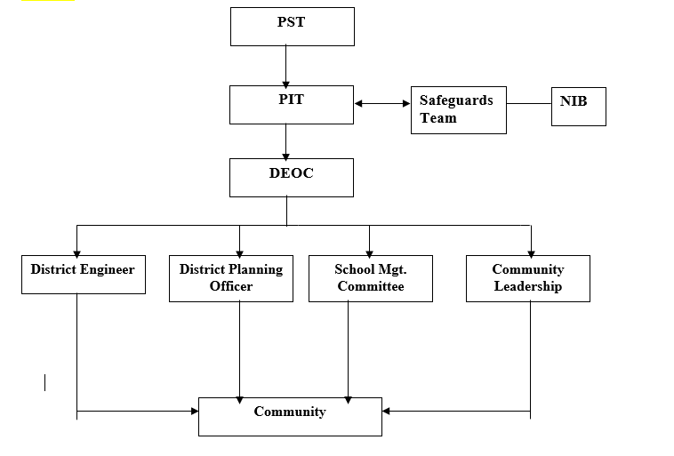
NaSIA
PTT
POC
Figure 6-1: Illustration of Implementation Arrangements

6.6 Environmental Protection Agency
The EPA is the national regulatory agency on the environment and has the mandate to review environmental and social management instruments prepared in the country before disclosing the document at the EPA website and the info shop of the WB. For the GALOP, however, EPA’s role will be determined by the scale of renovation works that will be undertaken under the project. The EPA will assist the MMDA’s in monitoring activities that affect humans and the environment at the sub project level. They will ensure that activities of contractors and artisans comply with laid down procedures and guidelines that mitigate risks of noise, air/ water pollution, waste collection and disposal. The EPA will also deal with environmentally related complaints using national guidelines and applying requisite sanctions to restore sanity in the project's operational area.

Table 6-1: Summary of Key Institutions/Focal Persons and their Responsibilities
Institutions/Focal persons/Unit | Responsibilities
Project Oversight Committee | - Oversight responsibility for entire implementation team
Project Technical Team (MoE, GES, NaSIA, NaCCA, NTC, CENDLOS, CEA, and NSS) | - Coordination
NACCA | - Development of new standard based curriculum to be used by teachers
NTC | - Teacher licensing/design of teacher training
NaSIA  SPED/SHEP | - School supervision/provide support for the design of inspection tools  - Conduction of National Standardized Tests (NST)  - Coordinate harmonization of inspection tools
Environmental and Social Specialists | - Facilitate implementation of ESMF, RPF, SEP and any other subsidiary instruments;  - Screening of sub projects guided by environmental and social issues related checklist list (refer to appendix 1 for detailed sub-projects checklists);  - Incorporate ESMF, RPF, RP, ESMP, ESCP and other relevant World Bank ESF requirements in biding documents and contract agreement;  - Organize and conduct national and district level training;  - Develop manuals and modules for capacity building and awareness creation;  - Facilitate monitoring and coordinate monitoring activities (refer to appendix 2 for detailed monitoring guidelines);  - Develop and ensure effective implementation of GRM;  - Liaise with relevant institutions on environmental and social issues including SEA/SH, labour influx etc.
DEOC | - Oversight responsibility at the district level;  - Ensure effective implementation of the ESMF/ESMP at the district level;  - Coordinate district level capacity building and training activities;  - Carry out periodic and surprise inspection in schools;  - Work to resolve conflicts at the district level.
SMC | - Management of GALOP activities at the sub-project level;  - Ensure strict adherence to E&S guidelines are complied with by contractors;  - Liaise between contractor and community/schools;  - Create awareness on the project at the sub project level;  - Liaise with other focal persons with regards to emerging issues.
Social investors | - Safeguard personnel of the investors, if any, will work under the guidance of the MoE safeguard team;  - Implement an ESMS (in case of a financial institution) in conformity with the project ESMF, RPF, RAP, SEP, ESMP, and ESCP;  - Prepare and submit safeguard reports to the MoE/GHS.
Contractor/Artisan | - Follow and comply with all E&S guidelines;  - Keep records of all E&S issues on site.

6.7 Internal Compliance Monitoring
There will be an internal compliance monitoring mechanism put in place to ensure that environmental and social guidelines are followed. This will comprise the following channels:
  - The SMC will ensure the observance of the ESMF guidelines at the renovation and operational phase of the project (monitoring indicators and feedback mechanism will be developed to guide them). Any member of the SMC can approach the contractor or artisan to do the right thing as the first level of resolution and then to the DEOC through the District Director of Education if required.
  - The DEOC of the respective districts (led by the District Engineer in this regard) will make routine as well as surprise visits to the schools during rehabilitation as well as occupancy phases of the project. During renovation, they will supervise the work of contractors or artisans to ensure they work according to environmental and social guidelines. They will act on resolving issues on the ground and will submit their monitoring reports to the PTT.
  - The Safeguards team at the national level will also undertake monitoring of renovation works and related environmental and social issues and report to the GALOP coordinating unit at the national level.
Safeguards specialists as part of their monitoring schedules will consult with SMCs contractors and community focal persons to ensure that mitigation measures outlined in the ESMP at this level is adhered to. The level of compliance, especially on social mitigation measures would however be determined by the level of involvement, sensitization and understanding or otherwise of the project in the beneficiary communities prior to the start of the project. Detailed Environmental and Social Management and Monitoring Guidelines are provided in appendix 2.

6.8 Capacity Analysis and Building for Implementation of Framework
The MoE, GES, EPA, MMDAs and communities are the main implementers of environmental and social safeguards in the project. The other bodies whose functions relate to the project in terms of oversight, project design and technical support include the PTT and the SMCs. The MoE and GES have successfully implemented Bank projects over many years. Since 2014, they have been implementing the Secondary Education Improvement Project using an RBF modality (IPF with DLIs) and have adequate staffing and capacity for financial management, procurement, safeguards and monitoring and evaluation. Safeguards capacity at the district and local level will be upgraded. It is therefore recommended that safeguards training, and clarification of roles be undertaken for the district staff and community actors.
The principal objective of the training will be to enhance staff capacity to implement the specific safeguard instruments e.g. ESMP and RP, which will be prepared during project implementation.

6.8.1 District Level Training
Training workshops led by the national safeguards team will be organized at the District level for the DEOCs, SMCs and contractors. These Workshops will focus on identifying and discussing environmental and social issues that will arise during the implementation of the ESMF and RPF. They will also sensitize participants about environmental and social considerations of the GALOP guidelines and environmental and social standards (ESS) as indicated in the ESF of the World Bank.

6.8.2 National Level Training
Similarly, workshops will be held at the national level for the key stakeholders involved in GALOP field implementation. It will focus primarily on policy issues and sharing of ideas and experiences. The E&S Specialists will be responsible for organizing and reporting on training programs.

PUBLIC CONSULTATIONS AND PARTICIPATION AND INFORMATION DISCLOSURE

7.1 Introduction
Stakeholder consultations are crucial in the preparation and implementation of the ESMF. Specifically, they aim to achieve the following objectives:
- To provide information about the project and its potential impacts to those interested in, beneficiaries of, or affected by the project, and solicit their opinion in that regard;
- To educate and solicit views from all stakeholders to enhance project implementation mechanisms and processes;
- To manage expectations and reduce misconceptions regarding the project;
- To ensure participation and acceptance of the project by all relevant stakeholders.

Stakeholder consultation would be carried out throughout the lifecycle of` GALOP. In line with this, the Project has prepared a standalone Stakeholder Engagement Plan (SEP) including a Grievance Redress Mechanism (GRM).

7.2 Community Participation
Community participation is vital in ensuring sustainability of any project. Communities to be targeted by GALOP may be among the most deprived in the country. This makes it more meaningful that they understand the various components of the project for them to identify themselves with it for successful implementation and to derive its maximum benefits. Steps should thus be taken by the PTT to sensitize and involve the beneficiary communities from the start of the project.

Community leaders – i.e., Chiefs, Opinion leaders and Assembly members – should be involved in decision making processes. Efforts should also be made to identify other groups in beneficiary communities (e.g., children, women, groups, the poor, parents, etc.) as they may constitute the major beneficiary group of the project. These groups should be educated on all aspects of the GALOP intervention including the benefits, challenges and financial implications among others. Various methods can be used to achieve this: focus group discussions, public announcements, animation, film shows, drama, and posters are some of the methods that could be used to educate the people.

7.3 Citizen Engagement/Education
Project beneficiary communities will be engaged and educated on all aspects of the intended intervention before implementation. The beneficiary communities should be briefed on the project, its objectives, implementation arrangements and delivery mechanisms, benefits, challenges and financial implications of the intervention. Citizen engagement would be a continuous activity between the community and the project implementers as outlined the stakeholder engagement plan developed for the GALOP. To ensure sustainability, i.e. ensuring proper maintenance of the facilities, the CE process should continue even after the project is completed.
The MoE/GES in their coordinating role will collaborate with the MMDAs to disseminate the required information on the project to the beneficiary communities to manage their expectation. Several methods including announcements, animation, film shows, drama and posters are some of the methods that could be used to educate the people.

7.4 Previous GALOP Stakeholder Engagement Activities
Consultations were undertaken throughout the country to sensitize major stakeholders from the MoE, GES and other implementing entities at the national, regional and district levels during the preparation of the parent GALOP, the first AF and the second AF, and these consultation activities will continue in all phases of the project. The list of participants and pictures from the previous stakeholder engagement activities is provided in Appendix 4 through 8.

7.4.1 Parent GALOP Pre-Appraisal Meeting
A pre-appraisal meeting was held on February 6, 2019 for project focal staff from MoE, GES, WB safeguards team, MoE safeguards team and social assessment consultant at the Peduase Resort Hotel. The main objectives of this meeting were the following:
- To brief participants on the general overview of the GALOP i.e. financial implications, PDO, components etc.;
- To educate participants on the new ESF of the WB; and
- To solicit views from participants on the implementation of the various components of the project.
These objectives were achieved through presentations on the overview of the GALOP, enhancing social performance of the project and group work on the various components.
Some views expressed by participants for effective implementation of the GALOP were:
- Parents participation;
- Stakeholder engagement throughout project implementation;
- Empowering the NIB to monitor state of facilities in schools;
- Mainstreaming current environmental and social issues (climate change, GBV, disability, non-discrimination) under ESF;
- Identifying special needs for inclusive and special education;
- Building capacities of teachers.
Views were also expressed during group deliberations under E&S for various components under GALOP:
Component 1
- GES/ Special and Inclusive Education (Guidance and Counselling Unit, Girls Education) – lead in-service training and capacity building on inclusion, safe schools, etc.);
- NACCA– New curriculum to include broad gender issues and inclusion education.

Component 2
- Environmental and safeguards consultants to assess and manage grant proposals with renovations/ rehabilitation activities;
- District engineers, planning officers & SMCs to be trained by safeguards consultants to manage routine monitoring at project site.

Component 3
- NIB/ SPED/ SHEP to coordinate harmonization of inspection tools;
- GALOP will identify and build on the existing GRM established under SEIP.

7.4.2 GALOP AF1 Zonal Consultations at the Regional level
Three zonal consultation workshops were organised to meet key stakeholders involving MoE/GES officials and District Education officials namely directors, statisticians, circuit supervisors, M&E and planning officers. Other stakeholder engagement with investors were held online through zoom and skype for inputs into the design of GALOP Additional Financing. The country was divided into three zones with the following regional composition:
- Accra zone (Greater Accra, Eastern, Volta, Central regions);
- Kumasi zone (Ashanti, Brong Ahafo and Western regions);
- Tamale zone (Northern Upper East and Upper West regions).
The major activities undertaken at the zonal were:
- Sensitization of participants on the GALOP and what the project intends to achieve;
- Presentation on environmental and social safeguards issues with regards to the project; and
- Soliciting views from participants on the project.

The following views and suggestions concerning the ESMF were expressed during the consultation workshops after presentation on GALOP:
- Poor sanitary facilities in schools need rehabilitation;
- Provision of facilities for pupils with disabilities (PWD);
- Consider inclusive education.
The following suggestions were made after presentation on potential environmental and social impacts that could be associated with the GALOP:
- Provision of appropriate PPE for workers and ensuring that all standards relating the work on site are complies with by contractors and artisans;
- What the government can do under the GALOP to avoid encroachment of school lands;
- The need to put measures in place to allow school authorities expresses their views on work on site without victimization;
- All stakeholders should be involved in the selection of schools that will benefit from the GALOP.
The following recommendations were made following the Zonal Consultations:
- Long distances from District Education offices, schools and primary schools to JHS also affect performance especially in the northern regions of Ghana;
- Enrollment and class sizes;
- Private schools absorbed by government could have added low performing students;
- The project should consider renovation of facilities to enhance learning conditions;
- Pupils' absenteeism;
- Facilities for the disabled persons.
- Check the number of schools with SMCs in place;
- GALOP and conflict areas;
- Consider lack of accommodation and other services such as water, electricity, etc.;
- Posting of teachers should be decentralized;
- Provide incentives to teachers who accept postings to remote areas;
- Consult with opinion leaders, chiefs and key people in communities to know the challenges on the ground in various communities before providing any intervention under this project.

7.4.3 GALOP AF2 Zonal Consultations at the Regional level
Consultation workshops were organised to meet key stakeholders involving officials from MoE, GES and other implementing entities, and Regional and District Education officials namely directors, statisticians, circuit supervisors, M&E and planning officers. The country was divided into three zones with the following regional composition:
- Southern zone (Greater Accra, Eastern, Volta, Central regions) held at Nkwatia-Kwahu in the Eastern Region;
- Middle zone (Bono East, Ahafo, Western North, Ashanti, Brong and Western regions) held at Kumasi in the Ashanti Region;
- Northern zone (Savanna, Oti, North East, Northern, Upper East and Upper West regions) held at Tamale in the Northern Region.
Discussions focused on the following:
- Project objective, scope, roles and responsibilities in implementation;
- Environmental and social risk and mitigation planning;
- Complaints and Grievance Redress;
- GBV/SEA/SH protocols; and
- Soliciting views from participants on the project.

7.5 Framework for Sub Project Level Consultations
Representative consultations will regularly be held as the need arises for GALOP-related activities at the subproject level. Participants will cut across various stakeholders, PAPs and focus groups in the selected communities, i.e., traditional leaders, women, youth, etc. Information obtained during consultations can be used to enhance the GALOP database and to aid decision making and addressing grievances.
A team will be constituted from MoE, GES and the Safeguards team to consult with the DEOC to plan consultation meetings at the sub project level. The venue or method for the consultation meetings will be decided on based on the prevailing situation on the ground. Irrespective of the method of interaction, the meeting will be structured to be interactive, with questions from the communities and answers and explanations from the safeguard specialists, MoE and GES staff assigned for that purpose. The main issues to be discussed would be related to components of the GALOP which may include the following:

- Sensitization on the GALOP and related environmental and social risks and impacts;
- Financial implications of the project;
- Selection criteria for schools;
- Safeguards issues;
- Grievance redress mechanism, including SEA/SH;
- Monitoring and supervision of project activities;
- Roles of communities in the implementation of the GALOP.

7.6 Stakeholder Engagement and Consultation in the unlikely event of outbreak of COVID-19
In the unlike event of an outbreak of the Covid-19 virus, the GALOP Project will prevent the spread of the disease among workers and in project communities by ensuring that all engagements and consultations are guided by the national protocols on COVID-19 pandemic and the guidance provided by the World Bank Technical Note on how to conduct public consultations in a manner that minimizes the spread of the diseases. Specifically, the project’s strategy for stakeholder engagement and consultations during an unlikely event of outbreak of the COVID-19 virus will include the following:
- Avoid public gatherings (considering prevailing national restrictions), including public hearings, workshops and community meetings;
- If smaller meetings are permitted, based on national updates on restrictions, conduct consultations in small-group sessions, such as focus group meetings but with appropriate social distancing and safety protocols such as the use of personal protective equipment, handwashing, hand sanitizing etc. If smaller meetings are not permitted, the Project will explore and conduct meetings through online channels, including WebEx, zoom, WhatsApp, skype, etc;
- Diversify means of communication and rely more on social media and online channels. Where possible and appropriate, create dedicated online platforms and chatgroups appropriate for the purpose, based on the type and category of stakeholders;
- Use traditional channels of communications (TV, newspaper, radio, dedicated phone-lines, and mail) when stakeholders do not have access to online channels or do not use them frequently. Traditional channels can also be highly effective in conveying relevant information to stakeholders, and allow them to provide their feedback and suggestions;
- Where direct engagement with project affected people or beneficiaries is necessary, such as would be the case of preparation and implementation of Resettlement Action Plans for this project, the project will identify channels for direct communication with each affected household via a context specific combination of email messages, mail, online platforms, dedicated phone lines with knowledgeable operators;
- Each channel of engagement will clearly specify how feedback and suggestions can be provided by stakeholders;
- In an unlikely event that all the above means of communication are not practicable in a particular circumstance, the event will be rescheduled to a later time, when meaningful stakeholder engagement will be possible.

7.7 Grievance Redress Mechanism
The legal framework for Grievance Redress has bases in the Constitution of Ghana (Article 20), as well as in the Land Act, 2020 (Act 1036). A Grievance Redress Mechanism (GRM) is an integral part of any administration. For accountability, responsiveness and credibility of any administration there should be an efficient and effective GRM to deal with concerns of stakeholders who may have issues with decisions and actions taken. The administration of the GALOP is no exception to this rule. The main objective of the GRM is to assist an entity to resolve complaints and grievances in timely, effective and efficient manner to satisfy all parties involved. Specifically, it provides transparent and credible process resulting in outcomes that are fair, effective and lasting. It also builds trust and cooperation as an integral component of broader community consultation that facilitates corrective actions.
The MoE through the implementation of the Secondary Education Improvement Project (SEIP) has put in place a GRM. GALOP will identify the weaknesses and harness the existing GRM established under the SEIP.

7.7.1 Grievance Redress Structure
A four-tier Grievance Mechanism structure is adopted for the GALOP in line with and integrated with the GES systems of handling grievances. This includes a national, regional, district and school/community level tier.
The GES has an elaborate structured grievance redress mechanism from the school-level through to the GES Council level. The existing GES grievance mechanism at the various levels will be linked with the MOE GALOP grievance system to manage complaints and grievances associated with the GALOP project. At the school/community level, the existing GES GM structures (learners, teachers, headteacher and SMCs) will be uptake points. The headteacher or a designated teacher shall receive, record, and facilitate resolution of grievances lodged at the school or community level. At the district level, the district education directorate, DEOC, and the Clients Service Units at the MMDAs will receive, record and resolve all grievances lodged at the district level or escalated from the school/community level. Grievances that are unresolved at the district level would be referred to the regional education directorate for resolution which is the third tier of the GM structure. If these grievances remain unresolved, they would be referred to the MoE and other implementing MDAs (which is the fourth tier) for resolution.
The grievance mechanism has a central online system housed at the PBME directorate at MoE that links up standard systems (standard or proposed) from the Client Service Unit (CSU) of MoE and CSU at GES. Each of these linked units would have a dedicated staff that records cases pertaining to GALOP, either manually or electronically and feed it onto the central online system. All complaints and grievances received at any uptake point shall be assigned a unique identifier and logged unto the central online system for tracking and case management. Case resolutions would mainly be the responsibility of the implementing units (GES, NaSIA, NaCCA, NTC, CENDLOS, CEA, and NSS) and the beneficiary entities (regional directorates, district directorates/DEOC and GALOP schools). Cases would only be transferred to the PTT, when all attempts fail.
The Safeguards Specialist or a dedicated staff at the PTT would be responsible for management of the central grievance redress system. The proposed GM structure is shown in Figure 7-1 below.

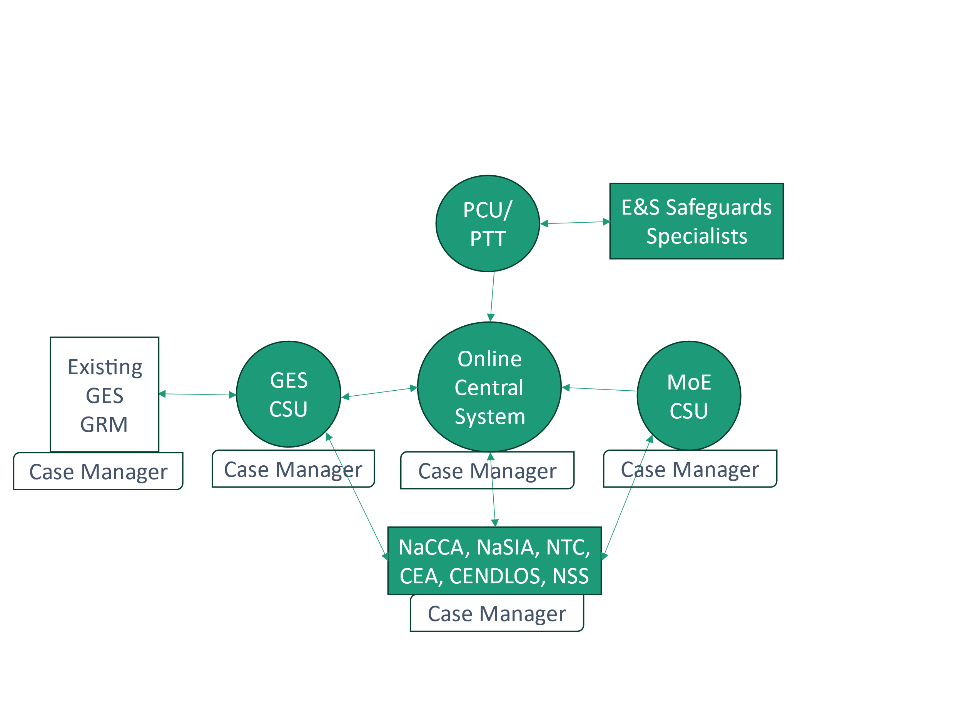
Figure 7-1: Proposed GALOP GM Structure
The GES has an elaborate structured grievance redress mechanism from the school-level through to the GES Council level. The existing GES grievance mechanism at the various levels will be linked with the MOE GALOP grievance system (as shown in Figure 7-1) to manage complaints and grievances associated with the GALOP project. The existing GES GRM structure to be linked to the GALOP system is shown in Figure 7-2.

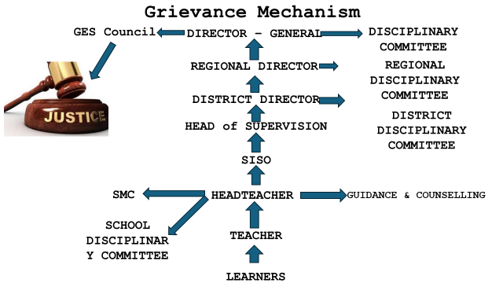
Figure 7-2: Existing GES GRM Structure

7.7.2 Grievance Uptake Options
The GALOP GM system has three toll free numbers which complainants or PAPs can directly call. There are also three toll-free numbers that can also be used to text or WhatsApp complaints to the Central GM Center at the MoE. Complaints can also be received via written letters, emails and in person (at any of the levels of project implementation from school/community level through to the MoE). In addition, complaints may also be registered with SMC members or Circuit Supervisors at the local level, who will document the complaints in a complaints Sheet and then register the call with the central system.
The GM numbers and addresses shall be disclosed and displayed at the schools, OOSC centres, district assemblies, district education offices, regional education offices, and community centers. The GM numbers and addresses will also be publicised through community information centers, advertisement and jingles on radio and television. Figure 7-3 below depicts a poster containing the various means by which complainants can access the GALOP GM.

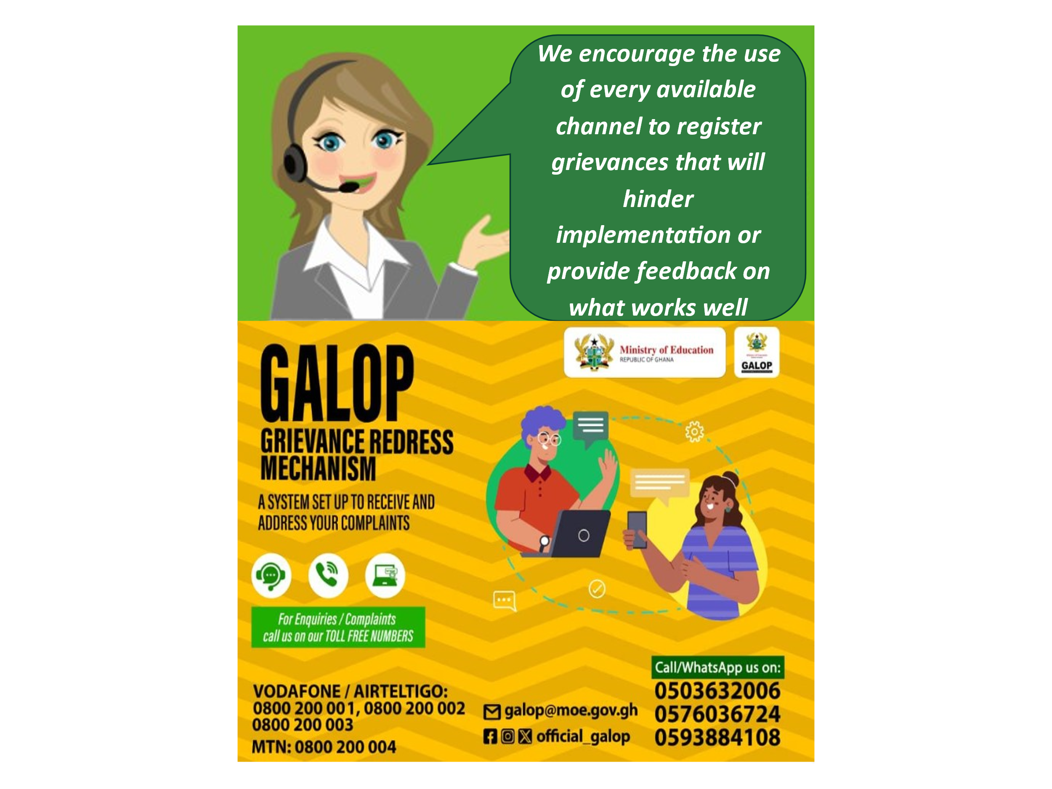
Figure 7-3: Grievance Uptake Methods
If a person is not satisfied with the GRM process and /or results, s/he can appeal to any independent body such as the Commission on Human Rights and Administrative Justice (CHRAJ) to seek redress or go to the law court as the last resort.

7.8 ESMF Disclosure
World Bank policies require continuous engagements with stakeholders during the preparatory and implementation stages of all projects. After incorporating stakeholders’ views in all environmental reports for projects, they are made available to project affected groups, local NGOs, and the public at large. Public disclosure of ESIA documents or environmental reports is also a requirement of the Ghana ESIA procedures. However, there is no limitation as to the extent and scope of disclosure. Stakeholder consultations have been undertaken in preparing this project and the ESMF. MoE, GES and the other implementing entities in collaboration with EPA will make available copies of the ESMF in selected public places as required by law for information and comments. Public notice in the media should be served for that purpose.
The notification should be done through a newspaper or radio announcement or both. The notification should provide:
- a brief description of the Project;
- a list of venues where the ESMF report is on display and available for viewing;
- duration of the display period; and
- Contact information for comments.
The EPA will assist in selecting display venues upon consultation with MoE, GES and the other implementing entities. These would be project sites specific and very informative to beneficiaries.

ENVIRONMENTAL AND SOCIAL MANAGEMENT FRAMEWORK IMPLEMENTATION AND MITIGATION STRATEGY

The ESMF provides a general impact identification framework and guidance on procedures to be followed and standards to be met in implementing the GALOP which should agree with national and World Bank safeguard provisions. The ESMF will ensure the screening of sub-project activities during implementation to inform the need to prepare appropriate environmental and social assessment instrument such as ESIAs, ESMPs, etc. On issues of land acquisition, restriction on land use and involuntary resettlement, the Project has prepared a standalone RPF to guide implementation and mitigation of such issues.

8.1 Screening of Sub-Projects and Potential Environmental/Social Impacts
Screening is a vitally important tool for predicting and understanding potential environmental and social impacts, as it can help determine whether environmental and social issues will be significant for a project. Screening of sub projects will be an important task during implementation. In doing this, it is imperative to consider the adjoining land uses within and outside a school compound. The screening process will consider the following issues:
- Basic information on the sub project;
- Adjoining land uses;
- Site specific characteristics;
- Sanitary facilities available and their user friendliness;
- Level of environmental awareness;
- Potential environmental, social, health and safety risks and impacts;
- Security issues; and
- Reviewer recommendations.

Detailed checklist for sub project screening is provided in Appendix 2 of the ESMF.

8.2 Environmental and Social Mitigation, Monitoring and Reporting
Monitoring is a key component of the ESMF during project implementation. Monitoring should be undertaken at the GALOP sub-projects implementation phase to verify the effectiveness of impact management, including the extent to which mitigation measures are successfully implemented. Monitoring should involve three areas:
- Compliance monitoring;
- Impact monitoring; and
- Cumulative impact monitoring.
The aim of monitoring would be to:
- Improve E&S management practices;
- Check the efficiency and quality of the EA processes;
- Establish the scientific reliability and credibility of the EA for the project; and
- Provide the opportunity to report the results on safeguards and impacts and proposed mitigation measures implementation.

8.2.1 Compliance Monitoring
This is to verify that the required mitigation measures as set out in the appropriate E&S safeguard instrument are implemented. Compliance monitoring will involve inspections during renovation, refurbishment or construction works. The operational phase of the sub-projects of the will also be monitored. Compliance monitoring will be done by MoE and GES with support from EPA.

8.2.2 Impacts Monitoring/Reporting
Monitoring of sub-projects impacts mitigation measures should be the duty of the Environmental and Social Focal Persons/Units. They will monitor activities to ensure that works are proceeding in accordance with the laid down mitigation measures. The MoE, GES and other implementing entities should ensure that the contractor submits quarterly report on work progress and any challenges in observing the E&S safeguards.

Table 8-2: Indicative Environmental and Social Mitigation Measures, Monitoring Indicators and Responsibilities
Impact issue | Proposed Action/ Measures | Implementation tool/ criteria | Monitoring/ indicators | Verification and Frequency | Project stage | Budget | Responsibility
Solid and liquid waste disposal | -Provide adequate waste reception facilities at construction/work camp sites. The bins should be well labelled and workers should be sensitize to appropriately deposit waste.  -Dispose of waste at District Assembly approved waste dump sites  -Contract certified companies to handle and manage hazardous waste (such as empty paint containers, empty chemical containers used for sanitization etc.);  -Asbestos is not anticipated. However, in case it is found on the construction site, a certified hazardous waste management should be contracted to handle and appropriately dispose them;  - Use certified companies to handle and dispose of septic waste generated during construction;  - Ensure septic tanks do not leak | -Waste Management Plan/Construction site management plan | Number of site waste bins  Final disposal records  Records of Hazardous waste disposed-quantity and method of disposal | Weekly checks by project engineers | Construction  Operation |  | Contractors foreman  Environmental and Social Focal Persons
Electronic waste disposal | -Provide adequate E-waste reception facilities at schools and office sites. The collection facilities should be accessible and workers should be sensitize to appropriately deposit E-waste.  -Dispose of E-waste at only approved E-waste collection sites  -Contract certified companies to handle and manage E-waste (such as end of life computers, monitors, tablets and accessories, etc.) | Implement E-waste Management Plan prepared for project | Number of E-waste collection posts operationalized  Final E-waste disposal records  Records of E-waste disposed -quantity and method of disposal | Monthly checks by project safeguards specialists | Operation |  | Environmental and Social Focal Persons
Waste oil/fuel disposal | - Provide drums or containers for temporarily storage of spent or waste oil from vehicles and equipment  - Dispose of waste oil through recognized oil marketing company or approved agent | Spill prevention and control plan | Waste oil drums or containers on site  Waste oil collection and disposal records | Monthly checks by project engineers | Construction |  | Contractors foreman  Project engineers  Environmental and Social Focal Persons
Air/noise pollution | - Provide sound equipment/ machinery for project  - Operate well maintained engines, vehicles, trucks and equipment.  -Use good quality fuel and lubricants  -Suppress dust generation at project sites  -Reduce traffic speed on unpaved roads through communities and at project sites  -Switch off engines of vehicles/trucks and earth-moving equipment when not in use. | -Part of contract agreement with contractor  -A routine maintenance program or plan for equipment/ machinery | -Maintenance plan implementation  -Grievances recorded | -Daily independent checks by project engineers  Maintenance records verified by project engineers  -Self check by contractor | Construction |  | Contractors /  Project engineers  Environmental and Social Focal Persons
Impacts on landscape including quarry sites and visual receptors | Project sites should be boarded off from public view and ensure good house-keeping at construction sites | Construction site management plan | Implementation of ESMP and end of project land restoration and reclamation plan | -Weekly self check by contractor | Construction |  | Contractors /  Project engineers
Impact on traffic | -Use only road worthy vehicles and trucks  -Use experienced drivers | Purchase sound vehicles and trucks /machinery for project  Driver qualification | -Traffic incidence records  -Grievances recorded | Project engineers to verify weekly;  Weekly self check by contractor | Construction |  | Contractors /  Project engineers
Water pollution | -No garbage/ refuse, oily wastes, fuels/ waste oils should be discharged into drains or water bodies  -Fuel storage tanks/sites should be properly secured  -Maintenance and cleaning of vehicles, trucks and equipment should take place offsite.  -Provide toilet facilities for construction workers  -Prevent soil, water, groundwater contamination as a result of latrines wastewater  -Design WASH facilities in a way to ensure resource efficiency and pollution prevention  -Proper handling and disposal of wastewater generated during operation of latrines | EHSP/ waste management plan  Spill prevention and control plan/EHSP  Construction site management plan | -Visibility of oil on water bodies  -On site erosion features  Proposed actions implemented | -Daily self checks by contractors  -Periodic reports on performance by contractor to project engineers  -Spot checks/audits by project engineers | Construction  Operation |  | Contractors /  Project engineers  Investor  Project engineers
Impact on fauna and habitat | -Avoid unnecessary exposure or access to sensitive habitat.  -Regular inspection or monitoring should be carried out in sensitive areas e.g. swamps/ wetlands the area prior to start of work. | If a sensitive habitat is discovered in the work area or vicinity, Project activities should cease. The contractor should notify project engineers who will consult Wildlife Division to determine the appropriate course of action. | Presence of sensitive habitat at project area/beach | -Regular self-checks by contractor  - | Construction |  | Contractors /  Project engineers/ Wildlife Division/ EPA
Impacts on inland water bodies and Fauna/ habitat | -Ensure proper storage and handling of fuels, oil, wastes, and other potentially hazardous materials.  -Regular monitoring of suspected or known sensitive areas should form part of the project activities.  -Project activities should avoid disturbance of habitat or | -Hazardous material management plan/ oil spill prevention and control plan  -Regular fauna observation report  -Awareness raising for contractor personnel | Implementation tools  Water accidents/ incidents recorded | -Daily self-checks by contractor  -Periodic reports on performance by contractor to client  -Spot checks and audit by project engineers  -Grievances recorded | Pre-construction, construction and maintenance |  | Contractors /  Project engineers
Physical displacement of PAP | For acquired sites, the affected persons to be given relocation assistance (cash or kind).  For acquired sites, to relocate communities and properties | RPF  Resettlement Plan (RAP or ARAP) | PAPs relocated and absent from site | Records to confirm PAPs received or provided with relocation assistance  Resettlement plan implemented | Pre-construction |  | Project engineers
Employment and loss of livelihood | PAPs provided with livelihood assistance or assisted to get new jobs immediately without any | RPF | Caretaker complaints | PAPs employed elsewhere or evidence of | Pre-construction |  | Project engineers
Loss of income.  General | Compensation for loss of income attributable to subproject impacts  Use local labour as much as possible and where readily available. | RPF  Resettlement Plan | livelihood assistance given  Project engineers to verify quota to locals prior to recruitment of construction workers |  | Construction |  | Contractors / Project engineers
Deprivation of use of land | Compensation or replacement land | RPF/  Resettlement Plan | Resettlement Action Plan implementation | Evidence of acceptable compensation paid  Resettlement plan implemented | Pre-construction |  | MoE, GES/, Project engineers
Loss of structures/ properties | Compensation for loss of permanent structures and assist to relocate other properties. | RPF/  Resettlement Plan | RPF implementation  Resettlement Plan implementation | Evidence of acceptable compensation paid  Evidence of  Resettlement plan implemented | Pre-construction |  | MoE,/ GES, Project engineers
Impacts on recreation and public areas | Place notices and warning signs at working areas | Grievance logbook | Grievance records | Warning signs/ notices in place  Monthly checks by the MoE/GES | Construction |  | MoE, GES, Contractors /  Project engineers
Impacts on cultural heritage/ archaeological interest /existing marine infrastructure and services | -Identify cultural heritage resources and existing ecologically sensitive areas. | Pre-construction surveys /  Chance finds procedure | Cultural/ archaeological resources/ existing infrastructure encounter incidence register  -Chance finds procedure under implementation | -Daily self-checks and verification by contractor  Periodic reports by contractor to project engineers | Construction |  | Contractors /  Project engineers
Impacts on human health/ safety and sanitation | -Cover buckets of trucks carrying construction materials such as sand, quarry dust, etc.  -Use road worthy vehicles/trucks and experienced drivers/operators  -Active construction areas to be marked with high-visibility tape  -Backfill and or secure open trenches and excavated areas. | Vehicle maintenance programme/plan in place  Construction site management plan | -Health and safety incident register  -Grievance records | Health and safety plan under implementation  -Daily self-checks and verification by contractor  -Spot checks by project engineers  -Periodic reports by contractor to | Construction |  | Contractors
Sexual Exploitation and Abuse /Sexual Harassment | - Contractor ESMP includes actions to prevent SEA/SH  - Contractor management and workers sign SEA/SH code of conduct  - Service provider mapping undertaken  - Clear referral pathway to access service providers in place.  - SEA/SH sensitive GRM in place. | PAASE; SEA/SH Action Plan; code of conduct signed by workers as part of their contracts | Compliance to contractor SEA/SH action plan  Referral pathway functioning | Periodic Checks by project safeguards officers,  Mission by WB safeguards specialist | Bidding stage  Pre-construction  Construction |  | Contractor  Project social safeguards consultant

8.3 Estimated Budget for the Implementation of ESMF for Year One

Table 8-1 presents the indicative budget for the first year of implementation of the ESMF.

Table 8-1: Estimated Budget for First Year of Implementation of ESMF
Item No. | Item Description | Unit Cost (GHS) | Total (GHS)
1 | Monthly allowance for Environmental & Social Safeguards Specialists | 7,500 x 12 x 2 | 180,000
2 | Training of 100 contractors/artisans on safeguards (environmental and social) | 1,000 x 100 | 100,000
3 | Quarterly monitoring costs (DSA) for Safeguards officers (2 safeguards & 2 officers from MoE/GES for 4 quarters | 14,000 x 4 | 112,000
4 | DSA for drivers | 7,000 x 2 | 28,000
4 | Fuel and lubricants for monitoring | 6,000 x 2 x 4 | 48,000
4 | GRM refresher training for 20 MoE/GES staff |  | 30,000
5 | Training of SMC’s in GALOP schools on safeguards and monitoring | 250,000 x 2 | 500,000
6 | Development of Site Specific Environmental and Social Safeguard Guidelines for small civil owrks for school management committees |  | 20,000
7 | Total |  | 970,000

APPENDICES

Appendix 1 – Elaboration of Project Components

Component 1: Strengthening teaching and learning through support and resources for teachers.
The parent GALOP and AF 1 includes three sub-components for component 1: (a) teacher capacity building and innovative delivery of in-service training (INSET); (b) school-based support and instructional leadership; and (c) provision of TLMs. The AF 2 will support the same subcomponents and provide additional focus at the pre-primary and early childcare level and strengthen the existing modalities for improved teaching and learning. The interventions will include (i) deliver teacher in-service training on innovative and improved teaching pedagogies on differentiated learning, play-based pedagogies including gender responsive, social, and emotional learning; (ii) expand continuous coaching and mentoring support for teachers including teacher well-being; and (iii) ensure that teachers and learners benefiting under the program are provided with the approved sets of TLRs to enhance foundational learning.

Sub-component 1.1: Teacher capacity building and innovative delivery of in-service training. The AF 2 will support the implementation of activities which include the following: (i) harmonize approaches, tools and materials for play-based and DL assessment and teaching; (ii) DL training for additional 35,000 teachers and caregivers at the foundational level; (iii) development of Social Emotional Learning (SEL) curriculum/modules and training on play-based learning at the foundational level (including childcare early stimulation (0-3 years); KG1-2; and early grades P1-4) in 6,000 additional schools; (iv) training on universal design for learning in beneficiary schools for greater inclusivity;. Interventions will focus on strengthening existing teacher capacity in the delivery of these improved and highly effective teaching pedagogies. These improved teaching pedagogies are beginning to demonstrate their effectiveness for improving learning under the original GALOP, where differentiated learning training is benefitting about 70,000 teachers in 10,000 of the lowest performing basic schools, and learner assessments are beginning to show some learning improvements. Play-Based and DL training modules have been developed and approved by the Ghana Education Service, and under the program, these modules will be quality assured by the National Teaching Council (NTC) for in-service training, digitized and uploaded on the NTC training platform for all KG and primary teachers. The Regional and Districts Teacher Support Teams (DTST) across all the 261 districts (12 per district, 3132 in total) will also be trained to implement in-service training for the KG teachers, including childcare givers, within their districts. The standard number of training days to provide effective capacity strengthening for KG (which could include childcare givers and parental engagement), primary and other support staff has been determined as 4 days of training before the first term, 3 days of training before the second term and 2 days of training before the third term. These would be delivered on a face-to-face basis and include sections for teacher demonstration. Complementary ongoing virtual trainings would also be incorporated to deepen the teacher’s understanding of concepts. The teaching pedagogies will be further deepened under the proposed program with stronger focus on implementation fidelity, digitized monitoring of individual learners by teachers in the classroom, effective supervision, classroom observation by SISOs, and sampled determination in the use of improved teaching practices in both KG and primary classrooms by the National Schools Inspectorate Authority (NaSIA).

Sub-component 1.2: School-based support and instructional leadership. The AF 2 will support the training of master trainers and roll-out of coaching and mentoring to ensure continuous support to teachers and caregivers for the roll-out of effective DL, UDL and Play-Based pedagogies in beneficiary schools and childcare centers. As with the in-service training approach funding will be provided at the district level for the roll-out of coaching and mentoring support to headteachers and teachers. This activity will be led by master trainers and comprising the DTSTs, SISOs and school heads who will also provide feedback on teacher progress. This activity will be funded through the Communities/Districts of Excellence (Co/DoEx). The DTST will also be provided with some transportation allowance to support SISOs in the coaching and mentoring at their respective districts. The National Teaching Council (NTC) will be responsible for the training of master trainers training while the GES will be responsible for the roll-out to teachers at the district level. Harmonized coaching and mentoring training modules to be utilized during the training have been developed by GES and quality assured by NTC.

Sub-component 1.3: Provision of teaching and learning materials (TLMs). The AF 2 will support the provision of teaching and learning resources for all beneficiary teachers, caregivers and learners. In addition to the in-service training of existing and deployed teachers, sets of teaching and learning resources will be provided for at the foundational level in 6,000 KG and primary schools and the beneficiary daycare centers across the country. The TLRs will include teacher guides, workbooks, templates, theme etc. for childcare centers, KG1 and KG2, two floor mats per class, reference materials for teachers, sets of stationery etc. The program will consider the procurement of a set of locally developed TLRs for beneficiary classrooms. All beneficiary childcare centers, primary school learners and teachers will be provided with sets of learning packages (including supplementary readers, lower and upper primary mathematics and English workbooks and textbooks) and teachers will be provided with printed teacher resources, dedicated DL resources etc. Most of these teaching and learning resources have already been developed and tested by the National Teaching Council (NTC) and National Council for Curriculum and Assessment (NaCCA) to ensure gender integration. The program will also target learners with special needs and teachers of learners with special needs by providing TLRs, learning packages, and assistive devices in the first year of implementation to ensure the achieving of learning gains within the program period.

Sub-component 1.4: Improved Identification of and Support to Students with Disabilities - Health and disability screening for learners (NEW). To enhance learning, an annual general health screening for children will be conducted for KG1 and P1 children to identify health issues and disabilities during “my first day at school”. UNICEF has conducted this for children and estimates about US$5.00 per child including follow up accessories e.g., eyeglasses. The screening will be expanded to identify any form of disability and will incorporate referrals for children who need special attention for the provision of assistive devices. The program will also consider targeted support in schools for teachers and assistance for children with learning and other disabilities. National Service Personnel (NSP) will be oriented/trained and leveraged to provide some support.

Component 2: Strengthen school support, management and resourcing
The parent GALOP and AF 1 includes four sub-components for component 2: a) learning grants to support activities focused on learning; (b) strengthening district education management capacity, including school Inspection and classroom observation; (c) strengthening SMCs for enhanced citizen engagement and (d) strengthen support for out-of-school children (OOSC) through the Education Outcomes Fund. This AF 2 will provide additional funding for the first three subcomponents of the parent GALOP and AF 1 sub-components. No additional funding will be provided to the sub-component 2.4 on strengthening support for out-of-school children (OOSC) through the Education Outcomes Fund will not receive additional financing under this AF 2. However, the AF sub-components under component 2 have been designed to enhance current activities as well resource the district and communities for stronger outcomes.

Sub-component 2.1: Learning grants to support activities focused on learning. The AF 2 will support the delivery of enhanced learning grants which will account for inflation and will be expanded in scope to additional beneficiary schools. Schools will receive initial advances of learning grants based on a base grant and per capita (depending on the number of students enrolled). During the first year, there will be no pre-requisites for schools to receive learning grants to fund activities under the SPIP, apart from financial management requirements of having a bank account and school level signatories for the funds. In the subsequent years however, the program will require that beneficiary schools demonstrate the following key deliverables in the preceding year of grant transfers: (i) individual DL learner assessment and monitoring on literacy and numeracy by teachers, (ii) submission of mSRC data for three (3) terms, (iii) publication (on school/school head notice board of latest NST assessment data for the school; and (iv) summary of KG and primary DL+ assessment, (v) compliance with agreed climate smart guideline. A main objective is to encourage the use of school level data and evidence-based decision making and processes.

Sub-component 2.2: Strengthening district education management capacity. The AF 2 will support and strengthen governance and program implementation mechanisms at the community and district levels for improved foundational learning. This sub-component will receive significant resources to ensure districts are fully accountable for learning outcomes and key project deliverables in their districts. Under the original GALOP, district grants were planned but implemented late during the program’s implementation. Under the GALOP AF, it is proposed that districts grants are provided in the first year of program implementation.

Selection of beneficiary districts from which communities of excellence will be drawn (NEW). All public basic schools will be ranked based on four criteria (poverty, NST assessment for P2, class size, and PTTR). The existing 10,000 GALOP schools will be set aside, and the bottom 6,000 schools will be selected to benefit under the GPE GALOP AF. At least 100 districts with the highest percentage of GALOP and AF beneficiary schools will be selected from which communities of excellence will benefit under the AF. Cocoa growing districts, and communities with high incidence of child labor and OOSC (GLSS 6) will be considered under the communities of excellence. Public basic schools within the selected communities will be supported to deliver prioritized foundational learning interventions. A District Readiness exercise will be conducted to ensure that management processes are at the right standard including for example, (i) that engagement on, and preparation of an up-to-date ADEOP has been completed, (ii) that NST results have been distributed to all schools in the district, (iii) that a up-to-date mSRC has been submitted by at least 80 percent of schools in the district, and (iv) that at least one district level meeting with DPCU, SISOs and district officials to discuss NST, mSRC, and DL+ reports in the past six months has been held.

Resourcing through performance-based district and regional grants (NEW). The amount of district grant per district will include a base grant (equal amount to each beneficiary district) and a per capita which will be based on agreed criteria including number of schools, number of circuits and SISOs, distance to schools, and terrain. In subsequent years, grants to districts will be made based on achieving key deliverables including: (i) preparation of ADEOP in the year preceding, (ii) district level DL learner assessment and monitoring on literacy and numeracy to inform district level meetings, including with SISOs, (iii) 100 percent school submission of mSRC data for three (3) terms, (iv) publication of latest NST assessment data and summary DL+ assessment results for the district on district notice boards, and (v) compliance with agreed climate smart guideline for limited infrastructure approved under the program. Education management grants to fund regional level coordination and monitoring of district level activities will also be supported.

Using data for decision making and to deliver training management processes (NEW). DoEx will be supported to improve the management processes and governance oversight using district level data and information. The intervention will support data collation, analysis and utilization for decision making at the district level with a view of monitoring district performance and gaps in achieving foundational learning. This data collation and analysis will be supported with technical capacity from the GEEDLab³². Districts will conduct a needs assessment to determine priority interventions and to inform the districts ADEOPs. The data collection and utilization will be supported with technical capacity from the GEEDLab.

Implementation of district level activities to achieve agreed deliverables including capacity building and training for improving learning gains (NEW). Technical and other support will be provided for DoEx and the capacity and resources of district directors will be deepened to implement prioritized interventions, train SISOs and other district level officials, to roll-out of DL training to teachers in GALOP and non-GALOP schools, organize right age enrollment drives including for out-of-school children, reading festivals and numeracy quizzes for KG1 – P4 learners to help improve literacy and numeracy , harmonize childcare and parental interventions modules across all basic schools in the district. The activity will culminate in a national reading and numeracy competition currently held by the MoE annually. Literacy competitions and ranking of districts based on literacy and numeracy will be encouraged and districts with 80 percent or more of learners at P2 and P4 who are able to read at grade-level will be rewarded.

Support SISOs to monitor and support schools, teachers, and classroom observation (NEW). All SISOs who are non-members of the DTSTs will receive the same level of DL and play-based approaches training which will be provided to teachers. The training package will include the new standards-based curriculum for KG, enhancement of the classroom environment, preparation of DL and play based TLRs using local materials, among other things. SISOs will be provided with tablets with reporting Apps to ensure digitized and effective reporting for easy analysis by districts, along with fuel, and transportation to support school visits. SISOs will reports on teacher DL and PB in-service training, teacher progress on implementation of new pedagogies, coaching and mentoring support using these tablets and digital platforms. This will ensure real-time data collection and analysis to guide subsequent financing of district and school level activities. SISO reports will be accessible by the MoE and designated GES officials at the District, Regional and National levels. The support to SISOs will also include capacity strengthening for community engagement and parental involvement in improving foundational learning and following on children’s regular attendance.

Sub-component 2.3: Strengthening SMCs (and supporting communities of excellence) for enhanced citizen engagement. This subcomponent will be tied to sub-component 2.2 above with SMCs and community leaders playing a critical role in the communities of excellence for improved educational outcomes.

Sub-component 2.5: Support to Communities of excellence to develop localized solutions for improved learning outcomes and childcare – CoE. This will receive financing through districts to do key activities (i) stakeholder engagement to identify bottlenecks (ii) develop a strategy for addressing challenges for their communities and receiving funding for addressing (iii) accountability – DEOC will receive CoEx progress as well as GES and CoEX will hold school accountable (iv) develop an annual results plan and monitor quarterly.

Sub-component 2.6: Childcare After and Targeted After-school Interventions – After school learning and childcare clubs, support community access to childcare, parental involvement, standards for early childcare.

Sub-component 2.5 Support for climate resilient infrastructure and basic school optimization. This will be a new sub-component and likely to be fully funded through potential future IDA resources. At this stage the AF 2 will support a very limited scope of this intervention. This intervention will support a limited number of schools prioritized by the district where learning gains to a large extent are impeded by poor infrastructure³⁶, and where optimization of JHS would lead to increased transition from primary and better-quality learning and services (i.e. science laboratory, computers, library etc.). The improved infrastructure will be climate resilient and would lead to climate co-benefit gains. The infrastructure intervention will be limited and only target areas where maintenance of old infrastructure and/or new infrastructure is critical for the safety and wellbeing of learners. Further this subcomponent will pilot a school optimization model framework which will assess how the location of Junior High Schools can be supported to optimize the deployment of teachers to areas of low teacher retention.

Component 3: Strengthening accountability systems for learning.
The parent GALOP and AF 1 includes three sub-components for component 3: a) development of an accountability for learning framework and dashboard; (b) Development and implementation of a national assessment strategy; and (c) policy reforms for efficient education sector human resource management, administrative and leadership practices. This AF 2 will support all 3 sub-components and deepen activity implementation for some sub-components. provide additional funding for the first three subcomponents of the parent GALOP and AF 1 sub-components.

Sub-component 3.1: development of an accountability for learning framework and dashboard. The parent GALOP and AF 1 project has seen the development and launch of the dashboard in all its 10,000 beneficiary schools. This AF 2 will extend the accountability dashboard to the additional 6000 beneficiary schools to support their accountability meetings.

Component 3.2: Development and implementation of a national assessment strategy. The AF 2 will continue to support the implementation of activities under this sub-component.

Sub-component 3.3: Policy reforms for efficient education sector human resource management, administrative and leadership practices. The AF 2 will implement targeted interventions to strengthen teacher deployment in schools recording a consistent low complement of teachers. The two new activities below will be specifically implemented with the AF 2 resources and implementation will go beyond the AF 2 GALOP beneficiary basic schools.

Deploy teachers to hard-to-deploy areas to improve pupil-trained-teacher ratios (NEW). The program will support interventions for equitable and innovative deployment, orientation, and support for teachers in areas where it is difficult to post and retain teachers. Implementation will be in prioritized on these key interventions (i) implement the teacher rationalization strategy by redeploying teachers from overstaffed schools to understaffed schools and alignment with the teacher’s language and learners L1 (included in the teacher recruitment portal); (ii) implement the GES policy for financial incentives for teachers deployed to hard-to-reach areas in discussion with teacher unions. These hard-to-reach schools will be identified using objective criteria including pupil to teacher ratio, high teacher turnover, difficult to reach schools among others; (iii) trained teachers within those communities who have not been absorbed in the government payroll will be prioritized in government annual recruitments. untrained community teachers in hard to deploy communities will be supported under the project to enrol in nearby colleges of education first to undertake an access course and then enrol in a degree program (UTDBE 2); (iv) the National Service Secretariat will release National Service Personnel with qualifications in education to the Ghana Education Service Headquarters to deploy to schools and hard-to-deploy areas to undertake their one-year mandatory national service. Those who complete their service in those areas will be given priority for recruitment as full-time teachers to stay in those areas with a bond to serve for at least three years after national service. Other NSS personnel will be trained to deliver specialized services e.g., reading programs, targeted remedial interventions, etc. within the period of service. This is expected to boost literacy and numeracy in the lowest performing schools where it is difficult to retain teachers.

Orientation, guidance and counselling support for teacher wellbeing (NEW). This will be provided proactively, especially to counselling coordinators at the district office to support the district director as first responders on teacher wellbeing issues at the district level. Special attention will be given to improve teacher wellbeing in remote locations. This support will include the (i) identification of teachers in need of counselling support; (ii) collaboration with district health officials to visit identified teachers and offer counselling sessions; (iii) referrals as and when necessary; and (iv) reporting to the Director General of the GES for remedial actions which may include but not restricted to, follow up on teacher arrears, promotional issues, change in teaching location and transfers, and approval of study leave among others. A teacher incentive package for teachers in very remote schools will also be considered (teacher incentive package – solar lamps in areas with no electricity, life jackets in riverine locations, first aid box, mattress, etc.).

Component 4: Technical Assistance, Institutional Strengthening, Monitoring, and Research
The parent GALOP and AF 1 includes two sub-components for component 4: a) Technical assistance for capacity building and institutional strengthening; and (b) Monitoring and evaluation, management and operational costs. This AF 2 will support all 2 sub-components as well as introduce key activities under these sub-components to deepen project outcomes.

Sub-component 4.1: Technical assistance for capacity building and institutional strengthening. The AF 2 will continue the support activities under this sub-component. Additionally, the AF 2 will be funding the establishment of the Ghana Education Evidence and Data Lab (GEEDLab) under this sub-component. Further, the sub-component will fund systems for stronger digitized systems in the MoE and supporting information collection and collation points.

Ghana Education Evidence and Data Lab (GEEDLab) and strengthened data systems. The 2023 partnership compact for Ghana and enabling factor analysis presented key challenges with evidence generation and data management for improved education delivery in Ghana. It indicated that ‘the systemic data credibility and management issues have negatively impacted the analysis of EMIS and other education sector data and evidence generation’. For example, key gaps continue to exist as schools are not identified by the same unique codes across datasets. Combining these different data systems would boost the analytical capacity of the MoE to make evidence informed policy decisions, monitor progress, and track program impacts. Under the current GALOP, an accountability dashboard has been developed to integrate different datasets (EMIS, mSRC, NST etc.) of the MoE and its agencies to bring them on to a common platform. The next step is to ensure greater utilization of these data to inform the design and implementation of interventions in the education sector. Further, the production and use of data at the sub-national level is very limited mainly due to the lack of capacity at this level. The MoE’s Statistics, Research, and Information Management division (SRIM) was set up to create and maintain a databank of information on the educational sector for policy formulation and decision-making through the collection and analysis of data, research and documentation tackle some of these issues. The existing gaps requires strengthening the capacity of SRIM to effectively deliver their mandate.

The GEEDLab will support the MoE to co-create shared research and learning agenda (RLA) (on an annual basis) which aligns with the strategic priorities of MoE and incorporates inputs from the Education Strategic Research Group (ESRG). ESRG will meet quarterly to refine the RLA, assess implementation progress, and endorse research outputs. The GEEDLab will be set up within the MoE and embedded within SRIM. The co-creation of research and learning agenda will consider global evidence on what works to improve learning, evidence from synthesis of interventions in Ghana (including the sub-national), evidence generation and education service delivery. The GEEDLab will work with the monitoring and evaluation (M&E) unit of the ministry to disseminate the evidence and ensure integration into program implementation. In addition, education research and evidence generated through the GEEDLab and other sources e.g., academia, will be financed under the program based on set criteria which will be detailed in the PIM. The activities to be included in the RLA include: (i) Policy-relevant research outputs (ii) capacity building of MoE (central and decentralized staff) (iii) technical input into policy documents (iv) communications and dissemination (v) development of a research repository and (vi) study-visits to promote knowledge exchange.

Support Systems for data/information collection and collation points will include (i) individual learner gains in literacy and numeracy by the teacher; (ii) observation and feedback to teachers and districts on their use of DL and play based approaches by SISOs, (iii) school mSRC data by school heads, (iv) summary PB and DL+ assessment results by headteachers, (v) NST assessments of KG2, P2 and P4 learners by NaCCA, (vi) classroom observation on the use of improved teaching practices, and school inspection by NaSIA, (vii) EMIS capacity strengthening and increased functionality by MoE, (viii) teacher uptake on digitized training by NTC, (ix) accountability dashboard strengthening and functionality by MoE, and (x) national level NST, DL+, and school inspection by NaCCA, GES, and NaSIA). NaCCA’s NST will be updated to include SEL and KG2 assessment which is currently not prioritized, NaSIA’s school and classroom observation checklist will be updated to provide insights on the implementation of the school coaching and mentoring by SISOs and KG Play-Based pedagogy, and NTC will be supported to incorporate KG Play Based pedagogy in the digitized in-service training offered to teachers, and to include coaching and mentoring in teacher licensing and the Continuous Professional Development (CPD) of teachers and school heads. The mSRC will be reviewed and scaled up to all KG and primary schools to improve its effectiveness. NaCCA will be supported to strengthen the NST and on international reporting HCI, and SDG by benchmarking its NST assessments.

Sub-component 4.2: Monitoring and evaluation, management and operational costs. Supporting activities under this sub-component will continue. Additionally, the AF 2 will allocate resources for dedicated Civil Society Partnerships to support project implementation monitoring across the country.

Component 5: Supporting the COVID-19 Coordinated Education Response Plan for Ghana for continued learning, recovery and resilience in basic education
This component was added to the parent GALOP Project through the first AF and restructuring. Activities have been implemented by the MoE. This component supported the (a) strengthening remote education service delivery; (b) safe school re-opening and re-entry after COVID; and (c) strengthened management for education sector resilience. The component also supported government’s policy reform around the use of digital devices in basic education schools. The component was successfully closed on November 30, 2021.

Component 6: Contingency Emergency Response (CERC)
A no-cost CERC will be included in accordance with World Bank IPF Policy which would allow for rapid reallocation of the grant proceeds in the event of a natural or manmade disaster or crisis that has caused or is likely to imminently cause adverse economic and/or social impact. A large part of the funding is GPE grant so any reallocation will need to be approved by the GPE Board.

Appendix 2: GALOP Sub Project Screening Form
A | BACKGROUND INFORMATION:
 | Date:
 | Name of School
 | Project Location (Region, District, Town)
 | School Population (Male and Female)
 | School Type (Mixed or Single)
 | Number of teachers (Male and Female)
B | DESCRIPTION OF ACTIVITY
 | Type of Activity (including objectives and outputs)
 | Land area to be taken by project activity, in ha
 | Any existing property to be affected, and by how much (total, partial demolition etc.)
 | Any plans for construction, movement of earth, changes in landcover
 | Date of commencement and expected completion date and estimated cost
Facilities Earmarked for Renovation/Expansion
(List them in the corresponding column)
C | PRELIMINARY ENVIRONMENTAL INFORMATION
 | Adjoining Land Uses |  |  |  |  |  | Name land use type (estimate and measure distances where feasible
 | - South
 | - North
 | - East
 | - West
 | Site Specific Characteristics |  |  |  |  |  | Estimate and measure distances where feasible
 | - Nature or slope of land
 | - Proximity to thoroughfare (path)
 | - Proximity to school boundary
 | - Proximity a residence or any community resource or facility
 | - Proximity to a road
 | - Proximity to a Stream
 |  |  |  |  |  |  | YES | NO |  |  |  | COMMENT
Would the Project potentially cause adverse impacts to habitats (e.g., modified,
natural, and critical habitats) and/or ecosystems and ecosystem services?
 | Are any Project activities proposed within or adjacent to critical habitats and/or environmentally sensitive areas, including legally protected areas (e.g., nature reserve, national park), areas proposed for protection, or recognized as such by authoritative sources and/or indigenous peoples or local communities?
 | Are there activities at the project site?
 | What is the current land use
 | Will the proposed activities have any impact on any ecosystem services biodiversity issues or natural habitats?
 | Will there be water resource impacts?
 | Will there be vegetation and soil impacts?
 | Will there be air quality or noise impacts?
 | Are there any new or changing river basin management planning or activities?
 | Involve the use of petroleum, diesel, liquefied petroleum gas, bitumen, biodiesel, ethanol and methane
 | Do activity have potential to generate solid or liquid wastes?
 | Environmental Awareness
 | - School Environmental Association or Club
 | - Collaboration with EPA or any Environmental NGO
 | - Environmental programmes and activities undertaken (symposia, lectures, film show, tree planting etc.)
D | PRELIMINARY SOCIAL INFORMATION
 | Sanitary Facilities Available |  |  |  |  |  | Type and Number (Comments if any)
 | - Toilets (type & number)
 | - Urinals (type & number)
 | - Disability friendly (Yes/No)
 | - Separate Facilities for Boys and Girls (Yes/No)
 | Site Specific Characteristics |  |  |  |  |  | YES | NO |  |  |  | COMMENT
 | Will there be restrictions or loss of access to public facilities or resources?
 | Has there been litigation or complaints of any environmental nature directed against the proponent or subproject?
 | Will the subproject require the acquisition of land?
 | What is the status of the land holding required by the project (customary, lease, community lands, etc.)?
Would the Project pose potential risks to community health and safety due to the
transport, storage, and use and/or disposal of hazardous or dangerous materials (e.g.
explosives, fuel and other chemicals during construction and operation)?
Would elements of project renovation, refurbishment, construction phase pose
potential safety risks to local communities?
 | Is there evidence of land tenure status of landowners and/or occupants (affidavit, other documentation)?
 | Are there outstanding land disputes?
 | Has there been proper consultation with stakeholders?
 | Will the sub-project cause any losses in livelihood opportunities?
 | Be sited in a location known to have been or is closed to a burial ground/grave, cemetery or archaeological site? Any cultural heritage/sacred sites in project area?
 | Is there a grievance process identified for PAPs and is this easily accessible to these groups/individuals?
Would the Project possibly result in economic displacement (e.g., loss of assets or
access to resources due to land acquisition or access restrictions – even in the absence
of physical relocation)?
 | Will there be any changes to livelihoods?
 | What are the main issues associated with community benefits?
 | Will any restoration or compensation be required with Affected persons?
 | Security
 | School Fenced or Walled
 | Proximity to community
 | Proximity to Police Station or Post (Estimate distance)
 | Encroachment
 | Thoroughfares
 | School Fenced or Walled
 | Proximity to community
E | IMPACT IDENTIFICATION AND CLASSIFICATION
 |  |  |  |  |  |  |  |  |  |  | Choose  L, M or H |  | COMMENT
 | Natural habitats |  | LOW (No natural habitats present of any kind)
 |  |  | MEDIUM (No critical natural habitats; other natural habitats occur)
 |  |  | HIGH (Critical natural habitats present; within declared protected areas)
 | Water Resources |  | LOW (Water flows exceed any existing demand; low intensity of water use; potential water use conflicts expected to below; no potential water quality issues)
 |  |  | MEDIUM (Medium intensity of water use; multiple water users; water quality issues are important)
 |  |  | HIGH (Intensive water use; multiple water users; potential for conflicts is high; water quality issues are important)
 | Natural hazards |  | LOW (Flat terrain; no potential stability/erosion problems; no known flood risks)
 |  |  | MEDIUM (Medium slopes; some erosion potential; medium risks from floods)
 |  |  | HIGH (Mountainous terrain; steep slopes; unstable soils; high erosion potential; flood risks)
 | Land tenure |  | LOW (No conflicts, disagreements around use of land)
 |  |  | MEDIUM (Process of land regularization and rights to natural resources being worked out with clear communication and grievance process in place)
HIGH (Land conflicts historically unresolved, community/ persons being evicted, settlers loosing rights and no transparency or
Grievance redress available)
F | SUMMARY OF SITE SENSITIVITY
 |  |  |  |  |  | Tick appropriately |  |  |  | Comment
 | [A] |  | HIGH
 | [B] |  | MEDIUM
 | [C] |  | LOW
G | IMPACT MITIGATION
 | Impact Identified
 | Mitigation options
H | DETERMINATION OF ENVIRONMENTAL CATEGORY BASED ON SCREENING
 |  |  |  |  |  |  |  |  | Tick appropriately |  |  | COMMENT
 | [A] |  |  | REQUIRES AN ESIA
 | [B] |  |  | REQUIRES PREPARATION OF ADDITIONAL E&S INSTRUMENT (specify) |  |  |  |  | Yes
 | [C] |  |  | DOES NOT REQUIRE FURTHER ENVIRONMENTAL OR SOCIAL DUE DILIGENCE – REFER TO ESMF
Reviewer Details
 | Prepared By:
 | Designation

Environmental aspect | Design Phase | Renovation/Refurbishment/ Construction Phase | Occupancy and Maintenance Phase
Water
Pollution
Surface flow
Air
Pollution
Noise
Soil
Soil loss
Contamination
Compaction
Bio-Diversity
Loss of Flora
Loss of Fauna
Extinction of species
Habitat Alteration
Waste Management
Hazardous waste
Non-hazardous waste
Resource Efficiency
Water use
Energy use
Population and Social Dynamics
Diseases
Quality of Life
Employment
Land uses
Others
Environmental Opportunities
Economy
Community health and safety

Appendix 3: Environmental and Social Management and Monitoring Guidelines

Renovation Phase
Environmental Guidelines | Responsibility
Air Quality Concerns  (1) Carryout dust and emission producing activities (Operating machinery, loading/offloading materials) preferably  after school hours to minimize exposure to schoolchildren  (2) Keep machinery and vehicles adequately tuned up and well serviced  (3) Use only new and unadulterated fuels and lubricants. Do not use spent oil  (4) Avoid operating machinery and equipment in windy conditions  (5) Cover loose materials (e.g., sand, soil) with canvas/plastic sheets while stacked onsite or transporting on a vehicle. If sheeting is not possible, then lightly sprinkle the surface with water  (6) Instruct the vehicle drivers to lower down the speed on earthen and narrow rural roads and road bends to reduce blowing of drag dust  (7) Obscure and isolate the active construction zone by vertical shields / blinds | Contractor/Artisan in charge  School Management Committee (SMC)
Water and Wastewater  (1) Do not draw water from a shared community water source without consent of the community  (2) Dispose of the wastewater by draining into the nearby drain or through a soaking pit  (3) Avoid throwing liquids/chemicals/paints into nearby water bodies or on land  (4) Avoid washing machinery, vehicles, construction implements in nearby surface waters  (5) Wastewater pipeline from toilets and lavatories be buried and well secured into the ground to avoid its damage by  vehicles, animals, and miscreants  (6) Provide containment structures or water diverting barriers in front of low lying rooms | Contractor/Artisan in charge  SMC
Noise Pollution  (1) Operate noise producing construction machinery preferably after school hours  (2) Avoid operating construction machinery at night time  (3) Carryout fabrication and loading /unloading activities preferably after school hours | Contractor/Artisan in charge  SMC
Public Utilities  (1) Carryout excavations / diggings after referring the local utilities layout map  (2) Devise a standard operating procedure for dealing with accidental damage to utilities along with an immediate  restoration plan  (3) Relocation of any public utility or facility be carried out well ahead of start of construction | Contractor/Artisan in charge  DE
Social Environment / Worksite Safety  (1) Make working staff aware of risks of personal injuries and the ways of avoiding (e.g., wearing helmets, dust  masks, earmuffs, safety goggles, gloves, etc.)  (2) Keep a first-aid box handy at the construction site  (3) The Site supervisor should know the standard operating procedures  (4) Keep schoolchildren off the active construction spots  (5) Use indicative signage and warning boards  (6) Stockpile the waste materials at a single spot preferably on one side the premises  (7) Reuse the demolition waste, debris, and excess soil for filling depressions and for making pavements etc.  (8) Do not leave the excavated foundations unfilled for long periods  (9) Pay wages according to Government’s notified minimum wage rates  (10) Pay same wages to women as to men for equal hours of work  (11) Avoid child and force labour  (12) Keep firefighting arrangements ready at the site  (13) Do not allow cigarette smoking and lighting of fire near work places and near inflammable materials  (14) Store the ignitable and inflammable materials separately and at a safe place away from any source fire | Contractor or Artisan in charge  SMC
Land Acquisition and Restriction of Land Use
(1)Prepare a RAP, ARAP or LRP as may be required
(2) Seek clearance of document from World bank and disclose
(3) Pay all compensation or implement provisions in the safeguards document before commencing any civil works
Sexual Harassment and Exploitation
(1) Sensitization of workers, school teachers and children on SEA/SH risk and mitigation plan under the project.
(2) Contractor management and workers sign SEA/SH code of conduct
(3) Identify SEA/SH service providers in the project area
Have clear referral protocol for SEA/SH response
(4) Work site should clearly have posters against sextual harassment and exploitation.
(5) Have confidential reporting channels for SEA/SH complaints

Operational/Maintenance Phase
Water and Wastewater  (1) Install water storage tank of at least 4 hours supply, based on consumption pattern/needs  (2) Carryout periodic cleaning and disinfection of storage tank, at least after every 6 months  (3) Use Health Department’s recommended disinfectants only  (4) Carryout regular and periodic laboratory testing of groundwater/drinking water quality  (5) Install water filters, if required on the basis laboratory testing  (6) Prefer source disinfection, wherever feasible  (7) ensure proper working of the septic tank  (8) Ensure regular cleaning and removal of grit from the drainage line  (9) Display instructions at prominent places, particularly near the lavatories and water points, requesting the  schoolchildren not to throw any solid article and paper into the wastewater drains or closets  (10) Prevent flow of wastewater towards drinking water source (hand pump) in case of damage or leakage of the  effluent pipeline  (11) Keep an emergency plan handy for dealing with an emergency | SMC  EPA
Air Quality, Aesthetics, and Landscape  (1) Sweep the floors after light sprinkling with water  (2) Carryout soaked cloth mopping of the furniture and other articles  (3) Liaise with the Forest Department for obtaining and planting trees and vegetative cover during each plantation season. Protect saplings by observing the recommended watering schedule and trimming  (4) Keep the firefighting arrangements handy  (5) Periodically check for adequacy of the firefighting arrangements  (6) Educate and make schoolchildren aware of dealing with emergency  (7) Keep the stove, heater, and or other similar articles out of reach of children  (8) Avoid open burning or burying of solid waste in the school  (9) Do not store any ignitable or inflammable material in the school  (10) Display telephone numbers of the local rescue agency at prominent places | SMC
COVID-19  In case of the reemergence of Covid-19, the Project will adopt the prevailing national COVID-19 protocols, World Health Organisation’s (WHO’s) guidelines, the World Bank local and specific circumstances COVID -19 protocols issued to include: (i) Risk Communication and Community Engagement (RCCE) Action Plan Guidance Preparedness and Response; (ii) Risk Communication and Community engagement (RCCE) readiness and response; (iii) Getting your workplace ready for COVID-19; and (v) a guide to preventing and addressing social stigma associated with COVID-19 | MoE/GES/Contractors

Appendix 4: Stakeholder Consultations Workshops at Regional Level

Sign-in Sheets during Consultative Workshop

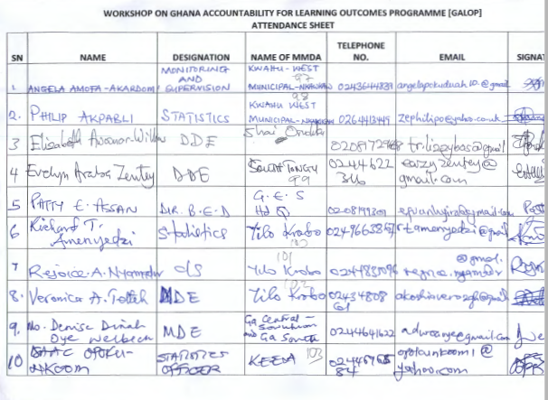

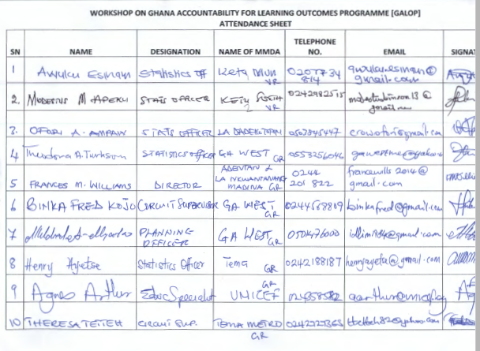

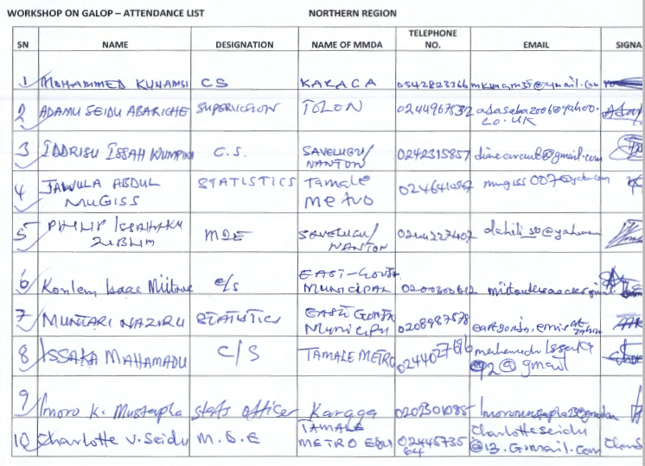

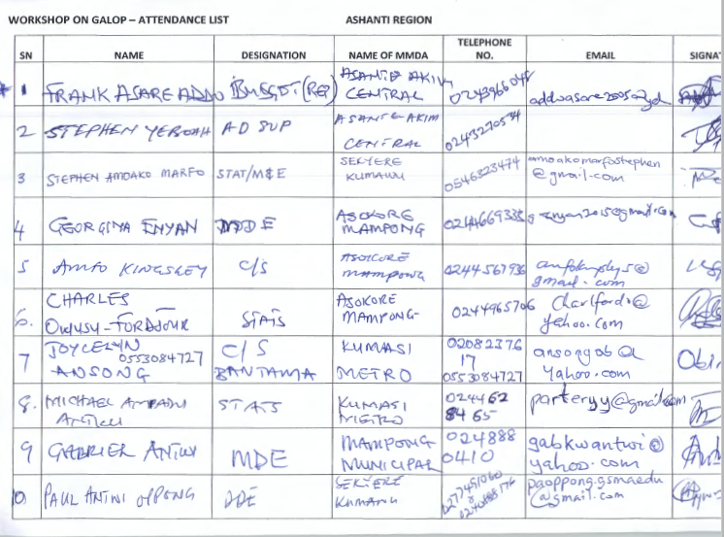

Appendix 5: Additional Consultations on the first AF (March 2020)

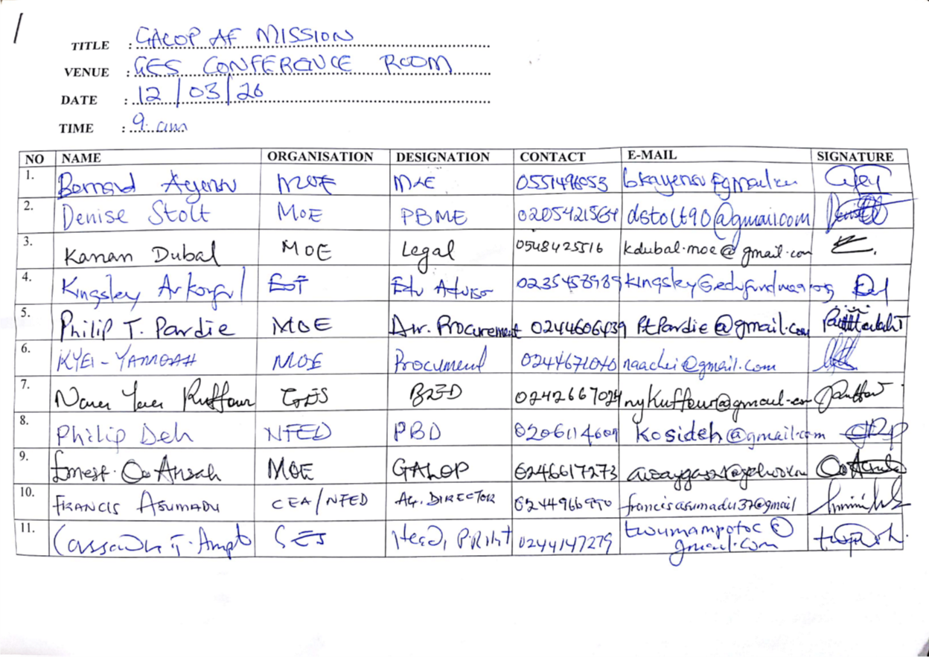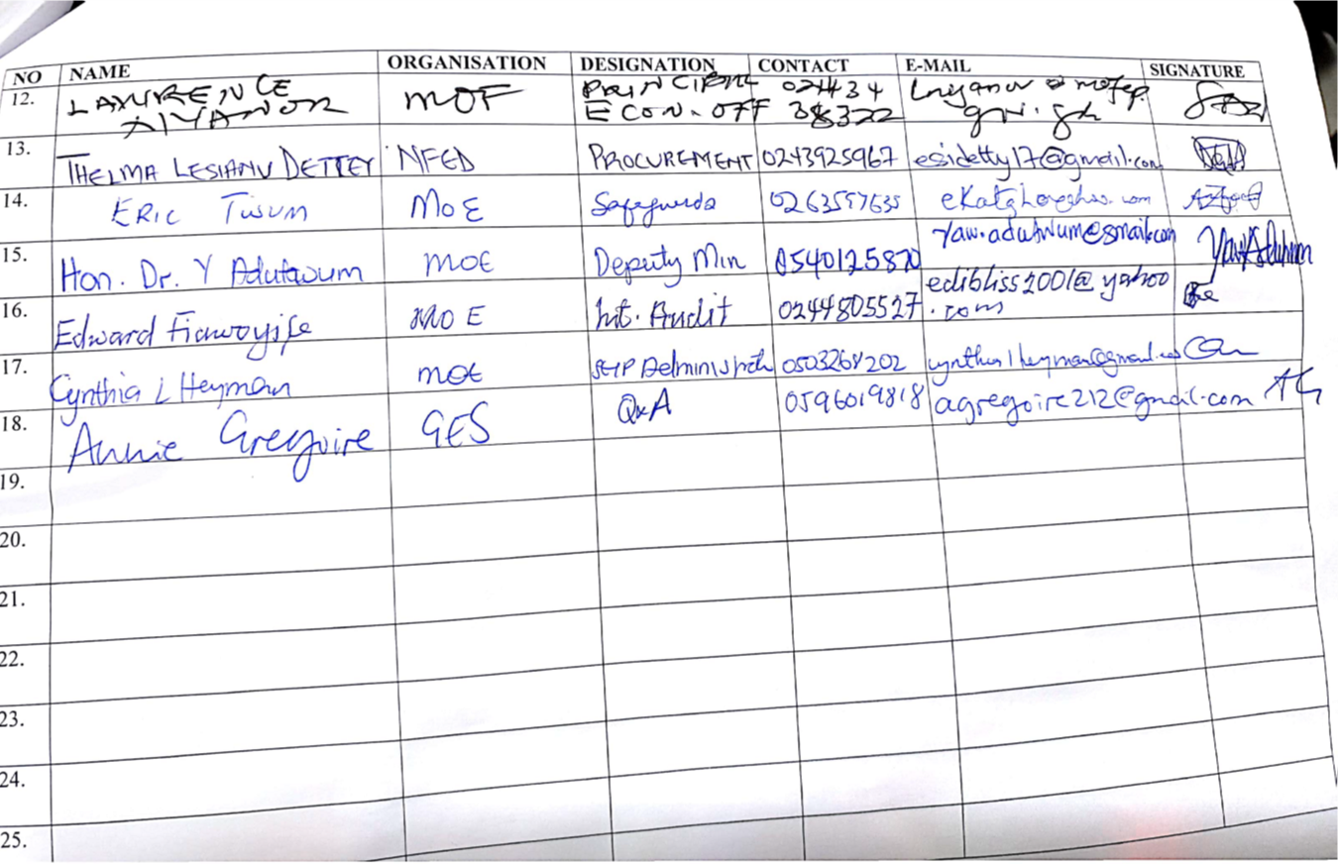

Appendix 6: Photos from Additional Consultations on the first AF (March 2020)

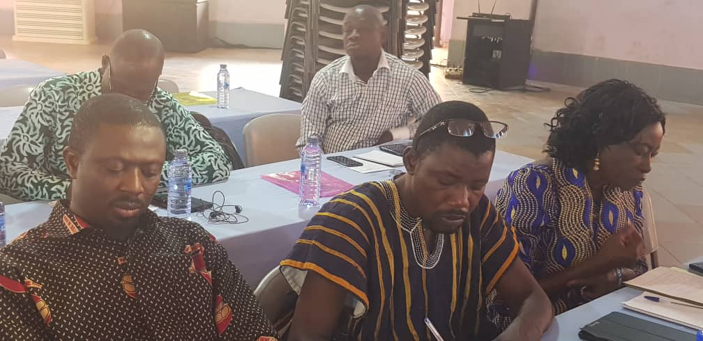 | 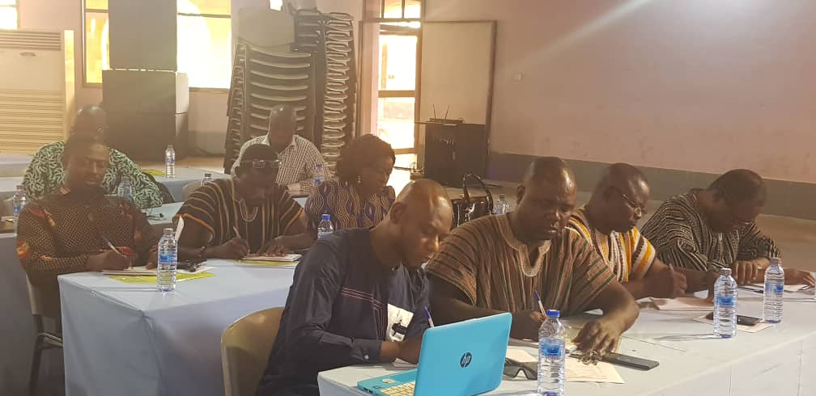
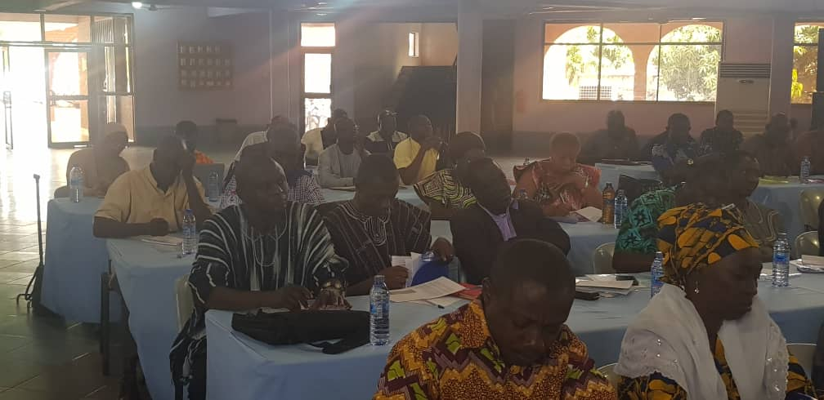 | 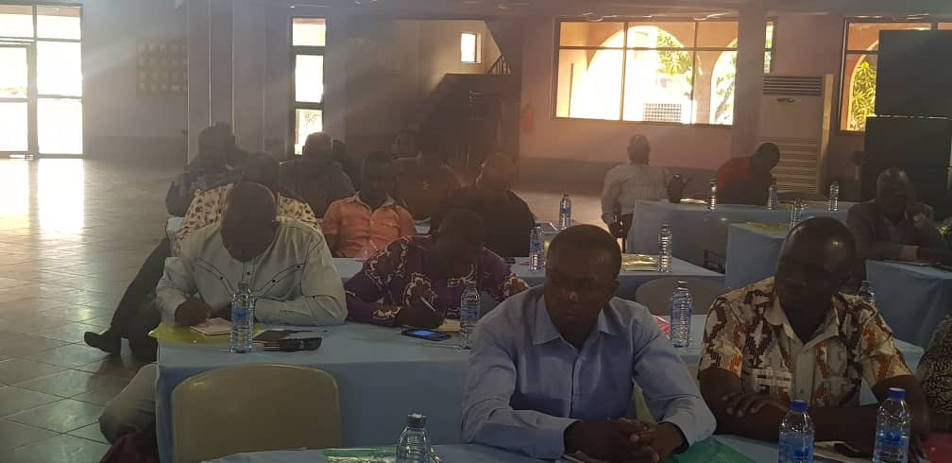

Appendix 7: Attendance Lists for Zonal Stakeholder Consultation Workshops for GALOP AF2

Attendance List - GALOP AF2 North Zone Stakeholder Workshop Held at Tamale, 24th - 28th June, 2024
No. | Name | Org | Designation
1 | Mbatia Joshua | GES North East Gonja | Budget Officer
2 | Sulemana Mutaka | GES East Mamprusi | Accountant
3 | Simon Amokase | GES North East Region | Regional Director
4 | Sophia Dimah --------dzo | GES Wa Municipal | DDE
5 | Ayishetu Ibrahim | Wa East | DDE
6 | Eliasu Minasara | Wa Municipal | Budget Officer
7 | Abubakari Z. Sumaila | Wa East | Statistics Officer
8 | Mercy Aduko | GES East Mamprusi | DDE
9 | Jeremiah O. Ansah | GES Headquaters | Head, Budget
10 | Alex Anning | GES | Head, Planning
11 | Lawrence Nyanor | Ministry of Finance | Principal Economist
12 | Mirabel K. Bentil | MOE | APO
13 | Kwadwo Opoku | WB | Economist
14 | Issahaku Iddisah | GES NEGD | DDE
15 | Thywill Cudjoe Kudesey | WB | MIS Consultant
16 | Eunice Ackwerh | WB | Snr. Education Specialist
17 | Bruno Daplah | GES Tamale Metro | Budget Officer
18 | Wilhemina Addo Anyane | WB | Social Dev Consultant
19 | George Amoasah | WB | Environment Specialist
20 | Anne Estella Kye-eebo | GES Bolgatanga Municipal | MDE
21 | Bhanu Pathak | UNICEF | CFO Tamale
22 | Gloria T. Dakpallah | UNICEF | Education Officer
23 | Nelson Konlan | GES Tamale Metro | MDE
24 | Nana Hagan | MOE/GALOP | Dep. Director
25 | Nana Ama Boa-Amponsem | Jacobs Foundation | Consultant
26 | Emmanuel Inkook | SAGES SSA | MEAL Director
27 | Dr. Issahaque Mumawaru | GES Savelugu Municipal | MDE
28 | Yahaya Baba Ibrahim | GES Savelugu Municipal | Statistics Officer
29 | Yahaya Sulemana | GES Kumbungu | DDE
30 | Alice Ellen Abeere-Inga | GES Kasina Nankana Municipal | MDE
31 | Gerhadt Seddoh | GES | Regional Stats Officer
32 | Sanda Mohammed Imoro | GES - UER | Budget Officer
33 | Zakaria Fadila | GES Savelugu Municipal
34 | Elias Azure Abange | GES Mamprusi West | DDE
35 | Mutaka Imoro | GES West Mamprusi | Statistics Officer
36 | Ibrahim Mumuni | GES Bongo | DDE
37 | Mohammed Kari

Attendance List - GALOP AF2 South Zone Stakeholder Workshop Held at Nkwatia-Kwahu
No. | Name | Org | Designation
1 | Nana Hagan | MOE/GALOP | Dep. Director
2 | Nathaniel K. Effum | GES - Nzema East | Director
3 | Desmond Dadey | GES New Juaben South | EM Officer
4 | Mustapha Haruna Appiah | GES Koforidua | MDE
5 | Rudolf Stephen Nuako | GES Cape Coast | Budget Officer
6 | Thywill Cudjoe Kudesey | WB | MIS Consultant
7 | Benjamin Tawiah | GES Nzema East | Planning Officer
8 | Phyllis Asante- Krobea | GES Cape Coast | MDE
9 | Kwadwo Opoku | WB | Economist
10 | Dinah Anderson | GES Winneba | MDE
11 | Elizabeth Akushey | WB | PA
12 | Thomas More Tsole | GES Akwatia | Dep. Director
13 | Michael Kwaku Dunyo | GES Akwatia | DBO
14 | Mirabel Bentil | MOE | APO
15 | Benjamin Kwasi Asare | GES Cape Coast | Regional Planning Officer
16 | George Effah | GES Takoradi | MDE
17 | Francis Yaw Agbemadi | GES HO | Regional Director
18 | Dominic Yao Dzanado | GES Anloga | Director
19 | Mawuli Fofowe Kofi Gati | GES Anloga | Statistics Officer
20 | Lawson Kordzo Samlafo | GES HO | Planning Officer
21 | Grace Adza- Awude | GES HO West | Budget
22 | Robert Hanson | WB | FM
23 | Lawrence Nyanor | MOF | PEO
24 | Prosper Yevu | GES North -Dayi | DDE
25 | Maxwell Amenu | GES North -Dayi | EMIS
26 | Hammond William A | GES Abuakwa North | Data Entry Officer
27 | Joyce Oduro | GES Effutu Municipal | Training Officer
28 | Paulina Slyn Eworde Gobe | GES, HO West | DDE
29 | George Amoasah | WB | Environmental Specialist
30 | Hilda Amegatcher | GES New Juaben North | Director
31 | Lawrence Gyimah | GES New Juaben North | Budget Officer
32 | Eric Sey | GES Ga East | MDE
33 | Selasee Oppong | GES Ga East | EMIS
34 | Clifford Henaku Budu | GES Ashaiman | MDE
35 | Ebenezer Kwesi Pobee | GES GAR - Accra | Dep. Regional Director
36 | Sam Dzanku | GES GAR - Accra | Regional Planning Officer
37 | Edmond Aggrey | GES Sekondi Takoradi | Metro. Director
38 | Lawrence Solomon | GES Sekondi Takoradi | Statistics Officer
39 | Emmanuel Essuman | GES - Cape Coast | Regional Director
40 | Agbemavor Setsoafia Adipa | GES HO West | Budget Officer
41 | Ivy Ayiku- Ocansey | GES Accra | HR
42 | Gloria Biney Gowtor | GES Takoradi | DDE
43 | Rafic Ben Sam | GES Takoradi | Regional Planning Officer
44 | Fuseini Alhassan | GES Takoradi | Budget Officer
45 | Humphrey Anim | GES Koforidua | Budget Officer
46 | Emmanuel Asare | MOE | Planning Officer
47 | Mrs. Ivy Asantewaa (PhD) | GES Koforidua | Regional Director
48 | Aminu Sulemana | MOE | DD
49 | Augustus Agyemfra | GES | DDE
50 | Ama Blankson Anaman | WB | Education Specialist
51 | Eunice Ackwerh | WB | Snr. Education Specialist

Attendance List - GALOP AF2 Central Zone Stakeholder Workshop Held at Kumasi
No. | Name | Org | Designation
1 | Kofi Dwomoh | GES Kumasi Metro | Regional Planning Officer
2 | Anthony Numako | GES Asutifi South | District Director
3 | Emmanuel Kwaku Siaw | GES Asutifi South | District Planning Officer
4 | Judith Mensah Panford | GES Kumasi Metro | Metro Planning Officer
5 | Robert Hanson | WB | Accountant
6 | Asakiya Sylvester | GES Techiman | Budget Officer
7 | Dorothy Opare- Baidu | GES Oforikrom | Municipal Director
8 | Nana Kugbeadzor Bakateyi | GES Bono East | Nkoranza
9 | Daniel Okoto Ansah | GES Bosomtwe | District Director
10 | John K. Amissah | GES Techiman Municipal | Municipal Director
11 | Beatrice Mamle Nkum | GES Berekum Municipal | District Director
12 | Adu Bediako Richard | GES Berekum Municipal | Planning Officer
13 | Samson Anawine Atogembero | GES Asokore Mampong Municipal | Director
14 | Haruna Awudu | GES Asokore Mampong Municipal | Planning Officer
15 | Wilhelmina Addo Anyane | WB | Social Dev't Consultant
16 | Aminu Sulemana | MOE | DD
17 | Florence Afful Dadzie | GES Bibiani Anhweraso Bekwai | District Director
18 | Faustina N. Forson | GES Asunafo South | District Director
19 | Adama Inusah | GES Asunafo South | Statistician
20 | Shirley Blankson | GES Aowin | District Director
21 | Mary Antwi | GES Ejisu | Budget Officer
22 | Kwabena Owusu | GES Ejisu | Municipal Director
23 | Nana Hagan | MOE/GALOP | Deputy Director
24 | Lawrence Addo | GES Bosomtwe | Budget Officer
25 | Kinsley Dwamena Asante | GES Dormaa Central | Municipal Director
26 | Joseph Baah Yeboah | GES Dormaa Central | Budget Officer
27 | George Amoasah | WB | Environmental Specialist
28 | Isaac K. Amankwah | GES Nkoranza | District Director
29 | Richard Tanor | GES Nkoranza | Budget Officer
30 | Richard Atanga | GES | Bibiani Anhwiaso Bekwai
31 | Thywill Cudjoe Kudesey | WB | MIS Specialist
32 | Augustine Suuk Gbali | GES Ejisu | Planning Officer
33 | Agnes Amihere | GES Tano South | Municipal Director
34 | Benedicta Badu Nyanta | GES Tano South | Planning Officer
35 | Nicholas Bassaw | GES Kumasi Metro | Metro Director Rep
36 | Kwabena Appiah | GES Oforikrom | Planning Officer
37 | Phyllis Boateng | GES Juaben | Municipal Director
38 | Selina Poku Okae | GES Juaben | Planning Officer
39 | Lucy Ama Ankuah | GES Tano South | Regional Director
40 | Dominic Boye Jnr | GES Tano South | Planning Officer
41 | Ezekiel Osei Bonsu | GES Bono East | Planning Officer
42 | Kporvi Francis Mensah | GES Western North | Head of Planning
43 | Dr. Amankwah Appiah | GES Kumasi | Regional Director
44 | Sarah Yeboah | GES Sunyani | Planning Officer
45 | Mirabel K. Bentil | MOE | APO
46 | Eunice Akwerh | WB | Senior Education Specialist
47 | Ama Blankson Anaman | WB | Education Specialist
48 | Elizabeth Akushey | WB | PA
49 | Ken Fosu | WB | External Affairs Officer
50 | Kwadwo Opoku | WB | Consultant
51 | Emmauel Asare | MOE | PBME
52 | Seth Ahenkora | GES Enchi | Budget Officer
53 | Gabriel Antwi | GES Sunyani | Regional Director
54 | Seth Boateng | GES Bibiani | Regional Director
55 | Kinsley Asare Anni | GES Bosome Freho | CEP Focal Person

Appendix 8: Pictures From CSOs Stakeholder Consultations for GALOP AF2
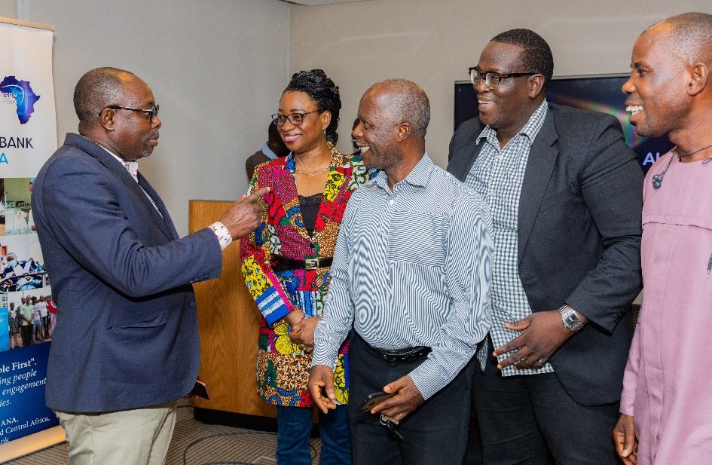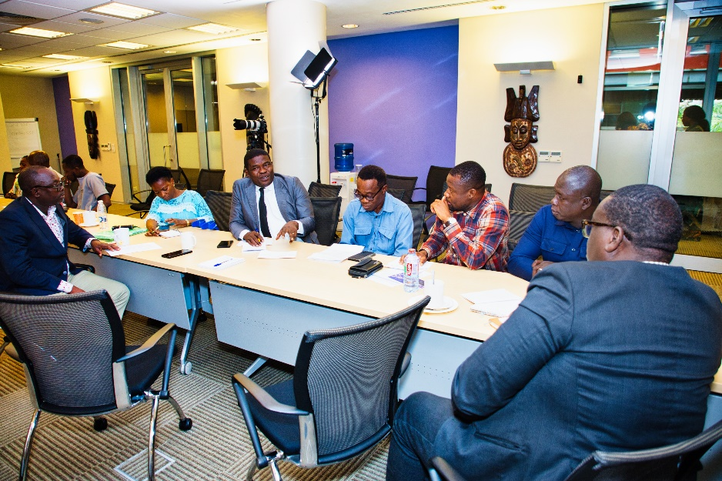
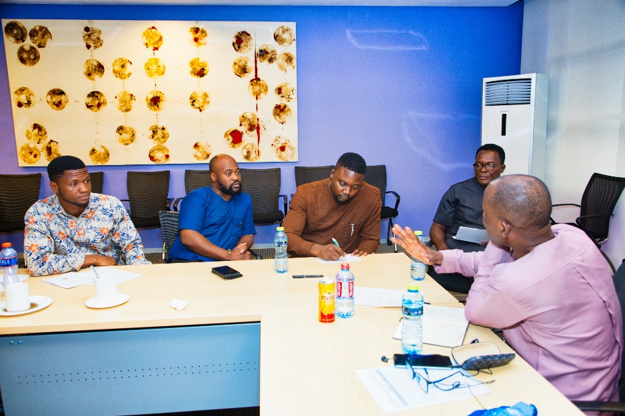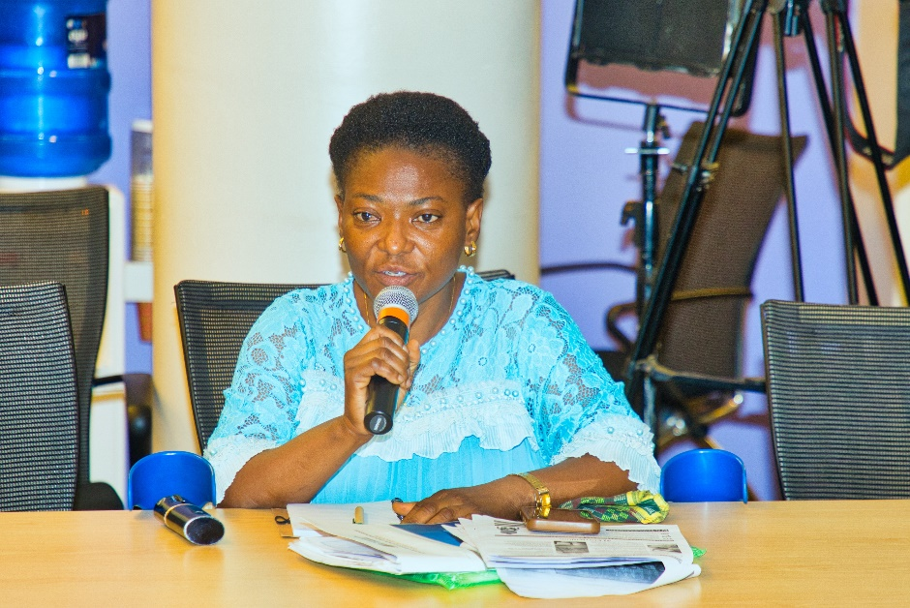

Appendix 9: Proposed GALOP Indicators
Project Development Objective Indicators by Objectives/ Outcomes
 | Indicator Name | PBC | Baseline | Intermediate Targets |  |  | End Line Target
 |  |  |  | 1 | 2 | 3
 | Improve quality of education in basic schools
1 | Increased percentage of targeted schools with teaching practices meeting inspection standards*. |  | 64.71 |  |  |  | 80
 | Increased percentage of KG classes with teaching practices meeting inspection standards. | Yes | TBD
2 | Number of students supported with better education in early childhood education (CRI) |  | 832,790 |  |  |  | 2,500,000
 | Females |  | 409,267 |  |  |  | 1,250,000
 | Number of students supported with better education in primary education (CRI) |  | 2,049,830 |  |  |  | 4,000,000
 | Females |  | 957,830 |  |  |  | 1,900,000
 | Number of students with disabilities supported with better education |  | 4,794 |  |  |  | 50,000
3 a | Increased percentage of P2 learners achieving basic proficiency or higher in literacy |  | 38.7%  (2022 P2 NST) |  | 50 |  | 60
3b | Increased percentage of P2 learners achieving basic proficiency or higher in numeracy |  | 62.1%  (2022 P2 NST) |  |  |  | 75
 | Strengthened education sector equity
4a | Increased percentage of targeted KG with PTTR below 50:1 * |  | 54.66  (2019) |  |  |  | 70%
 | Increased percentage of targeted AF KG with PTTR below 50:1 |  | 72.98  (2022) |  |  |  | 85%
4b | Increased percentage of targeted primary schools with PTTR below 50:1* |  | 81  (2022) |  |  |  | 90%
 | Increased Percentage of targeted AF primary schools with PTTR below 50:1 |  | 72.86 |  |  |  | 85%
 | Strengthened education sector accountability
5. | Increased number of schools using accountability dashboard data during cluster level* meetings |  |  |  |  |  | 15,000

Intermediate Results Indicators by Components
 | Indicator Name | PBC | Baseline | Intermediate Targets |  |  | End Line Target
 |  |  |  | 1 | 2 | 3
 | Component 1: Strengthen teaching and learning through support and resources for teachers
1 | Number of KG and primary teachers trained (Number) |  |  | 50,000 | 60,000 | 64,000 | 64,000
1b | Number KG teachers trained through INSET model |  |  | 15,000 | 25,000 | 29,000 | 29,000
1c | Number of primary teachers trained in differentiated learning approaches |  |  | 35,000 | 35,000 | 35,000 | 35,000
2 | Number of schools assessing and reporting Differentiated Learning literacy and numeracy outcomes for individual learners on DL + Platform (Number) | Yes | 733 | 5000 | 14,000 | 15,000 | 16,000
2a | Number of AF schools assessing and reporting DL literacy and numeracy outcomes for individual learners on DL + Platform with agreed set of TLRs and workbooks |  | 733 | 4500 | 5000 | 5500 | 6000
3 | Number of AF schools receiving at least 3 coaching and mentoring sessions by SISOs during the academic year (Number) |  |  | 4500 | 5000 | 5500 | 6000
4 | Increased percentage of children demonstrating school readiness in targeted schools by the end of KG2 |  | tbd |  |  |  | 70
 | Component 2: Strengthen school support, management and resourcing
5 | Number of schools resourced and adequately staffed | Yes |  | 3000 | 5000 | 5500 | 5500
6 | Number of districts receiving accountability grants and achieving performance targets in ADEOPs | Yes |  | 100 | 175 | 200 | 235
7 | Percentage decrease in Teacher Absentee Rate*  (percentage point increase from baseline) | Yes | 23% |  |  |  | 9 percentage point decrease over baseline
8 | Number of children undergoing health and disability screening |  | tbd | 10,000 | 50,000 | 100,000 | 200,000
9 | Number of children ages 0-5 benefiting from quality childcare interventions |  |  | 20,000 | 20,000 | 25,000 | 65,000
10 | Percentage of Mothers/caregivers of children enrolled in childcare reporting increased hours spent in economic activities including self-employment or paid work |  | TBD |  |  |  | 15
11 | Number of schools with after-school childcare/learning clubs with parental support in play-based learning |  | 0 |  |  |  | 1000
 | Component 3: Strengthen accountability systems for learning
12 | Numbers of communities of excellence implementing at least 80 percent of their approved implementation plan | yes | tbd |  |  |  | 800
 | Component 4: Technical Assistance, Institutional Strengthening, Monitoring, and Research
13 | Percentage of annual GEEDLab Research and Learning Agenda targets achieved | yes |  | 70 | 80 | 80 | 80

Note: Indicators with * denote indicators from the Parent Project

Ghana has an estimated 32,000 public and private basic education schools covering KG, primary and lower secondary schools, 2023.
The Basic Education Certificate Examination at the end of lower secondary was replaced by P4 National Standardized Test (NST) scores.
The parent GALOP has already prepared an electronic waste management plan which will be continuously implemented
Ghana has an estimated 32,000 public and private basic education schools covering KG, primary and lower secondary schools, 2023.
The Basic Education Certificate Examination at the end of lower secondary was replaced by P4 National Standardized Test (NST) scores.
Per the GALOP, the use of results-based financing is also aligned with GPE requirements for about 80 percent of GPE financing to be tied to results focused on improving foundational learning outcomes.
- The 1992 Constitution of the Republic of Ghana sets out the Rights, Freedom, Duties and Obligation of every citizen of Ghana. These are these are the constitutional rights of Ghanaians. The constitution also defines specific requirements for the protection of the Environment such as provided under: Article 37(3); Article 39(6); Article 41(k); Article 268 and Article 269.
- National Environmental Policy (Revised) 2010 comes in to replace the 1992 National Environmental Policy broad vision founded on and directed by respect for all relevant principles and themes of environment and sustainable development. The policy describes major environmental challenges in Ghana and recommends operational policies, sector strategic goals and sector environmental policies to combat them.
The original GALOP, trained about 70,000 teachers at the basic education level (KG, primary, and Junior High School) on improved pedagogies including differentiated learning.
The National Standardized Test (NST) funded under the original GALOP has showed some learning gains in 2022 over the 2021 baseline.
The Ghana academic year is made up of three (3) terms totaling about 40 weeks a year.
Training of master trainers comprising District Teacher Support Teams (DSTS), School Improvement Support Officers (SISOs), and school heads.
Training of guidance and counselling, girls’ education, special education, and CEA coordinators to improve foundational learning.
Over 200,000 tertiary graduates are posted at National Service volunteers annually and about 50 percent are assigned to educational institutions nationwide.
Paragraphs 12 and 13 of Investment Project Financing Policy.

